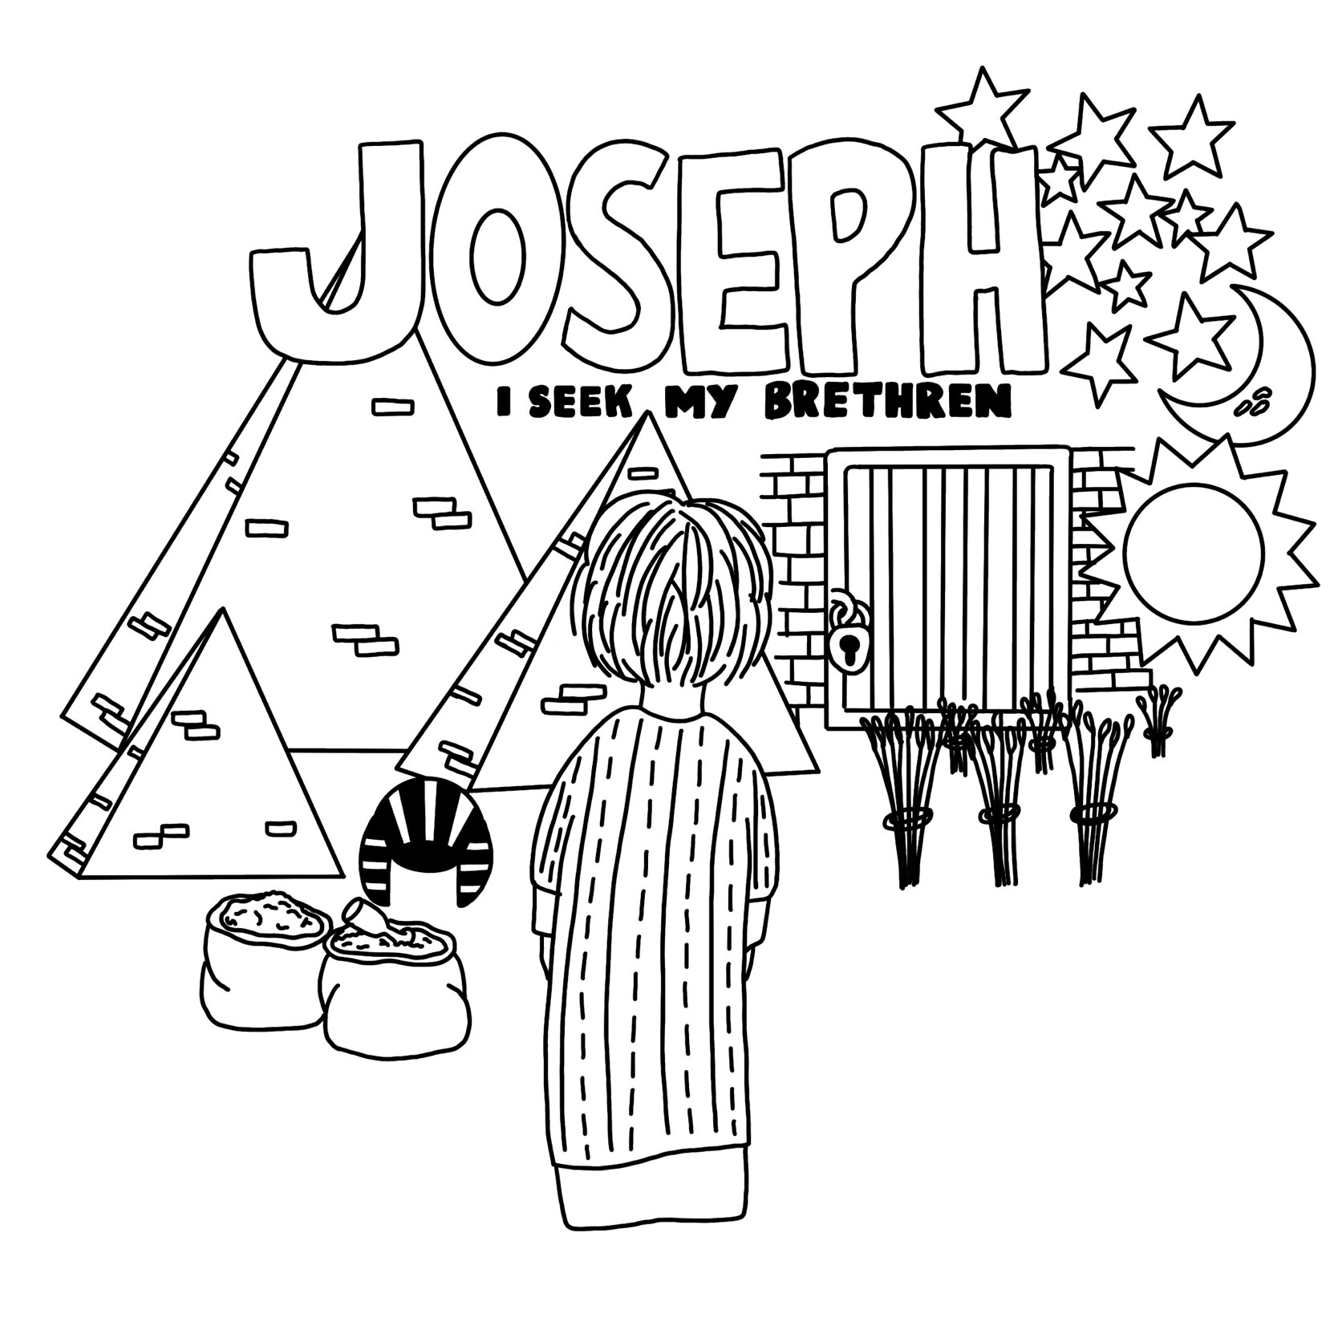
Manitoulin Youth Conference 2025 Workbook

TABLE OF CONTENTS
Section 1: Joseph and His Brethren in Canaan ………….……. Pg. 5
Section 2: Joseph and the Egyptians ………………………..…. Pg. 11
Section 3: Joseph and His Brethren - Tribulation …………..…. Pg. 25
Section 4: Joseph and His Brethren - Purification ………….…. Pg. 31
Section 5: Joseph and His Brethren - Revelation ……………. Pg. 35
Section 6: Joseph and His Family in Egypt ……………………. Pg. 40
Section 7: Research Questions ……………………………….…. Pg. 47
Appendix 1 – Joseph Bible Marking …………………...…. Pg. 61
Appendix 2 - Additional Study Resources ………………. Pg. 72

Discussion Group Breakdown

Day One
Section 1………….…. Pg. 5-10
Researching Jacob …. Pg. 47
Shechem …………...…. Pg. 52

Day Two
Section 2 …………... Pg. 11-24
In Egypt …………...…… Pg. 55
God Is Watching …...... Pg. 57
The Bread and The Wine.. Pg. 54
Day Three
Section 3 ………..…. Pg. 25-30
Section 4 ……...…… Pg. 31-34
Researching Judah .… Pg. 50
Attitude …………..……. Pg. 58

Day Four
Section 5 ………………..… Pg. 35-39
Researching Joseph ………... Pg. 51
Give and Forgive ……………. Pg. 59
Changing Ones Garments ... Pg. 53

Day Five
Section 6 ………………………….… Pg. 40-46
Researching Joseph as a type of Christ ……… Pg. 52
Watch What You Say ………………… Pg. 59
Separate, yet seeking to save ……... Pg. 56

Dear MYC Attendee!

We are so glad you have chosen to use your time and money this year to attend MYC 2025! We pray that the studies and time around God’s word sharing in fellowship with fellow young people will help you in your walk towards the Kingdom!

This workbook was originally written for MYC 2002 which was the last time the topic at conference was Joseph. We hope you will be able to take wonderful lessons from your study of this man!

WHEN TO START YOUR WORKBOOK
 | START DATE | END DATE
2-3 Pages/Week | February 1 | August 16
3-4 Pages/Week | April 1 | August 16
5-6 Pages/Week | June 1 | August 16
30 Pages/Week  **Bad option** | August 1 | August 16
You may be asking yourself.. “How long will it take me to finish this workbook?” check out this chart. >>
As you can see, the sooner you start the easier it will be to get your book done in time without unnecessary cramming.
Alongside this, the more time you give yourself to complete your preparation studies for MYC the more you will get out of the studies!

Additionally, the Section 7: Research Questions will take considerably more time per page to complete then the other sections as you will need to do a good amount of extra study to answer the questions. So plan your time working on this workbook accordingly!

We recommend beginning your studies by reading Genesis 30, 37, and 39-50 several times over!

If you have any questions or need any help please feel free to contact us at emujones24@gmail.com
We hope this study will help you as you seek to better manifest our God in the days remaining until His son returns! We look forward to seeing you at MYC 2025 or better yet, in the Kingdom, God willing!

Love in our shared Hope,
Bro. Ethan & Sis. Joanna Jones
Email: emujones24@gmail.com

Original Workbook Writers 2002
Bro. Mark Carr & Bro. Dan Wilton

Supportive Editor 2025
Bro. Stewart Cambridge
USEFUL RESOURCES
We recommend reading Genesis 30, 37, 39-50 several times to jump start your studies!
Websites | https://www.blueletterbible.org/ | Online Bible software, Interlinear Bibles, Bible Concordances, Bible Dictionnaires, etc.
 | https://www.biblegateway.com/ | Online Bible software
 | https://thechristadelphian.com/ | Christadelphian Office website, Christadelphian Books for sale, UK based
 | https://christadelphianlibrary.com/ | US based Christadelphian book provider
 | https://christadelphianbibletalks.com/ | Online Library of Christadelphian Bible Talks
 | https://christadelphianvideo.org/ | Online Library of Christadelphian Bible Talks
Books | “The Ways of Providence” | By Robert Roberts
 | “Teenagers of the Bible” | By S. Kingsbury
 | “The Book of Genesis – Verse by Verse Expositor” | By H. P. Mansfield
 | “The Story of the Bible” Vol. 1 | By H. P. Mansfield
Supplies | The Bible (w/ Cross Referenes & Side Margins) | Suggested Versions: KJV, NKJV, ESV
 | Colored pencils, Regular pencils, Pens, Ruler, Eraser, Notebook, Etc. | Pigma Micron pens & Prismacolor colored pencils are both high quality brands that last a while and don’t smudge or fade in your Bible
37:1-4 – Joseph – loved of his father, hated by his brethren
SECTION 1: Joseph and his Brethren in Canaan
In order to better understand the story of Joseph, we have to look at some background details of Jacob and his family.

- Jacob was a man of ups and downs, spiritual highs and lows. He often relied on his own power to accomplish things, so he struggled throughout his life to trust in God’s care and guidance. Fill in this little biography about Jacob to refresh your memory about him, and the people and events in life. Jacob (Gen 25:26)
  - Name changed to (Gen 32:28):
  - Parents (Gen 25:28):
  - Brother (Gen 25:28):
  - Father-in-law (Gen 28:2):
  - Wives (Gen 29:21-24, 28-29):
  - Number of years he served for his wives (Gen 29:20, 27):
  - Concubines (Gen 29: 24, 29):

- Complete the following chart about Jacob’s family: (Gen. 29-30;35:16-18)
Jacob
Rachel
Zilpah
(1) Reuben
(2)
(4)
(3) Levi
(10)
(9)
(7) Gad
(11) Dinah
(8)
(5)
(12) Joseph
(6) Naphtali
(13)

- Do you think the sons of the wives and the bondwomen (handmaids) were born of love or envy? Given the atmosphere they were born into, what do you think their characters were like? (See Appendix 2 pg. 72 for a possible suggestion of the timing of the births of Jacob’s children)

- Where were Jacob and his family living at this time? (Gen. 37:1) What is significant about this place?

- What does Joseph mean?
  - Strong’s Number: H3130
  - Hebrew Word:
  - Meaning:

- From what you know already about the story, what do you think the significance of his name in relation to his life could be?

- It says that Joseph was with “the sons of Bilhah and Zilpah” (v. 2) From the chart on the previous page, we saw who these sons were. Why do you think Joseph is with them and not with the sons of Leah?

- How old is Joseph at this time?

- Can you find at least three examples of people near his age, serving God in their youth:
1)
2)
3)

- What was the reason Israel (Jacob) loved Joseph more than the other brothers?

A useful exercise for this study is to color in “Jacob” and “Israel” in the book of Genesis (particularly from Ch. 32 onwards.) Keep a look out for any emerging patterns between the context of when Jacob is used and when Israel is used.
- Jacob made Joseph a “coat of many colors.” (v. 3) There are a few different ideas as to what this phrase actually means. Here are some of the suggestions put forward:
  - “coat of many colors or pieces” – made up of different lengths of material that contained the colors of the rainbow, a reminder of the covenant God made with Noah; very suitable for Joseph, a very “colorful” character
  - “coat of many hands” (literal translation) – covered to the hands and feet, a garment worn by a priest
  - “coat of many hands” – a coat that has been “handed down” from generation to generation, consistent with the idea of a priestly garment
  - Do you have a different suggestion? What is it and how could you prove it?

- What was the reason Jacob gave Joseph this coat? Based on the reason and the above suggestions what do you think the coat could have been like?

- Look up the word peaceably (v. 4)
  - Strong’s number: H7965
  - Hebrew Word:
  - Meaning:

- Look up where this word is used before in scripture.

“Joseph was innocent and excellent, but Joseph was young and untried, and God had a great purpose with him that required that he should be matured and perfected in character as men only can be perfected – in the school of adversity.” -The Ways of Providence pg. 62
37:5-11 – Joseph’s dreams
- Dreams have a lot to do with Joseph’s life. There are a number of incidents of dreams recorded in Joseph’s life. List the references for every incident you can find.

- Complete this chart to figure out the details of Joseph’s dreams in Genesis 37
 | Symbols | Who is involved/  What happened? | When was it fulfilled?  (Include reference)
Genesis 37:5-8
Genesis
37:9-11

- In your opinion, was Joseph doing the right thing in telling his family about the dreams, why or why not?

- When Joseph told his father his dreams, Jacob had two different reactions, list them:
  - Initial reaction (v. 10)

  - Subsequent reaction (v. 11)


- Look up the word observed (v. 11)
  - Strong’s number: H8104
  - Hebrew word:
  - Meaning:

- Give an example of a person in the New Testament, who had the same two reactions.
37:12-17 – Joseph seeks his brethren at Shechem, but finds them at Dothan
“These dreams were of God, as we may understand Joseph afterwards recognized from his declaration to Pharaoh: ‘It (the power to interpret dreams) is not in me: God will give Pharaoh an answer of peace’ and also his question to the butler and baker in prison: ‘Do not interpretations belong to God?’ These dreams were from God; If there be a prophet among you, I the Lord will make Myself known unto him in a vision and will speak unto him in a dream.’ (Numbers 12:6)

This was the nature of Joseph’s dreams – divinely communicated forecasts of coming events. They were communicated as a part of the agency that was to develop the future to which they pointed. The narration of them by Joseph filled the minds of Joseph’s brethren with envy – a bitter feeling that banishes mercy. Their self-esteem was hurt by dreams that appeared to them the mere embodiment of a petted boy’s complacency, and thus they were predisposed to act the part that was to send Joseph to the sphere of his discipline and promotion. ‘They could not speak peaceably to him.’ Their feelings settled into hatred was ready to seek and find an opportunity of putting its object out of the way. Joseph was perfectly innocent of anything to justify their malignity. He was free of guile, a lover of righteousness, loved of his father, and loved of God; and behold him the object of gathering clouds of enmity!”
– The Ways of Providence pg. 61
- Joseph’s brothers were supposed to be feeding their flocks at Shechem. What does Shechem mean? (v.12)
MAP WORK
Draw a map of the land of Israel and mark on it where Shechem is.
  - Strong’s number: H7927
  - Hebrew word:
  - Meaning:

- Using a Bible Dictionary explain whether or not Shechem was a good place for feeding sheep.

- Read Genesis 34:1-5, 25-31 and explain why Jacob may have been concerned about his sons being back in Shechem.

- Joseph was found wandering (v. 15) What does this word mean?
  - Strong’s number: H8582
  - Hebrew word:
  - Meaning:
It would be worth putting this map in the margin of your Bible!
See Appendix 2 pg. 72 for how to do that!

- Based on that definition how do you think Joseph might have been feeling when he couldn’t find his brothers in Shechem?

- In v.16 Joseph says “I seek my brethren” When it states that he sought his brethren, in what way do you think he did that? Do you think it was any deeper than merely ‘looking around’ for them? Why or why not?

- Based on what you know about the story of Joseph, find as many examples as you can in the life of Joseph where he sought the welfare of his “brethren” or those around him (you may want to leave this question and come back throughout the study).

- Upon the advice of the “certain man”, Joseph goes to Dothan to look for his brothers. Look up in a Bible dictionary the meaning of Dothan (v. 17)
  - Strong’s number: H1886
  - Hebrew word:
  - Meaning:

- With this meaning in mind, what is ironic about where they were and the conditions that existed? (To get the full meaning look up ”pit” in verse 20 – use other translations to make the verse clearer)

- Between Dothan and Shechem which was the better place to feed their flocks?

- Based on all of this why do you think Joseph’s brothers went to Dothan?

37:18-24 – Joseph cast into the pit
- “When they saw him afar off…they conspired against him to slay him” (v. 18). What does this tell us about how much they hated him?

- What was ironic about their statement “…and we shall see what will become of his dreams”? (v. 20)

- What would it have been like in the pit for Joseph? How did Joseph feel while in it? (see Genesis 42:21)

- What did the brothers do after they threw Joseph into the pit? What does this tell us about their hatred and insensitivity?

- We learn a lot about Reuben’s character in this chapter. In v. 21-22, what had Reuben tried to do?

- In v. 29-30, it says “Reuben returned” to the pit to find Joseph was not in it. Where do you think Reuben might have gone?

- Why was Reuben so upset that his brothers had sold Joseph? What was he really upset about?

- As we saw earlier, Reuben was the oldest of the brothers. Did he have the status and privileges that went along with this? What had he done to impact his standing with his father? (Genesis 35:22)

- From the events of this chapter, does it seem that Reuben is the leader of the brothers? Do they respect him as the eldest?

37:25-30 – Sold to the Ishmeelites
“The object of Joseph’s brethren was to kill him. They proposed to do this out and out before casting him into the pit; but this would have interfered with the purpose of God. They were therefore diverted from their purpose. Reuben was touched with compassion for his brother, and purposed that they should do nothing violent to him, but merely put him into a pit, and let him come to die there – his object being to release him afterwards, and take him back to his father. Reuben’s proposal was accepted; and Joseph, arriving, was seized and stripped of his outer coat. Nothing is said in the narrative of Joseph’s terror; but it comes out in their remarks one to another in Egypt twenty years afterwards, ‘We saw the anguish of his soul when he besought us, and we would not hear.’ The poor boy was let down into a living death, as it seemed, appealing in vain to the mercy of his hard-hearted and grown-up brothers.” – The Ways of Providence pg. 62, 63
- The brothers sell Joseph for 20 pieces of silver to a caravan of merchantmen called both “Ishmeelites” and “Midianites”. It is likely that these men were:
Ishmeelites by descent,
Midianites by country,
Merchants by profession.

- Who were the Ishmeelites? (Gen. 16:15)

- Were they allies or enemies of Israel? (Gen. 21:9-11)

- Why could it be significant that they took Joseph down to Egypt?

- What is the significance of the 20 pieces of silver? (see Lev. 27:5 and Ex. 21:32)

37:31-35 – Jacob’s grief
- Joseph’s brethren try to cover up what they had done to Joseph and make it look like it wasn’t their fault at all. Why is it significant that they killed a kid of the goats for blood to stain Joseph’s coat? (see Lev. 4:23, 28; Num. 7:16)

- Joseph’s brothers tried to comfort their father in his time of sorrow. What might this tell us about their characters and consciences?

- Do you think Jacob had second thoughts about what really happened to Joseph? Are we given any clues in this chapter?

SECTION 2: Joseph and the Egyptians
“Follow Joseph in his journey. From one dreadful experience he has plunged into another, and far worse. A father’s favorite, accustomed to the ways of love and the surroundings of comfort, he finds himself in the hands of unfeeling and mercenary strangers, who regard him as a chattel, and think only of how much he will fetch when they arrive in Egypt… exhausted with grief, broken down, unable to cry any more. It is not possible for human situation to be more agonizing; human prospects to be darker… and yet ‘God was with him,’ and was directing his way, and fitting him for exaltation and for untold usefulness in the execution of the divine purpose… The kingdom of God lies ahead, and Paul has told us that ‘through much tribulation we must enter therein.’ How much, and what sort we require, God knows and not we ourselves. Therefore, let us ‘humble ourselves under the mighty hand of God; and He will exalt us in due time.’ Joseph’s agonizing journey to Egypt was a journey to exaltation; and so is ours, if, like Joseph, we fear God, do His commandments, and commit our way to Him. But exaltation comes not at once. There were dark and dreary years before Joseph. Let us not be impatient.” – The Ways of Providence pg. 63, 64
39:1-6 – Joseph elevated in Potiphar’s house
- “Joseph was brought down to Egypt.” Egypt in the Bible is a very important symbol in scripture. What is it a symbol of? (Deut. 5:6; Psa. 89:10 margin; Hosea 11:1; Rev 11:8)

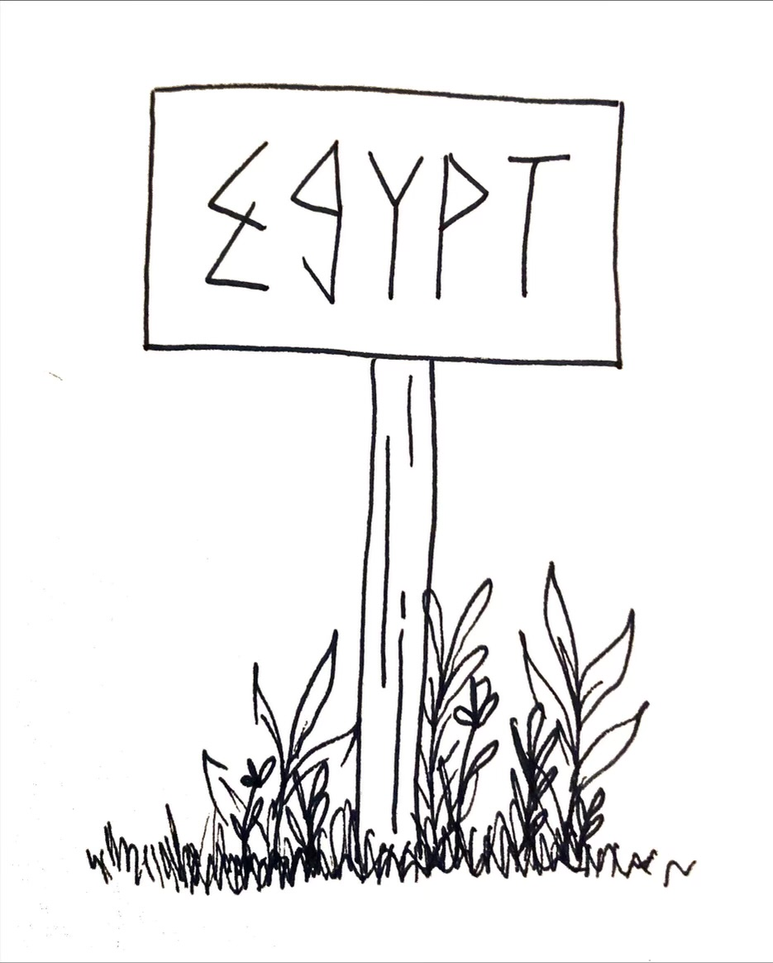
- Give an example of somebody else “going down” to Egypt. (Include reference)

- From these passages, how does God view “going down to Egypt”?

- Think about what kind of atmosphere Joseph, who was 17 at this point, was being thrown into! How do you think he felt?

- (v. 1) What does the name Potiphar mean? (Try Smith’s Bible Dictionary or Easton’s Bible Dictionary)
  - Hebrew Word:
  - Meaning:

- What do the words “captain” and “of the guard” signify?

- What does this tell us about his occupation?

- If we compare Joseph’s experience to Christ, what might Joseph being sold to Potiphar in Egypt be comparative to?

- “The LORD was with Joseph” while he was in Potiphar’s house (v. 2). How many times is this phrase used in this chapter? (List them)

- What does this say about how our Heavenly Father felt about Joseph?

- Find some verses that also mention how God protects and cares for His children.

- Joseph had to maintain a spiritual, positive attitude despite the terrible conditions that he was placed in. How can we become more like Joseph and maintain this same attitude in the difficult circumstances we find ourselves in?

- Potiphar trusted everything he owned into the hand of Joseph, because Potiphar could see that God was with Joseph. Color in the phrase “all that he did/had” in v.3-8. (It occurs six times.)

- In what way can we relate this to our work environment?

- Do you think that God will bless us, and those around us at work because of our actions? (provide some passages to support your answer)

- What does the phrase “ found grace in his sight ” signify? (v. 4)

- Find three other places where this phrase is used again in the life of Joseph.
1)
2)
3)

- Who else in the Bible is this phrase used about?
“Potiphar, captain of Pharaoh’s guard, buys him of their hands, and takes him into his house as a servant. Here we have to consider an instructive feature of the case. Joseph cheerily and faithfully addresses himself to the duties of his position. Had he been like some, he might have considered himself justified in sulking and dawdling, seeing that he was stolen and unjustly brought into his position. In that case, the Lord would not have been with Joseph; for the Lord is not with those who are slothful and contemptuous, from whatever cause. He is only with those who faithfully act their part in the circumstances into which He may bring them… there was nothing to tell Joseph that the act of his brethren was the act of God: but he feared God and submitted himself, knowing (as all true sons of God know and recognize) that God ruleth in the kingdoms of men even now, and orders the steps of those who please Him by their faith and submission.” – The Ways of Providence pg. 64, 65
39:7-12 – Joseph resists Potiphar’s wife
- We see in v. 6 that Joseph was a “ goodly and well favoured” (KJV) young man. What does each of these words mean? (try other versions, like the NIV and NKJV)

  - “goodly” –

  - “well favored” –

- Find at least one woman and one man who were described in similar ways. (Provide reference)
  - Man –
  - Woman –

- For the examples you found, were good looks a positive or negative thing in their life? Are there any lessons we can learn from this?

- Take a moment to consider the situation that v. 7 suggests. How old would Joseph be here?(approximately)

- Do you think he’d ever faced a situation like this, or seen anything like this before?

- List off some possible ways Joseph could have dealt with this situation, and the pros and cons for each situation. Think about how you would have dealt with this situation.
Possibility… | Pros + | Cons -

- What is the best way for us to deal with sin and temptation? (provide a reference or two)

- Joseph produced three reasons why he could not lie with Potiphar’s wife. What were these reasons?
1)
2)
3)

- Ultimately, whom did Joseph say he would be sinning against?

- Find 2 other references that state the same attitude about whom sin affects the most.
1)

2)

- In v. 8-12, we see Potiphar’s wife tried three different ways to seduce Joseph. Or you could say, Joseph tried three different ways to stop the temptation. Fill in the chart and show what we can learn from each (how we should deal with temptation!).
 | What Potiphar's wife did… | How Joseph reacted… | What we can learn…
1
2
3

- What was the final act in this temptation and how did Joseph react?

- There is a series of verses in the New Testament that deal with temptation, which without a doubt are based on this event here. What are those verses?

39:13-23 – Joseph falsely accused and cast into the king’s prison
- Potiphar’s wife is shown to be selfish and deceptive. Find other women in the Bible who seem to be equally as deceptive or selfish. List two and how they might be similar to Potiphar’s wife.
 | Woman | How is she similar to Potiphar's wife?
1
2

- Given what we know of Potiphar’s occupation, the evidence in the hands of Potiphar’s wife, and the status of Joseph as a slave, what might Joseph be feeling about his chances of survival in this situation? How would you feel if you were in this situation?

- Potiphar’s wife blames Potiphar for the embarrassment that “happened”. How many times did she accuse Potiphar?

- There is another very similar situation in the OT where blame was put upon another’s shoulders in a very similar manner. Can you think of that situation and who was involved?

- What does the word mock mean? (v. 14)
  - Strong’s number: H6711
  - Hebrew word:
  - Meaning:

- Using your Strong’s or Englishman’s Concordance (or an online Bible program), find where else this word is used in the OT. (be sure to note any special significance)

- There are several things we can take from Potiphar’s reaction to the situation (v. 19-20). Why do you think Joseph wasn’t killed for his indiscretion?

- Do you think Potiphar knew who the real guilty party was?

- If Potiphar did know, why do you think he still punished Joseph?

- Name another person faced with a similar situation to Potiphar’s. What was the result on that occasion and what was the reason he meted out the punishment? (Try the New Testament)

- Look up the word prison (v. 20)
  - Strong’s number: H5470
  - Hebrew word:
  - Meaning:

- Has this word been used before in the story? If so, where?

- What might the conditions of the prison have been like?

- How would you feel if you were thrown into prison for being accused of something you had actually avoided doing?

- Look up the word bound (v. 20)
  - Strong’s Number: H631
  - Hebrew word:
  - Meaning:
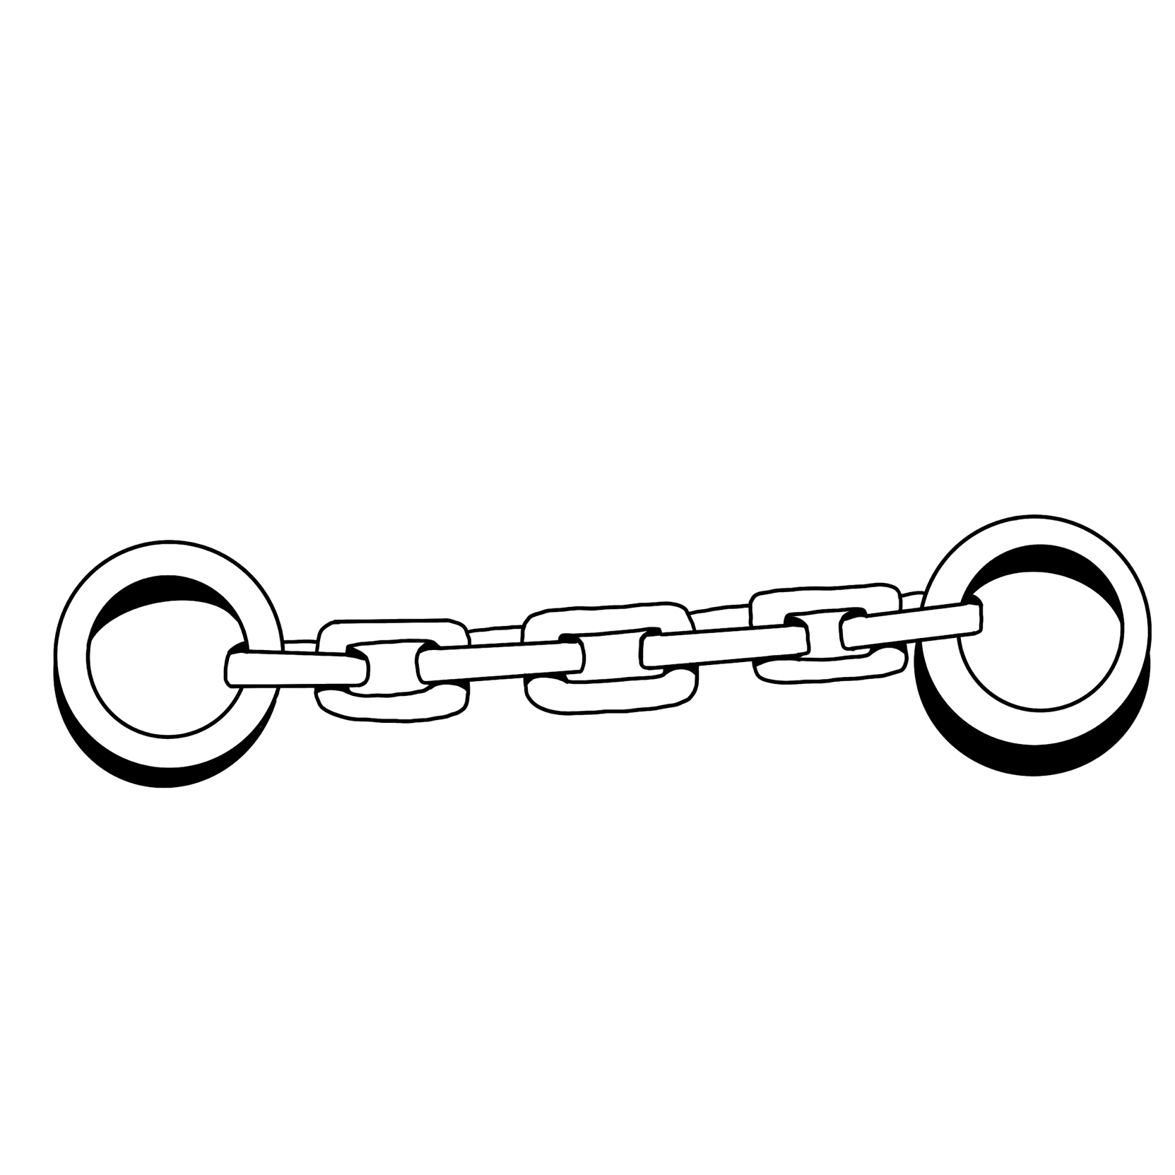
- In Numbers 30:2, the same word is used. What does this verse tell us?

- How is this word related to the trial Joseph was enduring here?

- How does this relate to us today?

- In v. 21, we have two words used to describe how God took care of Joseph: “mercy” & “favor” Look up each of these words
“Mercy”
  - Strong’s number: H2617
  - Hebrew word:
  - Meaning:

“Favor”
  - Strong’s number: H2580
  - Hebrew word:
  - Meaning:
“Joseph is suddenly plunged into a lower deep than ever. He is not only in a strange land, but disgraced, and in a position debarring hope—not only a slave, but a branded slave; not only a prisoner, but a prisoner under circumstances that shut off all prospects of a possible release. In the first moments of his incarceration, Joseph must have been in a dreadful state of mind. We know what came after, which makes it difficult for us to realize the darkness of his situation. Joseph did not know what was coming after. He only knew the dreadfulness of his position—a prisoner and an outcast, unjustly banished from his country in the first instance, and now the victim of a false accusation. He had said, ‘How can I do this great wickedness, and sin against God?’ and this was the consequence… He was prostrate in an affliction, which seemed to lack a single ray of hope, yet in which God was guiding him to great blessedness. Joseph had to be fitted for exaltation and the exercise of power, and therefore he had to suffer for his own good, and for the bringing about of a great result to the whole house of Israel.” – The Ways of Providence pg. 66, 62
- How many times is this word (Favour H2580) used in the life of Joseph? (Include references) What might be significant about this number? (try using an online Bible program or Englishman’s Concordance)

- This gives us great insight into the man Joseph, for immediately each of these rough, godless men saw in Joseph something remarkable and of great value. There is a lesson for us in this as we interact in the world. What exhortation can we take from this point about Joseph’s character?

- Despite being thrown into prison Joseph seems to still be blessed in the work he does, so much so that people notice. There is a similar instance in Acts where men were faithful in prison and others noticed. Explain the incident and provide reference.

- In what way does this teach us about how we should endure trials? Come up with at least 3 passages that reinforce this idea of how we should bear our trials.
1)

2)

3)

- What is the value of bearing our trials in this way?

40:1-8 – Pharaoh’s butler and baker cast into prison and dream dreams
- We are told in v. 1 that the butler and baker are put in prison because they “offended their lord.” What do you think they might have done to offend Pharaoh?

- What is the location of the prison Joseph is in? (Look closely at v. 3)

- Based on his location, do you think that Joseph would have felt secure or comfortable, believing he was out of danger from Potiphar’s wife? Why are why not?

- Joseph is assigned to look after the chief butler and baker (v. 4) Who assigned Joseph to look after these two men?

- In v. 5, it is stated, “they dreamed a dream both of them, each man his dream in one night” and in v. 8, “We have dreamed a dream”. What do you think these phrases are telling us?

- Look up the word “sad” in v. 6. What does is literally mean?
  - Strong’s Number: H2196
  - Hebrew word:
  - Meaning:

- How does this change your image of how these dreams affected the Butler and Baker?

- Yet again Joseph is seeking after the welfare of others. Think about the first time this theme came up, compare and contrast the two different groups Joseph treats as ‘his brethren’.

- What does v. 8 tell us about Joseph?

40:9-15 – Joseph interprets the butler’s and baker’s dreams
- The chief butler’s dream (v. 9-13): Fill in the chart to describe the details of the butler’s dream and the interpretation.
Details of butler's dream | Interpretation given by Joseph

- When the butler dreamed of the vine, there is a 3-stage process that happened to that vine (v. 10). List these 3 stages and find the meaning of each of them.

Stage 1 -
  - Strong’s number:
  - Hebrew word:
  - Meaning:

Stage 2 -
- Strong’s number:
- Hebrew word:
- Meaning:

Stage 3 -
- Strong’s number:
- Hebrew word:
- Meaning:

- There is another event in the OT where this 3-stage process takes place - but not with a vine. What was the item?

- What were the events surrounding it? (Num 16, 17)

- In answer to 69, where was that item kept?

- What was the significance of where it was kept?

- How can this item relate to the Butler’s dream and its interpretation?

- There are obvious allusions to Christ in this dream. What do you think this dream signifys in type? Why three branches?

- What did this dream signify to the Butler?

- When relating this to the symbol of Christ’s sacrifice, what then does the wine seem to represent?

- Joseph chose to use this opportunity to ask that his life be spared from the prison (v. 14) Do you think this was an act of faith on Joseph’s part or a weak moment? Explain.

- How did Joseph describe being brought to Egypt? (v. 15) Compare what is stated in Deut. 24:7 with what Joseph stated. What did the Law state about this?

- It is not very often that the word “Hebrew” is used. At this time, Jacob was a small family group and owned no land. Why might Joseph use this term to describe himself as coming from the land of the Hebrews? What does “Hebrew” mean?
  - Strong’s Number: H5680
  - Hebrew word:
  - Meaning:

40:16-19 - The chief baker’s dream
- “When he (the baker) saw that the interpretation was good…” What does it seem like might have been going through the baker’s mind? How might you fall into this same trap of thinking?

- Fill in the chart to describe the details of the baker’s dream and the interpretation.
Details of baker's dream | Interpretation given by Joseph

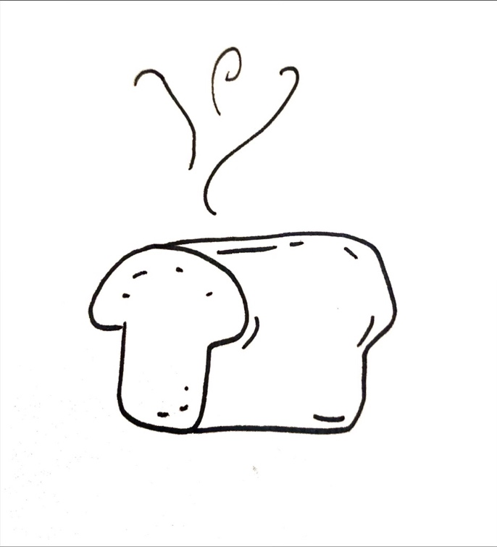
- What was the significance of the three baskets? The literal Hebrew for baskets is “three wicker baskets” or “three baskets full of holes” – how does this relate to what the three baskets signified?

- What are bakemeats? (try other translations)

- What do you think is the difference in significance between the grapes and the bakemeats?

40:20-23 – Interpretations are vindicated
- In your opinion, what was the purpose of God giving these men dreams like this?

- Joseph asked the chief butler to remember him. What in actual fact happened? Relating this to Christ and ourselves, in what way can we be similar to the butler?

“Joseph made the most of the circumstances to bring about his release to no purpose. When apprising the butler of his coming liberation, he said, ‘Think on me when it shall be well with thee, and show kindness, I pray thee, unto me, and make mention of me unto Pharaoh, and bring me out of this house. For indeed, I was stolen away out of the land of the Hebrews, and here (in Egypt) also have I done nothing that they should put me into the dungeon.’ But alas! The butler was like the ordinary run of mortals. When he found himself in prosperity, he was satisfied to enjoy his portion without a thought for the welfare of others. ‘Yet did not the chief butler remember Joseph, but forgot him.’ However, the butler was to be made use of. Joseph’s deliverance was not to come through the butler’s gratitude, not at once. It was to come after a considerable patience-requiring lapse of time, through the providentially developed baser desire of the butler to please Pharaoh.” – The Ways of Providence pg. 68,69

41:1-13 - Pharaoh’s two dreams
- Joseph is described as a “young man” in this chapter (v. 12)What is his age? (v. 46)

- Who else in Genesis is described as a “young man”? (H5288, before the time of Joseph) How might that fact make Joseph’s story more powerful?

- Joseph was in prison another 2 years after he interpreted the dreams of the butler and baker (v. 1) Why do you think God allowed Joseph to stay in prison another 2 years?

- The butler remembered his faults (v. 9) What were his “faults”?

- Pharaoh’s dreams are a background for Joseph’s release from prison. His dreams are the third and final set of dreams in Joseph’s life. What does Job 33:15-17 tell us about dreams?

- How do these verses in Job apply to Pharaoh?

- Why do you think God gave these dreams to Pharaoh?

- Why do you think it was necessary for Pharaoh to have his dreams as a background for Joseph’s release?

- What verse does v. 25 and 28 remind you of?

- What does this tell us about how God used Pharaoh?
Prophecy is not only given so that we can see what happened after it has happened – it is also given for a guiding light for the future!

41:14-36 - Joseph before Pharaoh
- What do you think is the significance of Joseph shaving and changing his raiment before he appeared before Pharaoh? (v. 14). How could this be linked to the Law of Moses?

- Joseph is brought before Pharaoh to interpret his dreams (v. 15) In v. 16, Joseph made it clear to Pharaoh it was God, not himself, that knew the interpretation of the dreams. What lesson can we take from this?

- Fill in the details of Pharaoh’s two dreams (v. 17-21, 22-24)
Details of first dream… | Details of second dream…

- In the KJV, “kine” and “ears” are used, what do they mean? Why do you think God chose these two things to convey the sense of the dreams?

- Why do you think God gave two dreams with the same interpretation to Pharaoh?


- Why do you think Pharaoh would listen to this crazy sounding interpretation of a young foreigner and prisoner?

- There are some amazing connections in this chapter to the book of Daniel (particularly Dan. 2). List as many comparisons between Pharaoh and Nebuchadnezzar as you can find.

- List as many comparisons between Joseph and Daniel as you can find.

- Joseph not only gives the interpretation – he has a plan (v. 33-36). What was the plan he suggested to Pharaoh?

41:37-52 - Joseph’s high authority and family & the seven years of plenty
- In v. 37 –52, we see Joseph elevated to governor over Egypt. What types of Christ can you pick out in this section of verses?

- How could Joseph’s experience in Egypt be typical of what the children of Israel went through later in Egypt?
- In this section Joseph’s life takes a positive turn. Fill in the missing verses and missing quotes in this chart to contrast what Joseph’s brothers did to him with what Pharaoh does to him:
Joseph’s Brothers | Pharaoh
Gen. 37: “they stript Joseph out of his coat” | Gen. 41:42
Gen. 37: “cast him into a pit” | Gen. 41:14
Gen. 37: “let us sell him to the Ishmeelites” | Gen. 41:40, 43

- Look up ruled (v.40) in Strong’s, other translations and your center margin.
  - Strong’s Number: H5401
  - Hebrew word:
  - Meaning

  - Other translations:

- Based on what you learned, what does the word imply?

- Joseph was given Pharaoh’s ring, vestures of fine linen and a gold chain (v. 42). What might each of these represent from a symbolic stand point? (include proof references)
  - Ring –

  - Clothes of fine linen –

  - Gold chain –

- Joseph’s name is changed to “Zaphnath – paaneah” (v. 45). Try to find the meaning of this name (use your margin, concordance or study books).

- Why do you think Joseph was given this new name?

- Pharaoh gives Joseph Asenath to be his wife (v. 45). What does Asenath mean? (Strong’s doesn’t really help. You will need to use another Bible dictionary such as Brown-Driver-Briggs Lexicon etc).
  - Meaning:

- Who was she?

- Where is On? (try a Bible dictionary)

- What does this tell us about Joseph’s ranking?

- Names in the Bible always have meaning and significance – What does Manasseh mean? (v. 51)
  - Strong’s Number: H4519
  - Hebrew word:
  - Meaning:

- How might this meaning relate to both Joseph and Asenath, his wife?
  - Joseph –

  - Asenath -

- Ephraim (v. 52)
  - Strong’s number: H669
  - Hebrew word:
  - Meaning:

- What might be the significance of Ephraim’s name?

- Do you think the people were bringing 1/5 of their corn because they had faith in Joseph and the plan or because they had to? Explain your reasoning.

- Would you have had faith in a young foreigner like this? Why or why not?

- In chapter 39 we saw that Joseph was given charge over all that Potiphar had. Now, he is given charge over the whole of the nation. Color in the phrase “all the land of Egypt” in this chapter (it occurs 9 times). (look in Appendix 1 pg. 61 for color suggestions and additional Bible marking)

- Joseph gathered corn “as the sand of the sea” (v. 49) Find other references where this phrase occurs and figure out what it is used to describe. (a Bible computer program will help with this)
  - Other occurrences:

  - Meaning (what is it used to describe?):

- “Joseph was thirty years old when he stood before Pharaoh”. Where is similar language used of Jacob?

- Where is similar language used of Moses and Aaron?

- Why do you think this was the case? Why are their ages revealed when they stand before Pharaoh?
“Joseph is hurriedly summoned. The rest is familiar as a household word. Joseph finds himself transferred in a moment from a dungeon to a throne. The blackness of midnight gives way to a sudden burst of noonday splendor which abides with him through a long and illustrious day. God delivers him from all adversity, and, as he expressed it, ‘made him forget his toil and his father’s house.’ From a prison keeper’s servant, he is transformed into a governor of Egypt— the king’s minister: an object of universal defense, and controller of the land’s pouring treasure. It was God’s work in providence. God’s hand was visible at one or two points; but in the main, it was accomplished in an unseen manner by means of perfectly natural circumstances.” – The Ways of Providence

41:53-57 - The seven years of famine
- The seven years of plenty are finished and the seven years of famine have begun (v. 54) Why might God have chosen to cause the times of plenty and famine to last for 7 years? Do you think there is any connection to the symbolic significance of seven in the Bible?

- What might the symbolic meaning of the famine ‘being throughout the whole earth’?

- What role do famines play in the Bible? Find other places where famines occur (look for literal and spiritual famines).

- Based on these passages what do you think is a spiritual significance of a place having a famine?

SECTION 3: Joseph and His Brethren - Tribulation
42:1-5 - The sons of Israel come to buy corn
- We are now taken back to Jacob and his family in the land of Canaan. Why do you think Jacob is called “Jacob” here and not “Israel”? (v. 1)

- Upon Jacob’s instruction, the brothers go to buy corn in Egypt (v. 2-3) Why do you think all 10 brothers go down to Egypt to buy corn? Why not just send a few brothers to get food for all of their families?

- Jacob would not let Benjamin go down with his brothers (v. 4). Approximately how old was Benjamin at this time? What do you think this tells us about Jacob?

- Why do you think Joseph didn’t go back home to find his family, when he was first released from prison?

42:6-17 - Joseph imprisons them
- Joseph is governor over Egypt and selling food to all the people (v. 6) Why do you think Joseph is selling the food himself? (couldn’t somebody else do this??)

- Look up governor (v. 6)
  - Strong’s Number: H7989
  - Hebrew word:
  - Meaning:

- When Joseph’s brothers come to buy food, he recognizes them, but they don’t recognize him(v. 7, 8). Why do you think Joseph doesn’t reveal himself immediately to his brothers?

- In v. 6, what do Joseph’s brothers do?

- Find the other 4 times they do this.

- What does this fulfill?

- How would Joseph have felt when this happened? Do you think it was reassuring for him?

- What does v. 9 show us? Why do you think Joseph spoke so roughly to them? (v. 7)

- The brothers are shocked when Joseph accuses them of being spies! (v. 9) Why did they say they were all one man’s sons? What do you think was the point of saying that? (v. 11)

- How do you think Joseph felt when the brothers mentioned Benjamin? (v. 13)

- How do you think Joseph felt when they mentioned him? (“one is not”)

- Why do you think they mention Joseph and Benjamin at all? Does this tell us anything about their spiritual growth up to this point? Explain.

- Joseph uses the phrase: “By the life of Pharaoh” (v. 15) How important was the Pharaoh in Egyptian culture?

- Why do you think Joseph uses this oath?

42:18-28 - They are released on the condition of Benjamin’s return
- Joseph is testing and trying his brothers to see how much they have changed (v. 15-20) How many did he say he would send back originally to fetch Benjamin?

- Joseph seems to give his brothers 3 days to decide which one would go back. Who did they decide would go back? Could they decide? Why or why not?

- Only one is kept, who is the one chosen? Why do you think Joseph choses him?

- Joseph said that when they brought Benjamin, their “words (would) be verified.” (v. 20) How might this principle apply to us? (cp. 1 Cor 3:13)

- Why do you think Joseph insists on Benjamin coming to Egypt?

- We see in v. 21 how alive the brothers’ consciences are! How long had it been since they sold Joseph into Egypt?

- What might this verse tell us about how Joseph felt in the pit?

- The word “guilty” in v. 21 is usually used in the sense of the infringement of the rights of another. Gesenius puts it “to fail in duty”. How do you think Joseph’s brothers had failed in their duty?

- Why do you think Joseph used an interpreter?

- This is the first of 7 times Joseph cries (weeps) in the story. Find the 7 times and the reason why he cries each time.
Reference |  | Reason why Joseph cried…
1 | 42:24
2
3
4
5
6
7

- What do you think this tells us about Joseph’s life?

- How many recorded times does Jesus cry (weep)? (Provide references)

- How was Joseph’s life similar to Christ’s life in this respect? (take a look at Isa 53:1-4)

- What lesson is there for us?

- When one of the brothers discovers his money in his sack, what is the brothers’ response? (v. 28)

- How are we to read their response in v. 28? Are they blaming God or are they realizing God acting in their lives to test them?

42:29-38 - Jacob’s dilemma and concern for Benjamin
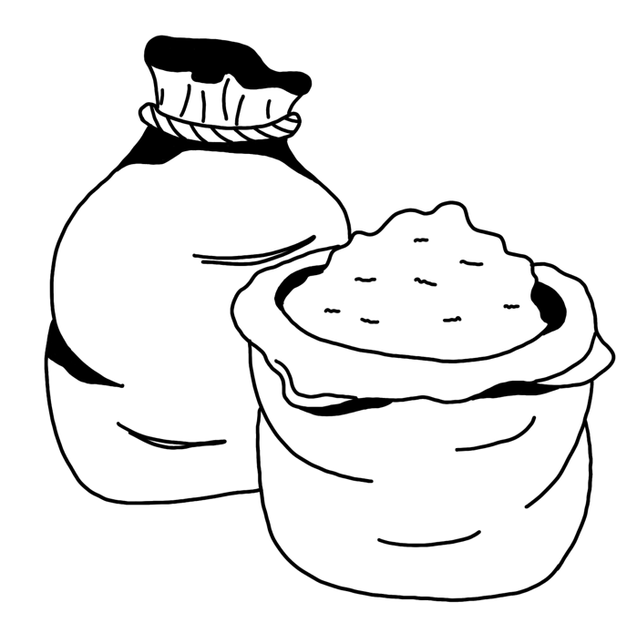
- When the brothers return to Jacob, they give their father a report of what happened in Egypt. What do they tell him? (v. 29-34)

- Compare their report here to the report they gave to their father about Joseph over 20 years earlier (37:32). Have they changed?

- How have they grown spiritually?

- How has their attitude to their father changed?

- When they discover that all the brothers have their money in their sacks, again it says, “they are afraid” (v.28, 35). Why are Jacob and the brothers so shocked to find their money returned?

- In what way do you think Joseph was testing them by giving them their money back?

- Jacob says, “All these things are against me” (v.36). Was there a reason for all these things happening to him? Explain.

- Do you think Jacob realized what the reason was?

- What does this teach us in our lives?

- What does v. 36 tell us about Jacob’s suspicions of Joseph’s disappearance?

- Reuben offers his 2 sons to his father if he doesn’t bring Benjamin back safe (v. 37). Did Jacob have any reason to trust Reuben?

- Do you think it was a good or bad idea for Reuben to offer the lives of his 2 sons in exchange for Benjamin? Why?

- Knowing the situation they were in, how could Jacob justify his refusal to let Benjamin go down to Egypt?

- In v. 38, Jacob makes the comment about Benjamin that “he is left alone.” Does this show Jacob’s favoritism? Or is it something else? Explain.

- Do all the other brothers not matter? How would you feel if you were one of the brothers?

43:1-14 - Jacob relents under Judah’s surety
- Jacob is again called Israel (v. 6, 8, 11). Why do you think this is?

- Compare v.7 to 42:13. Did Joseph ask them these questions or had they given this information? (see also Gen 43:27)

- Judah pledges his own life to spare Benjamin’s (v. 8-10), What mistakes had Judah made? (ch. 38)

- Why did Jacob trust Judah (apparently more than Reuben cf. Gen. 42:37)? Did he have any reason to?

- How do you think this incident shows that Judah has grown spiritually?

- This incident is a foreshadowing of a later close association of Judah and Benjamin. Where do we see them together later in scripture?

- Judah became surety for Benjamin. What is surety? Find a couple of references that refer to surety that help us understand what it is (maybe start with Proverbs 6:1 and 11:15)

- In v. 10, we get an idea of how long they waited to return to Egypt. How long do you think they waited? How badly do you think they needed food?

- What 6 gifts did they take with them? What is the significance of the gifts?
Gift | Significance?
1.
2.
3.
4.
5.
6.

- Where else in the story are balm, spices and myrrh used? What is the irony in this?

- Do you think there is any significance of these gifts related to Christ? Explain

- On top of gifts, Jacob tells them to take extra money. How much money did Jacob tell them to take with them? (v. 12, 15)

- What law in the Law of Moses is perhaps connected to this?

- Jacob says farewell to his sons, including Benjamin, with the words: “God Almighty give you mercy before the man, that he may send away your other brother, and Benjamin. If I am bereaved of my children, I am bereaved.” (v. 14) Was this a big step for Jacob? Why?

- What does this example teach us?

- What is Hebrew for God Almighty? (v. 14)
  - Strong’s numbers: H410 & H7706
  - Hebrew word:
  - Meaning:

- Where else is it used?

- What do you think it reveals to us about Jacob in this situation?

SECTION 4: Joseph and His Brethren - Purification
43:15-25 - The brethren return to Egypt
- Joseph’s brothers go to Egypt with the presents and the money their father instructed them to take. They present themselves before Joseph, and after about 22 years, Joseph finally sees Benjamin again. Do you think Joseph really expected to see Benjamin with his brothers? (v. 16)

- The brothers are afraid again (as we saw in 42:28, 35). Why did they think they were taken into Joseph’s house?

- What do you think they are afraid of having happen?

- Why did Joseph actually bring them into his house?

- Why do you think they try to explain their situation to the steward?

- Why do you think Joseph put on a banquet for his brothers?

- Look up “seek occasion”(v. 18). What does this phrase mean? (using a Bible program will help)
  - Strong’s Number: H1556
  - Hebrew word:
  - Meaning:

- How does it apply in this situation? (Hint: see Job 30:14)

- The steward makes a remarkable statement in v. 23. How do you think the steward knew about the “God of their father”?

- Name another person in the OT who had a Gentile steward that was familiar with the God of Israel. Who was the steward?

- What do these 2 examples teach us about preaching, especially to our friends and family?

43:26-34 - Joseph entertains his brethren
- In v. 26 and 28, we see Joseph’s brothers bowing down to him again. How many times have they bowed down to Joseph now?

- What do you think was going through Joseph’s head at this time?

- When the brothers sat down in Joseph’s house for a meal, they were seated apart from the Egyptians and in order of age from oldest to youngest (v. 32-33). Why were they not seated with the Egyptians?

- Benjamin’s “mess” was 5 times as much as the other brothers (v. 34). What does 5 represent symbolically in the Bible? Why might it be significant here?

- Do you think the brothers were just as jealous of Benjamin now as they were of Joseph years earlier? Explain.
44:1-13 - Joseph again tests his brethren
- In these verses, Joseph gives specific commands to his steward regarding his silver cup (v. 1-2). Whose sack was the steward to place the silver cup in?

- Why this brother’s sack? What do you think Joseph’s purpose was in doing this?

- Joseph sent for his brothers when they were out of the city, but “not yet far off” (v. 4). Why do you think he did this?

- What city (v.4) do you think is being referred to here and what would your proof be?

- Do you think Joseph is acting hatefully and with vengeance towards his brothers here? Why or why not?

- Could any of Joseph’s actions in this section fit into the theme of “I seek my brethren”? Explain.

- The steward says Joseph uses the cup for “drinking” and for “divining”. What do you think it could mean by “divining”? (try your margin)

- When the steward accuses the brothers of stealing the silver cup, they are shocked (v. 7-8). What do they offer as a logical reason why they couldn’t have done this?

- “Let him die” (v. 9) - Here, the brothers pronounced judgment of death on the man who was found with the cup. Who else in the OT pronounced judgment of death upon himself, but was spared from it? (Provide reference)
Historical Fact: The code of Khammurabi were laws that existed before the Law of Moses and quite possibly would have been at use during this time in Egypt. The code of Khammurabi decreed that theft from a palace required restoration 30-fold or death!

- Why do you think the search for the cup starts at the oldest (Reuben) and goes to the youngest (Benjamin)? (v. 12)

- Where in the NT is there a “search” made of the oldest to the youngest? What was the outcome of that “search”? (Provide Reference)

- Take note of the brothers’ reaction when the cup was discovered in Benjamin’s sack (v. 13). What was their reaction?

- Did they blame Benjamin? Did they abandon him?

- What does this tell us about the brothers now, compared to what they did to Joseph?

44:14-34 - Judah’s confession and plea for Benjamin
- Why do you think Judah become the spokesman on behalf of the brothers? (v. 16)

- In v. 16, the brothers recognize what the cause of all this trouble is. What did they recognize was the cause? Why is it so amazing that they realize this now?

- Why did Judah admit guilt and iniquity when he was sure that none of his brothers were guilty of stealing the cup? Do you think he knew that it was planted there? Explain.

- Consider Judah’s speech in v. 18-34: How does Judah acknowledge Joseph’s power?

- Judah offers his life for Benjamin’s. This is a changed Judah - what do you think has caused the change?

- Contrast Judah now with Judah of chapters 37 and 38.
Judah then… | Judah now…

- In v.28, Joseph finds out for the first time what his brothers told Jacob after they had sold him into Egypt. How do you think Joseph would be feeling right now?

- Benjamin is described as a “little one” in v. 20. Why? (remember we already saw that he is about 30!)

- “..his life is bound up in the lad’s life” (v.30). Who else is the same language used of in the OT?
- In v.33, Judah requests that he be made a “bondman” or hired servant to Joseph. What story in the NT does this make you think of? Are there any more parallels to this story in the life of Joseph?

SECTION 5: Joseph and His Brethren - Revelation
45:1-15 - Joseph reveals himself to his brethren
- When Joseph made himself known to his brethren, he ordered all the Egyptians to leave (v. 1). Why do you think he did this?

- What could be the type of Christ here?

- “Doth my father yet live?” (v. 3) Where else had Joseph enquired about his father?

- Why do you think Joseph asks again about Jacob?

- When Joseph revealed himself, his brothers were obviously shocked. Look up “troubled” – what does it mean? (v. 3)
  - Strong’s Number: H926
  - Hebrew word:
  - Meaning:

- How do you think you would have felt if you were one of Joseph’s brothers when he revealed himself? Would you have felt the same way his brothers did? Explain.

- Take a look at Zechariah 12:9-11. What is described here is similar to the situation we are looking at. What are these verses in Zechariah talking about? What comparison can be made to Joseph’s brothers?

- Why do you think Joseph says, “…whom ye sold into Egypt”? (v. 4)

- In v.5-8, Joseph’s makes an amazing declaration of his understanding of God’s providence. What do you think providence is? (try a Bible dictionary or a standard English dictionary)

- How did Joseph show his understanding of providence?

- How do you think you would have reacted if you were Joseph? (honestly!)

“It could not be imagined that the objects of the Father’s love should be left to the operations of change; that he should leave undirected, in the morass of human life, the steps of those whose eyes, affections and trust are directed to him in daily prayer. The righteous fall into trouble, but it is for their good. They come out of it to find themselves benefited. When trouble comes, do not think it is not from God because it is natural. It may not differ from the trouble of other men in apparent origin and form, but it differs from theirs in being under an invisible supervision which aims at a result, and will say, at a certain point, ‘Thus far and no farther,” – The Ways of Providence pg. 16, 28
- What lesson can we learn from Joseph’s forgiveness?

- What was the first word of the message Joseph wanted his brothers to pass along to their father? (v. 9) What does this teach us?

- What do you think Joseph meant when he said “God..hath made me a father to Pharaoh”?
(v. 8)

- Look up “come to poverty” (v. 11). What does it literally mean?
  - Strong’s Number: H3423
  - Meaning:
  - Hebrew word:

- What does this tell us about the severity of the famine?

45:16-24 - Pharaoh’s invitation to dwell in Egypt
- “It pleased Pharaoh well and his servants” (v. 16) that Joseph’s brothers had come. Look at this section of verses and list some things that show us how highly esteemed Joseph was both by Pharaoh and the people.
►
►
►
►
►

- “Come unto me: and I will give you…” (v. 18). Where are these words echoed in the NT? Who said this and why do you think he quotes these words of Pharaoh?

- When his brothers left to return to their homes to bring their families to Egypt, Joseph gave each of them changes of clothes. Benjamin, however, was given 300 pieces of silver and 5 changes of clothes (v. 22). How much is 300 pieces of silver in today’s terms?

- Joseph tells his brothers, “see that ye fall not out by the way” as they return to their father (v. 24). What does this phrase mean? (try other translations)

- What do you think would have caused them to “fall out of the way”?

45:25-28 - Jacob receives the news and rejoices
- When reading the Bible account, we often lose the impact of certain events because we know the story too well. Clear your mind and try to see things from Jacob’s perspective: Do you think there is any chance that your son Joseph is still alive? (42:38)

- Your sons return from Egypt and tell you that Joseph is alive and that he is the governor of Egypt. How do you feel? Do you believe them?

- “…the spirit of Jacob their father revived” (v. 27) when he saw the wagons that Joseph had sent. What does “revived” mean?
  - Strong’s number: H2421
  - Hebrew word:
  - Meaning:

- What do you think this tells us about Jacob’s state of mind when he heard the news that Joseph was alive?

46:1-7 - Migration to Egypt
MAP WORK
Draw a map of the land of Israel and mark on it where Beersheba is.
- Why do you think Jacob is called Israel (v.1) here then called Jacob again? Why do you think the names keep switching?

- At Beersheba, Jacob offers sacrifices to the “God of his father Isaac”. What does “Beersheba” mean? (v. 46)
  - Strong’s Number:
  - Hebrew word:
  - Meaning:

- What happened at Beersheba previously? Why did Jacob go here to make an offering?

It would be worth putting this map in the margin of your Bible!
See Appendix 2 pg. 72 for how to do that!
- When God speaks to Jacob in a vision, Jacob responds by saying “Here am I.” (v. 2) Who used this phrase earlier in the story? (Provide reference)

- Where else is this phrase used in the Bible? Who used it in each case? (Provide references)
►
►
►
►
►
►

- The promise in v.3 is a confirmation of a promise God made earlier to Jacob. When and where was the promise first given?

- “…the God of thy Father” (v. 3). Where else is this used in Genesis?
►
►
►

- Why do you think Jacob is told not to fear? What would he have to fear at this time?

- “I will there make of thee a great nation.” Who was this promise first made to? Where?

36. In v. 4, what 3 additional things did God promise Jacob?
1)
2)
3)

- “…bring thee up again” (v.4). (What does this phrase signify? Where and how is it used elsewhere in the story?

- Where is the second part of this promise fulfilled? Does the promise have a greater fulfillment?
46:8-27 – The descendants of Jacob
“Jacob having received information of all that had been transacted, proceeded to break up his encampment, and go down into Egypt as Joseph and Pharaoh had invited him to do. Isaac had been dead ten years, and Jacob had attained the age of one hundred and thirty. Having arrived at Beer-Sheba on his way thither, he offered sacrifices to the God of Isaac. On this occasion, God spake unto him, and said, ‘I am God, the God of thy father; fear not to go down into Egypt: for I will there make of thee a great nation: I will go down with thee into Egypt; and I will also surely bring thee up again: and Joseph shall put his hand upon thine eyes.’ In this promise Jacob was reassured of a resurrection to life. The action of putting the hand upon the eyes represents death. Hence, to tell Jacob he should die, and yet that he should be brought up again, was telling him in effect that he should rise from the dead again to possess the land.” – Elpis Israel

46:28-34 – Jacob meets Joseph in Goshen
- Enter into the feelings of both Jacob and Joseph as they meet. What do you think Jacob is feeling?

- What do you think Joseph is feeling?

- Compare/contrast their reunion to the father and son in Christ’s parable of “The Prodigal Son”.

- Joseph weeps for a “good while” when he meets his father (v. 29). We already looked at the seven (recorded) times that Joseph weeps. In this instance, what do you think this reveals about Joseph?


- Israel makes an amazing statement in v. 30. Who in the NT made a similar statement? About whom?

- Joseph made sure his brothers told Pharaoh right away that they were shepherds (v. 33-34). Why did he do this?

- Joseph’s brothers would be an abomination in whose eyes?

- Knowing this, Joseph was not ashamed of his brothers. Where is the same principle mentioned, that Christ isn’t “ashamed” of us, his brethren?

47:1-10 - Jacob presented to Pharaoh
- Joseph chose only 5 of his brothers to appear before Pharaoh (v. 2). Why do you think he did this? Why five?
SECTION 6: Joseph and His Family in Egypt

- The number 5 is significant in the story. Use your concordance to find at least 4 references to “5” in the story of Joseph. Do you think that 5 was a special number in Egypt? (see Isa 19:18)
►
►
►
►

- We aren’t told whom Joseph picked - who do you think he might have picked and why?
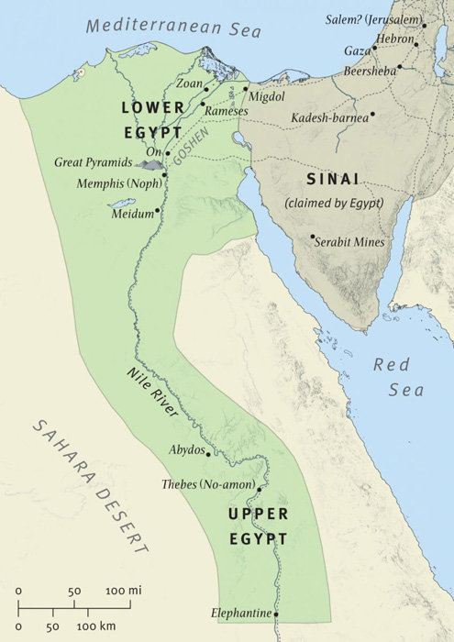

- Joseph chose to put his family in the land of Goshen. The Egyptian name for this place was Rameses (v.11) and in Psalms 78:43, it is called the “field of Zoan”. Research and list some facts about this area of land during this time. Why do you think Joseph chose this place for his family and do you think it was a good choice? Explain.

- Why do you think Joseph didn’t put them in one of the cities of Egypt?

- When Jacob meets Pharaoh, he blesses him twice (v. 7, 10). How does this, in a small way, fulfill God’s promise to Abraham in Gen 12:3?

- Why do you think he blesses Pharaoh twice?

- When Pharaoh asks Jacob his age, Jacob says his days had been “few and evil” (v. 9) How old is Jacob at this time?

- Why do you think Jacob describes his life in this way?

47:11-12 – Israel possesses the best of the land
- We saw in an earlier question where Rameses (Goshen) was located. We’re told Joseph places his family there and takes care of them “according to their families” (v. 12). What does this phrase mean? (look in your margin and also find a cross reference)

- What does this tell us about how much they needed Joseph now? How do you think they would have felt about this?

47:13-21 – Egyptians made bondservants to Pharaoh
- The famine becomes “very sore” in the land (v. 13). People from all over Egypt and Canaan come to Joseph to buy food from him – Joseph becomes a “saviour” for the whole world! The Egyptians soon run out of money, and give their belongings to Joseph in exchange for food. What did they give Joseph first? (v.15-17) What was second? (v.18-22) What was last? (v.23-25)
1st
2nd
3rd

- How do you think this can relate to our life in Christ? (Provide references)

- Look up v. 21 in other translations (try the NIV). How is it translated?

- Explain why you think this translation might be significant? (consider what happens to the children of Israel after Joseph dies)

- “We and our land will be servants unto Pharaoh” (v. 19). The Law of Moses speaks of land being redeemed or given back to its owner in Lev 25:23-28. When was the land given back? Why was this done?

- Do you think Egyptian law was the same as Jewish law? Do you think the Egyptians got their land back?

47:22-26 – The priests’ land tax-exempt
- The Egyptian priests had a portion of land assigned to them by Pharaoh and Joseph was not able to buy this portion of land (v. 22). What does the Law of Moses say about priests’ land? (Lev 25:32-34)

- Joseph took one-fifth of the people’s crops (v. 24). How much was the Jewish tithe? (hint: look up the word tithe in your concordance)

- Is there a practical lesson for us (in our service to God) with regards to these amounts?

47:27-31 – Jacob’s command concerning burial
- Jacob made it clear to Joseph that he did not want to be buried in Egypt (v. 29). Jacob made Joseph put his right hand under his thigh. Find other references to this (under his thigh) and to thigh. What did this represent?
►
►
►

- Why do you think Jacob made Joseph swear to take him to where his fathers were buried? Why do you think it was so important to Jacob?

- What do these verses reveal about the relationship Jacob and Joseph had? Why do you think Jacob didn’t tell Reuben, his eldest son, where he wished to be buried?

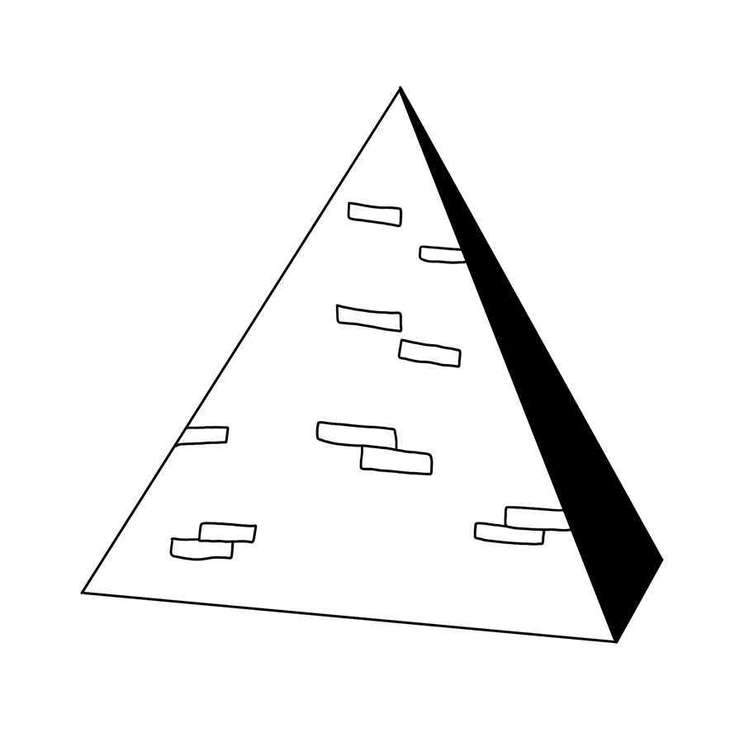
- “If now I have found grace in thy sight.” (v. 29). Where did we first see this phrase occur in the story of Joseph? Why do you think Jacob would use this phrase when speaking to Joseph?

- Look up “bed’s head” (v. 31) in the Septuagint or NIV, how is it translated there? What does Hebrews 11 say Jacob was doing in this verse?

- Why do you think Jacob needs a staff? (cp. Gen. 32:24-32)
- What do you think the staff could be a symbol of? Explain.

“Seventeen years having passed after his arrival in Egypt, the time drew nigh that Jacob must die. This residence in the land of Ham had not at all diminished his attachment to the land of Canaan. When, therefore, he found his end approaching, he took an oath of Joseph, saying, ‘Bury me not, I pray thee, in Egypt: but I will like with my fathers, and thou shalt carry me out of Egypt, and bury me in their burying-place.’ And Joseph promised to do as he had said. But why was Jacob thus anxious? All his care was for his body after death that it might be duly deposited in the cave of Machpelah where Abraham, Isaac, Rebekah, and Leah, were sleeping.” - Elpis Israel

50: 1-14 – Joseph buries his father in Canaan
- In v. 2, Jacob, at the end of his life, is called Israel. From what we’ve seen so far, what do you think this indicates to us?

- How long did the Egyptians mourn for Jacob? Is there any significance of this amount in Egyptian customs?

- How long did the “children of Israel” mourn for Jacob? (v. 10)

- Find the NT passage that talks about mourning as a believer compared to those who have no hope. Do you think there is any connection between that verse and the amounts of time the Israelites versus Egyptians mourned? Why or why not? (Include reference)

- List examples of people in the Bible who were mourned for, even though they had the hope of the resurrection (provide references).
►
►
►
►

- Jacob told Joseph to bury him “in my grave which I have digged for me in the land of Canaan” (v. 5). Where was this burying place? (v. 13)

- Who had bought the land originally? (Provide reference)

- From v. 5, what does it seem Jacob had done to the land?

- When Joseph made his request to go and bury his father in the land of Canaan, Pharaoh allowed him to go (v. 5-6). Would you expect Pharaoh to say anything else?

- Why do you think Joseph would even ask?

- Do you think there are any types or Christ in this? Why or why not?

- Who went up with Joseph to bury his father? (v. 7-9). What do you think this tells us about Joseph?

50:15-21 – Joseph reassures his fearful brethren
- Joseph’s brothers were extremely afraid that Joseph would take revenge on them now that Jacob was dead (v. 15). Where else did we see his brothers feeling totally scared?

- Do you think they have reason to be afraid here? Explain.

- How well did they really know Joseph if they thought he would take revenge now? (v. 16 says that Jacob actually advised the brothers to approach Joseph in this way. Maybe this implies that Jacob himself didn’t fully appreciate Joseph’s forgiveness..?)

- In v. 17, we have the last recorded time that Joseph weeps. Why does he weep here?

- “I seek my brethren..” Joseph again displays his mercy love, and understanding of God’s providence to his brothers (v. 19-21). How do you think his brothers felt when they heard and saw this now?

- Joseph comforted them and “spake kindly unto them” (v. 21). What does your margin say about this phrase?

- Find others places where this phrase is used and who it is used of. (use your margin to get you started)
 | Reference | Who is it used of?
1
2
3
4 | 2 Chron. 30:22 | Hezekiah “spake comfortably” to the Levites

50:22-26 – Joseph’s long life, message of redemption and death
- We see Joseph was very blessed by God in the latter end of his life, after going through so much trial and hardship. Joseph was blessed by being able to see his great-grandchildren. Who else was blessed in the latter end of their life like Joseph, after going through so much pain and trial? (Include reference)

- Joseph declares to his brethren that God would visit them, bring them out of that land, and take them to the land that he promised to give to Abraham, Isaac and Jacob (v. 24). How did Joseph know God would bring them out of the land of Egypt?

- Do you think his brothers knew this as well? Why or why not?

- What do you think this tells us about Joseph’s understanding of spiritual things? Is there anything you personally could learn from Joseph’s example? Explain.

- Joseph made an oath with his brethren that they would carry his bones out when the “children of Israel” left Egypt (v. 25). Where is it recorded that they did this?

- When were Joseph’s bones buried?

- Where were Joseph’s bones buried?

- Who brought his bones up out of Egypt?

- Why is this place significant? When else did this place come up in the story?
- Why do you think Joseph didn’t have the children of Israel take him back to Canaan as soon as he died?

- Where in the NT is this commandment about his bones shown to be an act of faith?

- Why do you think this was an act of faith?

Historical Fact: One scholar has counted 27 references in ancient Egyptian literature to this as an ideal age to live to!
- How old was Joseph when he died? (v. 26)

- Referring back to Q.52, what great leader of Israel died at the same time that Joseph’s bones were buried?

- How old was this leader when he died?

- Think about everything we’ve considered. What is the greatest lesson for you personally from the life of Joseph?

“In studying the events of Joseph’s life, therefore, we are studying a case in which God was at work beyond all question; and from which, therefore, we shall be able to learn instruction with regard to the experiences of our own lives, if our lives like his are framed in the fear of God and committed to His keeping in prayer and well-doing; for his case, like all the others, was “written for our learning”…It may seem to them that God is not only working with them, but actually working against them. Let them remember the agony of Joseph in the pit, in slavery, in false imprisonment and learn the darkest paths of their life may be the ways appointed for them to reach liberty and life, wealth and honour – yea, a throne in the Kingdom of the antitypical Joseph (Jesus Christ) who himself had to tread the dark and tearful valley of humiliation, and who in the day of his glory, will introduce all of his brethren, amongst many bright stars, to the most interesting of Jacob’s sons.” - The Ways of Providence (pg 60, 70)
This section is a dedicated area to further our studies on these people, events and concepts and hopefully gain a deeper understanding of the lessons these people learned and how we can apply them in our lives today.
SECTION 7: Research Questions

The section is broken into three parts:
1. Acknowledge 2. Choose 3. Try
Taking the first letter of each word it spells the word ACT, which is a concept pulled from James 1:22 “But be ye doers of the word, and not hearers only, deceiving your own selves.” There we see the importance of acting out (aka doing) the things we hear and believe.

In the Acknowledge section you will answer research questions that look specifically at how these people acknowledged their need for God in their lives.
The Choose section focuses on the choices the different people made and some of the major examples and principles we can take into our own lives when we have to make choices.
Finally the Try section focuses on the determination of these people to keep trying their best, regardless of where they had come from or how things were going.
Here’s a few general guidelines we have for you with regards to section 7

1. Please complete sections 1-6 to the best of your ability before starting this section (you will need the background knowledge from sections 1-6 to use and build on in this section)

2. Be sure to work in a group, if this is possible, to share and discuss ideas! (Group chats work well too!)

3. Don’t be scared by the apparent length of some of the questions – often, a lot of typing is needed to steer you in the needed direction, so the point gets explored to its fullest.

4. Answer questions on separate pieces of paper. There is basically no space for your answers here.
Bring your answers to MYC for discussion!

5. Try to get your hands on “Teenagers of the Bible” and read it! (pg. 8-98) It’s an easy read and we guarantee you won’t regret it!

6. Be sure to pray for God’s guidance as you study His word and as you seek to live the lessons and principles you discover!

ACKNOWLEDGE
#1 - Researching Jacob
When we look at the development of Jacob’s character, we will quickly see a tremendous lesson of the dramatic spiritual impact that we (especially young people!) can have on others in the Ecclesia.

Part 1 Jacob’s name was changed to “Israel” in Genesis 32:24-32.
- Make a list of the details of the events that happen in this section of verses.
- How do we know that Jacob wrestled with an angel? What was the outcome?
- What are the meanings of both names?
- Why did God change his name?

Part 2 God gives Jacob a “wakeup call” in Genesis 35:1-15
- Jacob is told to build an altar for God. Building altars and sacrificing to God has to do with dedication to God, as well as preaching to those around (it was something others could see!) Find 3 occurrences of Abraham building altars in Gen 12 and 13.
- What does Jacob tell his family in v.2-3? What does this tell us?
- Since his name was changed to “Israel” in Gen 32, Jacob has not been called “Israel” up to this point. What does God say to him in 35:9-12? Why is this a wakeup call for Jacob?
- In v. 21, 22 we have “Israel” twice, but in v. 22-29 we have “Jacob.” What does this tell us?

Part 3 Joseph comes on the scene in Genesis 37.
- Jacob is called “Israel” twice in this chapter. Find these 2 places and show why he is called “Israel” in these places.
- We see that when Jacob is called Israel, he is seeing things through eyes of faith and often demonstrating divine will (as in 43:11-13). Also, when Jacob is mentioned in context with Joseph, he is often referred to as “Israel.” Show how this is this true for: 43:8, 45:28, 46:29,30 and 48:11-14.
- Jacob took a long time to learn to live up to the name God had given him! We have a name to live up to - what name is that? How do we live up to our name?
“When teenagers respond to the call of the Truth, what a reaction it has in the ecclesia! The spiritual pulse begins to quicken; there is a stirring amongst the members. They all join in transformation.”
– Teenagers of the Bible (pg. 95)
Part 4 Gen. 37:11 tells us that Jacob “observed the saying” (regarding Joseph’s dreams).
- Look up the word “observed” (Strong’s). What does this suggest about how Jacob viewed Joseph’s dreams?
- Each of the following 3 passages have the same word in them, which is translated “observed” here in Genesis. Look up the passages and describe of whom and what each passage is speaking of.
Ex 20:19 – “Keep” Isa 62:6 – “Watchmen” Psa. 103:17-18 – “to such as keep”
- Using these verses as a guide, what does Gen. 37:11 tell us about Jacob’s thought process, and what lessons are there in this for us to consider?
- Mary, the mother of Jesus, went through a very similar process. There are 3 different ways in which Mary’s thought process is described in Luke 1&2 (1:29 “cast in her mind,” 2:19 “pondered them in her heart,” 2:51 “kept these sayings”). Look up each word used to describe how Mary reacted to the information that was given to her (each word’s meaning is different, and sheds light on how intent Mary was on listening and understanding what God was saying to her)
- “Listening attentively” is a dying art. Consider others who attentively listened and come up with at least 3 additional examples. For starters look at Mark 12:41-42 (consider the method the coins were given to the Temple).

Part 5 There is little mention of God by Jacob or his sons during the time that Joseph is in Egypt.
- In Gen. 42:36, Jacob says “all these things are against me.” He didn’t ACKNOWLEDGE the reason for these things happening to him. What was the reason? How can we sometimes be like Jacob in responding to events in our lives?
- In Gen. 43:13-14, Jacob seems to be re-energized in spiritual things and declares “God Almighty give you mercy before the man.” What has caused Jacob to be re-energized spiritually? (v. 3-9)
- Remembering he is re-energized at this point, Gen. 43:13 is a huge display of self-sacrifice on Jacob’s part. Why?
“During the long period of Joseph’s captivity in Egypt, Jacob mourned, as only a father can, for the loss of a son who was a ray of sunshine in the Truth amidst the darkness of an evil world and the disappointment of unheeding members of his own family…which of the brethren would respond to the anguish of their father? To our surprise it is Judah…with these words from the lips of Judah, there is a dramatic effect on his father Jacob. Jacob would see that his son was maturing in spiritual things and that his hard heart had been touched by the things he had suffered. And that is an effect that can still be seen today in the lives of those who allow the Word of God to direct their thinking.” – Teenagers of the Bible (pg. 63-65)
- Take a look at Gen. 45:25-28. Jacob thinks his sons have told him the biggest lie of their lives in
v. 26 when they return from Egypt and tell him that Joseph is alive! But something changes his mind - what is it that actually convinces him that Joseph is alive? (read carefully…is it what he sees or what he hears?) What can we learn from this about influencing others by the example we show?
“..from this point onward in the narrative, an entirely new spirit sweeps through the record, evidencing the dramatic change that has taken place in Jacob. There is an important lesson here for young people. Their attitudes and frame of mind have a great bearing on the atmosphere of ecclesias…when the young people are active and joyous in the work, a remarkable change can come over a meeting.” – Teenagers of the Bible (pg. 94-95)
- Have a look at Jacob’s blessing of Joseph’s sons in Gen. 48.
- Read v. 8-20. What is unusual about this blessing?
- Jacob is mentioned in the “Faith Chapter” (Heb 11:21). Of all the events in Jacob’s life, this blessing is mentioned as the pinnacle of his faith. Why?

Part 6 Take a look at Jacob’s blessing of his sons in Genesis 49. Take special note of v. 18. It is between the blessings of Dan and Gad.
- Is it spoken directly to any of his sons?
- What does it reveal about Jacob’s level of spirituality at the end of his life? Why is this verse so remarkable?

#2 - Researching Judah
This question has to do with leadership and repentance. Judah was the fourth oldest son of Jacob, born to Leah, after Reuben, Simeon and Levi (Gen. 29:35). He didn’t receive the blessing either, however the lineage of Christ came through Judah, and we’ll soon see why.

Part 1 First, start at Gen. 37.
- What indications in this chapter are we given that Judah has become the leader of the brothers?
- Who do you think came up with the plot to stain Joseph’s coat with blood, in order to deceive their father? Explain.
- Is Judah a positive or negative influence on his brothers?
- What is his attitude toward his father in this chapter?
- How would you describe his character at this point in the story?

Part 2 Now, let’s look at Gen 38!
- Judah went down from his brethren. What does this one word tell us?
- Who did Judah become friends with? Was his “friend” a good influence? (v. 12, 20)
- Read v. 12 –26. What sin did Judah commit?
- What lessons do you think he learned from this?
- Is this chapter in chronological order? Why is it right in the middle of the story of Joseph?
- Contrast this story to Joseph’s example in 39:7-12.
- Look at v. 27-30. Where else does a scarlet cord come up in the Bible? Can you figure out how the two events are connected?
“Judah is shown to be a mindless, insensitive man, lumbering through life with his chief concern of having a good time. Unbeknown to him, God’s ministering angels were nearby, watching all and recording all. Judah might have been appalled to realize that his escapades would be exposed through the inspired record for all the generations to see. The reason why God has preserved this story to warn those who are following the same course of self-destruction. It is a reminder of the consequences of our actions, for flesh has not changed, and we are subject to the same propensities… leaving us with strong warnings about the frailty of human nature” – Teenagers of the Bible (pg. 32)
- If we have a look at Gen 43:8-10, we see Judah is well on the road to spiritual growth at this point.
- Pick out some words that indicate to us that Judah has grown spiritually.
- Why has he changed? What lesson does this provide us?
- Jacob said he would not send Benjamin down to Egypt with his brothers – that was final! (42:38). Why does he take that back now and why does he trust Judah?

Part 3 Now, take a look at Gen. 44:14-17.
- What is the situation? Why does Judah take charge in this incident?
- v.16 is an amazing confession and ACKNOWLEDGEMENT by Judah on behalf of all the brothers. What does he confess?
- Why is it amazing, that out of all the brothers, Judah is the one to acknowledge this?
- Is he a positive influence/example to his brothers now? Why?

Part 4 Consider Judah’s speech in Gen. 44:18-34.
- What is so memorable about his speech?
- Count up the number of times “father” appears in the speech, and then “brother” or “lad.” How many times each? What does this teach us?
- How would you describe his character now?
- What has brought about this change?
- Gen. 44:34 “…lest I see the evil that shall come upon my father.” Here is the final stage of true repentance and mature love. What do we learn from Judah’s attitude here about how our attitude should be towards sin?
“Judah is not pleading on the basis of a protestation of their innocence, but on the devastating effect their conviction would have on the one who was now so dear to them all. He spoke eloquently of his father, an old man and Benjamin, the little one, the son of his old age. Never before had he thought so dearly about his father and family.” – Teenagers of the Bible (pg. 82)
Part 5 Judah’s blessing is recorded in Gen. 49:8-12.
- What does this blessing tell us about how Jacob feels and how God feels about Judah now?
- Who or what is “Shiloh”? Where else is Shiloh mentioned in the Bible?
- What amazing promise is in this passage?
- What lessons does Judah’s remarkable change teach us: About God? About ourselves? About the influence we can have on others?

Part 6 Judah made an extraordinary turnaround and, above the others in this story, changed his heart to be in tune with God.
- When did God openly establish that Christ was to come through Judah’s lineage? (reference)
- Although God knows the end from the beginning, we do not. In your opinion, was this event of Judah’s repentance the key to Judah being named heir to kingship? Explain and find precedence for your answer (think of one of Judah’s brothers).
“Judah is the man who represents the greatest conversion from the depths of sin to manifestation of spirituality. He is the man who proves that ‘with God nothing is impossible’… Judah chose a careless and selfish course of action, leaving a trail of confusion behind him, and yet many years later, under the influence of Joseph, he became a humble and godly man. This teaches us that nobody is beyond the merciful arm of God, providing they are prepared to repent and seek a new way of life.” – Teenagers of Bible (pg. 32, 97)

#3 - Researching Joseph
Joseph was the 11th of Jacob’s 12 sons, born to Rachel (30:22-24). His two sons (Manasseh and Ephraim) received the blessing from Jacob (Gen. 48), because all the other brothers proved themselves unworthy. In the section TRY, we’re going to consider part of Jacob’s blessing to Joseph (question #1), as well as many different aspects of Joseph’s life and character. Right now, we’re going to look at the central theme of Joseph’s life “I seek my brethren.” In this, we see how Joseph ACKNOWLEDGED what God had given him, how he CHOSE to dedicate his life to the things of God, and then how he TRIED to “seek his brethren” in a self-sacrificing and humble way. He took responsibility for himself – then went after his brothers. “I seek my brethren” - above all in Ecclesial life, this is what God calls us to do. Joseph’s life revolved solely on this fact. So must ours.

Part 1 Although the phrase “I seek my brethren” only occurs once in the story, this idea comes up throughout the story.
- Find as many examples in Joseph’s life where he sought the welfare of others ahead of his own (remember Christ’s response in Lk. 10:29 to being asked, “Who then is my neighbor?”)
- Joseph looked out for all aspects of his brethren’s welfare, and we are exhorted to do the same. Find at least 5 ways we are to care for each other in the ecclesia. Think physically, emotionally and spiritually.
Part 2 Find passages that speak of one “seeking” someone out. Look at parables, visions, and real life events. Come up with a minimum of 7 examples. How do these examples add to Joseph’s “seeking” of his brethren?
- In Gen. 42, Joseph, as governor of Egypt, sent his brothers away the first time when they came to buy corn. Why did he do this? What was he looking for in them?
- What was he looking for when he imprisoned all 10 of them and asked 1 of them to go back to their father to get Benjamin?
- When he kept Simeon in prison, what was he looking to learn about them here?

Part 3 Turn to Gen. 50:14-21.
- What was the concern of Joseph’s brethren?
- How did Joseph react to their words and why?
- Turn to the following passages and discuss what they state about forgiveness. Matt. 18:21-22, Matt. 5:23-24 (be careful when reading this one, who was wronged here?)
- Practically, how can we become more forgiving like Joseph? (remember ACKNOLWEDGE)

Part 4 Joseph changed and matured spiritually as he grew from a boy into a man. His circumstances refined him into the great man of faith we have witnessed. We often get the impression that the same faith Joseph had at 17 is the same he had at 30 – this is not necessarily the case. One area in which he noticeably changed was in his attentiveness to listen and understand what his brothers really needed (Joseph may not have been wrong in how he dealt with his brothers at 17, but he definitely changed his approach when he was older)
- What differences in Joseph’s dealings with his brethren can you see from 17 as opposed to 30?
- If you can find differences, what does that teach us as young people?
- Compare this now to David’s life: How did David start out? How did he finish up?
- Was David stronger or weaker spiritually at the end of his life? Why or why not?

#4 - Researching Joseph as a Type of Christ
Joseph is an excellent example for us to learn from and follow. The Lord Jesus Christ is, of course, the perfect example for us to follow; but the details of Joseph’s life can help us better understand the life of Jesus. Joseph was just a “shadow” or “type” of Jesus and the amazing things Jesus did in order to “seek his brethren.” At different points throughout our studies, we considered some of the ways that Joseph was a type of Jesus. Now, we’re going to get serious!

Part 1 Find 30 types or comparisons relating Joseph’s life to Jesus’ life (don’t just think of Joseph…think of Judah, Pharaoh, Potiphar, Jacob, Simeon, Benjamin, etc.) We realize that the first 10 or 15 types may be fairly easy for you to get, but make sure you do your best to get 30 – the last 20 or so may really require you to think hard! A good way to set up your page might be like this:
“There may be (young people) today who endeavor to walk in the steps of Joseph and after the greater example of our Lord Jesus Christ. These young people may be called upon to love their brethren as Joseph did, and to show faithful obedience towards God, after the fashion of Joseph and the Lord Jesus Christ. There are still people as hard-hearted and spiteful as Joseph’s brethren… sometimes such people are drawn to the Truth by examples in their own age group which illustrate and manifest some of Joseph’s maturity of sacrificial love.” – Teenagers of the Bible (pg. 27)
 | The life of Joseph | Reference | The life of Jesus | Reference
1
2
…30

CHOOSE
#1 – Shechem
Part 1 The theme of Shechem is one of the most intriguing and exciting parallels in the story of Joseph. From this theme comes the foundation point of the entire story “I seek my brethren”.
- What does the word Shechem mean?
- Look up Shechem on a map. Where is it?
- What surrounded it on both sides?

Part 2 Shechem was known significantly in Scripture for a number of key events taking place there. Look at the following verses and explain what is happening in each passage (Shechem is not mentioned, but we know Joshua and Moses stood in Shechem with Israel around them at these times). Make a list of the key themes that emerge from these passages:
- Deut. 11:26 – 32, Josh. 8:30-35
- Joseph was buried in Shechem. Find the passage that shows us this.
- Jacob was buried in the cave of Machpelah, in Hebron (Gen 50:13). Why wasn’t Joseph buried with his father there?
- Detail the events that were involved in Joseph’s burial (think who, what, when, why, how…)
- What does this tell us about the significance of Shechem to Joseph and to those after him?

Part 3 Turn to John 4:1-42 and read this passage at least 2 times. How do we know this is Shechem?
- Read John 4:1-4 again and turn to a map of Israel.
- Where had Jesus been and where was he going?
- What then is strange about verse 4? (think of the topography of the land…taking the same journey, how would you get to where you were going?)
- What then does this tell us about why Jesus came here? Was meeting the woman a chance encounter?
- How does Christ’s attitude about this woman shed light on Joseph’s character?

Part 4 As one of the themes of Shechem is to CHOOSE, another important theme is “mercy and truth.” Look at the following verses and discuss how each deal with the seeking of truth and once truth was revealed, how mercy played a part.

- John. 4:16-24
- Deut. 27:9-13; 30:15- 20
- Gen. 37:12-18
- Josh. 21:21
- Psalm 108

- CHOOSING God’s way means serving Him correctly – in spirit (sincerity) and in truth (John 4:24). List ways we can practically involve these 2 aspects in our service and worship: in our ecclesias, in our personal lives
“Throughout this traumatic period in a strange city (Egypt), Joseph hung on to his understanding of the Truth. It was all he had in the world. It may be that God will lead us into trials for the same reason… to learn that the Truth is all that matters in a world of mirages and false values”. – Teenagers of the Bible (pg. 36)

#2 – Changing Ones Garments
Part 1 The act of renting (or tearing) one’s clothes is similar to the act of baptism. In the Bible, the clothes (garments) represent the old way of life, which must be torn or ‘put off’ and replaced with new, clean garments, or a new way of life. In Eph. 4:22-24, Paul tells us to ‘put off’ our old way of life and ‘put on’ the new man.
- There are 3 occurrences of clothes being rent in the story of Joseph.
- Find these 3 occurrences and state who was involved.
- In each case, what did they do after they had rent their clothes? Did the renting of the clothes represent a true change?
- What does this teach us about how the act of baptism must be done?

Part 2 Keeping the spiritual significance of garments in mind…
- Look at Gen. 45:22 – What could this be telling us about the brethren at this point?
- Look at Gen. 49:11- Why could this verse be describing Judah’s “baptism”?
- Find some verses in the NT that talk of ‘putting off’ the old man and ‘putting on’ the new man in baptism.

Part 3 There is tremendous significance in the coat that Joseph wore, both physical and more importantly spiritual. Let’s take a look at the deeper aspects of this theme.
- Look up and describe what this coat was like: Coat (Strong’s H3801) Colors (Strong’s H6446)
- Going through the story of Joseph, find as many occurrences as possible where Joseph “wore” that robe (spiritually speaking) so that those around him could see it.

Part 4 Look up the following passages using the same word for “coat”
- What does the “coat” represent to each person in these passages?
- Exo. 28:4 “coat”, 2 Sam. 13:18 “garment”, Isa. 22:21 “robe”
- Using these 3 passages, describe what this coat symbolized in relation to Joseph and his character. What does it tell us about Joseph, and how his father viewed him?

Part 5 Think about how this relates to us as young people? Whatever the coat was made of, it was no doubt a visible reminder of his status before God and men.
- Do we wear a “coat” in any way?
- Find at least 3 passages that describe either: How do we “wear” a spiritual garment? How do our actions appear as a garment to those around us?

Part 6 Clothing is a hot topic for young people today. We have to CHOOSE every day what we wear to school, work and the Ecclesia. When our elders speak about “modesty” we often get our backs up because we often believe their view of modesty is outdated. Come up with some reasonable guidelines for young people to live by when it comes to dress and appearance. (Include references)
Warning: Do NOT fall into the trap so often used “We are free to do as our conscience dictates. If others don’t like it, too bad.” Think first of others, then ourselves. Scriptural proof and precedence is a must in this question. No “I feel this” or “In my opinion”. Let your mind be led by spirit, not the flesh and be truly honest with yourself.

#3 – The Bread and The Wine
In our consideration of the dreams of the butler and baker, the idea of self-examination (in the bread and the wine) enters the picture.

Part 1 The dreams of the butler and the baker seem to be linked to the memorials. Find as many occurrences where bread and wine are used in the Bible, other than in the last supper.

Part 2 Let’s now focus on the “memorials” (bread and wine) that those who are baptized partake of each week. It can be a struggle to find the value and true impact of this feast. Making this feast live and impact us every single week is imperative to our growth and well-being in Christ.
- What did the symbol of bread and wine mean to the butler and baker?
- What should they mean to us?

Part 3 Consider Peter and Judas. Both partook of the bread and wine, both betrayed their Lord. When they examined themselves, they came to different conclusions.
- After self-examination, what CHOICE did each make?
- How do their conclusions relate to how we could “eat and drink unworthily”? (1 Cor 11:29) Weren’t they both unworthy?
- With regards to the bread and wine: How can we sometimes have the same attitude as Judas? How can we sometimes have the same attitude as Peter?

Part 4 Consider the thieves on the cross, one on either side of Jesus. Although bread and wine are not there, the impact of what each truly meant was there (Luke 23:39-43).
- Explain what went on during this incident with the 2 thieves.
- What did the partaking of Christ’s sacrifice mean for these two men?
- What sort of self-examination did these men go through?
- What CHOICE did each of them make?

Part 5 The fundamental aspect of the memorials is self-examination. Joseph must have examined his life on an ongoing basis.
- Although the record does not recount for us when he did this, using your imagination, in what events could you see him assessing his life?
- What do you think about during times of self-examination?
- What should we be thinking about? (try to provide references)

#4 – In Egypt
This question has to do with Egypt. Of all the places from which Abraham and Isaac had been commanded to stay separate, Egypt was the worst! We looked at ‘going down to Egypt’ earlier in the workbook and what that meant in a spiritual sense. But, now we’ll look at Egypt in a very real, literal way and see how it was just like any modern city is today (whether Toronto, Detroit, London or Adelaide). We’ll see what Joseph had to face! Joseph was in Egypt at about 1700 BC. He was the only ‘Christadelphian’ in this huge, ungodly country. He faced many of the same problems that we face at school or work today. He was all alone, without a friend, without his Ecclesia and surrounded by people that constantly tried to appeal to his lusts and desires.
“Joseph is thrust into the slave markets of Egypt. What scenes must have met his haunted eyes! Here was the place he had only been told about in hushed tones. Here was a huge metropolis with every king of excess and superstition. Rulers rode in golden chariots and enjoyed every kind of luxury. Medicine was advanced and the arts had reached a level where the Sphinx and Pyramids were everyday events. There were universities and shopping malls of alluring goods. People dealt in the slavery of human beings… we could easily be describing any large city in the world today. The scene has not really changed much at all over the years.” – Teenagers of the Bible (pg. 36)

Part 1 Research Egypt at about the time that Joseph was there. Try to find information that will help you, in some way, better understand the story of Joseph. Think about the following areas:
- King – who was the pharaoh at this time? How was he treated by the people?
- Gods – what were some of the predominant gods?
- Business and education – what sort of facilities did they have?
- Common people – what was daily life like for a common person?
- Entertainment – what forms of entertainment did they have?
- Wars – did the Egyptians have enemies at this time? Were they at war with any nations?

Part 2 One very real temptation (that we probably haven’t thought of!) that Joseph likely faced was when he came before Pharaoh. Pharaoh was treated as a “god” and all who came before him were expected to bow down to him. Think hard about this situation! Imagine what happens…
- Does Joseph bow down to Pharaoh when he comes before him to interpret his dreams? Why or why not?
- Why is this a real temptation for Joseph?
- How can we face the same temptation today?
- List some practical ways that we can be ‘in the world, but not be a part of it,’ like Joseph (Phil 2:14-16; 1 John 2:15-16).
“…rarely, if ever are the desirable qualities of humility, modesty and acceptance of reproof taught (in the world). These matters are left to the family and the ecclesia, and we can thank God that we have a divinely patterned institution, a haven where these principles are upheld and encouraged in the midst of an intolerant world.” – Teenagers of the Bible

Joseph’s excellent education at home in his early years allowed him to withstand extreme pressure and temptation in Egypt! If God has given you parents and other family members in the Truth, and they’ve taught you God’s ways… then thank God for that blessing! If they’re still trying to teach you…then thank God as well, and don’t ever take it for granted or ignore the lessons they’re trying to teach you!
TRY
#1 – Separate, Yet Seeking To Save
The Nazarite vow has to do with separation. In Jacob’s blessing to Joseph (Gen. 49:26), Jacob says that Joseph was “separate from his brethren.” This is one of the most amazing aspects of Joseph’s life – that he was constantly “seeking his brethren” yet he was still separate from their evil ways! This is what we should all be striving for!
“Despite the traumatic events that happened to Joseph as a teenager, he never lost faith in God, and thereby saved not only himself but all his brethren as well, though it took many years. This is an important principle to understand. Faithful adherence to the Truth in the tempestuous early teenage years can have a far reaching impact on others. The fruit of a good example may not be realized for some time.” – Teenagers of the Bible (pg. 32)
Part 1 Read Genesis 49:22-26, the blessing of Joseph. Note the phrase, “they shall be on the head of Joseph and on the crown of the head of him that was separate from his brethren.”
- In relation to “him that was separate” (Strong’s #5139 – Nazyir), the same Hebrew word Nazarite. Where in the law is the Nazarite vow spoken of? Once you find that chapter read it a minimum of at least 2 times.
- There were 3 separate aspects of a Nazarite vow. What were they?
- The true meaning of the Nazarite Vow was so that a common Israelite, male or female could become a high priest (in figure), normally reserved only for the Levites. Bearing this in mind, what did each of the 3 parts of the vow signify in relation to the priest?
- Of Joseph it was said “the blessings shall be on the head of Joseph, on the crown of him that was separate (Nazyir) from his brethren.” This is the first time Nazarite is used in the scripture and it is without doubt who the Nazarite vow was modeled after. Find all 3 aspects of the vow at work in Joseph’s life.

Part 2 The root of the word Nazarite comes from the word meaning “an unpruned vine.” Turn to
Leviticus 25:1-5 where this principle is taken from.
- After reading about the Nazarite vow in part 1, how does this relate to this passage?
- What was the law in this passage supposed to be teaching Israel?
- How does that compare with a Nazarite’s oath?
- Which part (out of the 3) of the Nazarite vow compares to Levitcus 25? What did this part of the vow symbolize?

Part 3 Samson was a Nazarite (Judges 13-16). He broke the first 2 aspects of his vow with little consequence until he toyed with the third.
- When did he break the first 2 aspects?

- What was the third aspect, and what did it symbolize in his walk to the Kingdom?
- After falling, Samson returned to God in prison. What interesting event took place to signal his return to Yahweh?

Part 4 Find other Nazarites in the Bible.
- What was strange about each person?
- Did any of them keep their vow totally?
- If the object of being a Nazarite was to be a priest, why was John the Baptist a Nazarite?
- What then do you think the vow was truly to symbolize?

#3 – God Is Watching
This question has to do with Joseph’s ‘God-consciousness’, or his acknowledgement that God was watching Him and caring for him – in everything he went through.

Part 1 “God” is mentioned 38 times in the story of Joseph, most of them related directly to Joseph.
- Find these 38 occurrences and color them in your Bible. (Refer to Appendix 1 pg. 61 for specifics)
- What does this reveal about Joseph?
- How does Hebrews 11:6 apply to Joseph?
- How can we TRY to become more God-conscious in our lives?

Part 2 “The LORD was with Joseph.” Where is this mentioned in Gen. 39? Remembering the rollercoaster of events in this chapter, what does this teach us: About God? About Joseph? Explain

Part 3 Earlier in the workbook we saw that Joseph went to Dothan to look for his brothers on the advice of a “certain man” (Gen. 37:15). This man was possibly an angel..!
- Did Joseph find this man or did the man find him?
- The man asked him a question: “What seekest thou?” Find other occurrences in the Bible where angels appear to men and women, and ask them questions. (Include references & details)
- Where else do we find angels working in disguise?
- What other passages talk about the work of the angels?
- In your opinion do you think the ‘certain man’ was an angel? Why or why not?

Part 4 Joseph saw God’s providential hand working in his life.
- Find all the occurrences of God’s hand acting in Joseph’s life.
- Where does Joseph himself show his understanding of God acting in his life?
- How did Joseph’s understanding change his character, attitude and perspective?
- What other verses can you find that talk about God’s providence?
- What can we learn about God working in our life? What does it teach us about our attitude and perspective?
“In a trial far worse than the treatment he had received from the Ishmeelites, Joseph only survived by elevating God in his mind, and distancing himself as far as possible from seductive temptation. But let us remember that Joseph was not entirely alone, for God’s angel was with him.” – Teenagers of the Bible (pg. 39)

#4 – Attitude
Joseph had a positive attitude to the circumstances that God brought into his life. He realized God had chosen the “Hebrews” to be His special people and he TRIED to share the hope of the promises to Abraham with all around. He realized that he was a “stranger and pilgrim” awaiting God’s kingdom (Heb 11:13-16), and this helped him to accept the circumstances that God had brought in his life. Joseph also had a very humble attitude towards others.

Part 1 Take a look at the word “Hebrew”
- What does “Hebrew” mean? (Strongs H5680)
- Who was first called a “Hebrew”? (Gen 14:13)
- Find the 3 places in the story where Joseph is referred to as a “Hebrew.”
- How did the Egyptians know Joseph was a “Hebrew”? What does this teach us?

Part 2 Joseph knew the promises God made to Abraham. He viewed the land of promise as the “land of the Hebrews.” (Gen 40:15)
- What were the “promises made to Abraham”?
- What does this attitude toward the land tell us about Joseph’s faith in the promises?
- How can we TRY to develop the same faith, as Joseph, in the promises to Abraham?

Part 3 Joseph could have had a pyramid built for him, because of his high position in Egypt, but we know he didn’t!
- Where and when was Joseph buried?
- What does this add to our view of Joseph “the pilgrim”?
- Find the verse in Heb. 11 where Moses makes decision about Egypt and being a pilgrim.
- What do these examples teach us about humility and worldly accomplishments?

Part 4 Joseph’s brothers didn’t have the same attitude as Joseph concerning the “pilgrim life.” How did they view themselves and where they came from? (Gen. 42:7, 13) We are just like Joseph’s brothers sometimes – how?

Part 5 Jacob knew that he was to be a stranger and a pilgrim in the land (Gen. 37:1).
- What does Gen. 36 tell us Esau, Jacob’s brother was doing?
- What does Gen. 47:9 reveal to us about Jacob and about the principles of “pilgrim life”?
- Jacob went down to Egypt when he knew Joseph was still alive. Do you think he was still being a “pilgrim” by doing this? (consider Gen. 46:4)

Part 6 We must TRY to live as “pilgrims” now.
- How can we do this?
- How can we develop humble attitudes and learn to accept what God gives us in life?
“We are shown here the alertness of Joseph’s mind to the presence of God, and the acceptance of his lot without complaint… We don’t know what Joseph felt, for we are not told. But we may fairly assume that he had moments of sadness, placed the matter before God in prayer, and got on with his duties, knowing that he had done all that was possible. Therein lies a great example for us.” – Teenagers of the Bible (pg. 43, 45)
Part 7 Joseph’s positive attitude had an impact on those around him. It’s evident that Joseph had a happy countenance, or he would not have been able to ask why the butler and baker were so sad (Gen. 40:7).
- What does this teach us about how we should live our daily lives?
- What kind of attitude should we have towards people and the events that happen in our lives?
#5 – Watch What You Say
We know how Joseph was always “seeking his brethren” in his actions and his words. Joseph’s speech
was always positive, constructive and full of grace, even when others were negative and resentful.

Part 1 Joseph and his brothers:
- How would you describe Joseph’s brothers’ speech? Give examples from early in their life and compare it to examples later in their life. Did their speech change? Explain.
- How would you describe Joseph’s speech? Give examples from early in his life and compare it to examples later in his life. Did his speech change? Explain.

Part 2 The word “peace” or in Hebrew “shalom” is a hallmark for Joseph.
- Find all the occurrences of the word SHALOM (Strong’s # 7965) in the story of Joseph (Gen 37- 50). It should come up 9 times.
- Explain why each of these occurrences has significance.
- “Peace” was the first word Jesus spoke to his disciples when he appeared to them after his resurrection (John 20:19, 26). Why do you think this was his first word?
- What can we learn from Joseph and Christ’s examples in terms of this word peace?

Part 3 The words we choose are very important!
- What warning does Matthew 12:36-37 give us?
- What other passages in the Bible indicate how vitally important our words are?
- What are practical things for us to TRY to choose the right words and “watch what we say”?

#6 – Give And Forgive
We’ve looked at many instances where Joseph gave of himself to help others. Now, let’s look at Joseph’s forgiveness – another amazing quality shown to us in this young man, that we all should seek to have.

Part 1 Thinking back to what Joseph endured at the hands of his cruel brothers…
- Why did God allow Joseph to suffer through all of this? (consider Psa. 105:17-22)
- Why did God subject Joseph to the humiliation of being sold as a slave into Egypt?
- What can we learn from Joseph’s example in this?
- Now, having considered that… Show the instances where Joseph displays his forgiveness to his brothers.
- In Gen. 50:17, Joseph’s brethren didn’t think that Joseph had completely forgiven them for what they had done to him. But, he had! What does this teach us about forgiveness? (with regards to others)
- Find 3 other passages about forgiveness in the OT and NT.
- With Joseph’s amazing example and these other passages, how can we TRY to become more forgiving?
“Reconciliation (being joined to God) was the fire that burnt in Joseph’s heart and he spared not himself to bring his brethren along the long road of repentance. As Joseph preserved, so will the Lord Jesus Christ with his brethren… those who are prepared to acknowledge their sinful past, and to seek full reconciliation with Yahweh through the work of his beloved Son. We can take heart that at the end of days we might be counted amongst the godly young people of the Bible, like Joseph, who did all to the glory of God.” – Teenagers of the Bible (pg. 98)

Part 2 Forgiveness involves patience – to try to work with others, to truly forget others’ mistakes, and to allow God to work with that individual to change them.
- Show specific instances where Joseph had patience and self-control, both in his own situations and in his dealings with others (think especially of when his brothers come to Egypt!).
- Find other passages in the Bible that talk about patience. What do they teach us?
- Trace the idea of “waiting on God” in the Bible (find at least 5 occurrences).
- What did this phrase mean to those in the Scriptures?
- What should this phrase mean to us?
- What encouragement does Hebrews 6:12 give us?
“Just pause and think what could have been going through Joseph’s mind. He had pleaded with his brethren and they had not listened. Here he was, a lad of seventeen years being sold as a common slave. What bitter thoughts might have gone through his mind. Joseph could have made a vow for revenge. But his record shows that he overcame all thoughts of hostility and malice and instead wondered at the providence of God; what was the purpose of this? How would the dream of his brethren bowing before him ever be fulfilled? He believed the vision, and knew that God would somehow bring it to pass. And, with this belief, Joseph had confidence that, one day, he would have opportunity to convert his brethren and direct them toward principles of truth and honesty.” – Teenagers of the Bible (pg. 27)

Congratulations! You have completed the required MYC prework!
Looking forward to seeing you in August, God willing!
May your studies help you in your walk towards God’s kingdom!
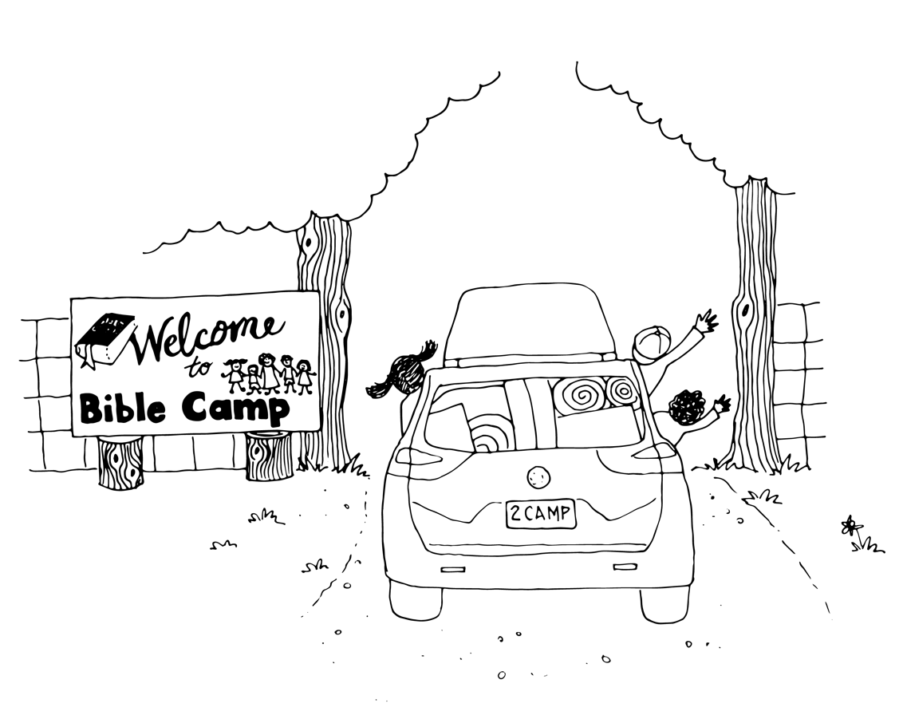
APPENDIX 1 – Bible Marking
Below is a suggested highlighting system to add clarity to your Bible pages and to outline key events and themes. Feel free to use whatever is most helpful to you in your studies!
Genesis 37
Chapter Outlines (Write in side margins)

37:1 Joseph brings their evil report
37:4 Joseph brothers hate him
37:5 Joseph’s first dream
37:9 Joseph’s second dream
37:13 Israel sends Joseph to his brethren
37:18 Joseph’s brothers conspire against him
37:23 Joseph’s coat stolen & Joseph thrown in a pit
37:26 Judah suggests to sell Joseph
37:31 Jacob’s sons lie about Joseph
37:36 Joseph is sold into Potiphar’s house

Geography/Location (Orange)

37:1 “in the land”, “in the land of Canaan”
37:7 “in the field”, “arose”, “stood upright”, “round about”
37:10 “come”, “to the earth”
37:12 “Shechem”
37:13 “in Shechem”
37:14 “vale of Hebron”, “came to Shechem”
37:15 “in the field”
37:17 “departed hence”, “Dothan”, “Dothan”
37:18 “afar off”, “came near”
37:19 “cometh”
37:20 “come”, “into some pit”
37:22 “into this pit”, “in the wilderness”, “rid him out of their hands”
37:24 “into a pit”
37:25 “down”, “lifted up”, “Gilead”, “down to Egypt”
37:27 “upon him”
37:28 “out of the pit”, “into the pit”
37:29 “unto the pit”, “in the pit”
37:34 “upon”
37:35 “rose up”, “down into the grave”
37:36 “into Egypt”

Time Words (Aqua)

37:2 “seventeen years old”
37:3 “Now”, “old age”
37:4 “when”
37:17 “after”
37:18 “when”
37:20 “now”
37:23 “came to pass, when”
37:28 “Then”
37:32 “now”
37:34 “many days”

Important Words/Phrases (Yellow)

37:8 “for his dreams”, “for his words”
37:11 “observed”
37:13 “Here am I”
37:16 “I seek my brethren”
37:21 “he delivered him out of their hands”
37:22 “to deliver him to his father again”
37:24 “pit was empty”
37:25 “to eat bread”
37:26 “Judah”
37:27 “were content”
37:29 “rent his clothes”
37:30 “whither shall go?”

Sin (Red)

37:2 “evil report”
37:4 “hated”, “could not speak peaceably”
37:5 “hated him yet the more”
37:8 “hated him yet the more”
37:18 “conspired against him to slay him”
37:20 “slay him”, “cast him”, “we will say”
37:26 “What profit”
37:27 “let us sell”

Jacob (Underline, Light Green)
37:1 “Jacob”
37:2 “Jacob”
37:34 “Jacob”
Israel (Color Light Green)
37:3 “Israel”
37:13 “Israel”

Genesis 39
Chapter Outlines (Write in side margins)

39:1 Joseph prospers in Potiphar’s house
39:7 Potiphar’s wife tries to tempt Joseph
39:11 Potiphar’s wife frames Joseph
39:14 Potiphar’s wife lies to the servants
39:17 Potiphar’s wife lies to Potiphar
39:20 Joseph is thrown into prison

God (Purple)

39:2 “the LORD was with”
39:3 “the LORD was with”, “the LORD made”
39:5 “the LORD blessed”, “blessing of the LORD”
39:21 “the LORD was with”
39:23 “the LORD was with”, “the LORD made it to prosper”

Geography/Location (Orange)

39:1 “to Egypt”, “down thither”
39:2 “in the house”
39:5 “in the house”, “in the field”
39:8 “in the house”
39:9 “in this house”
39:11 “into the house”
39:12 “in her hands”
39:13 “in her hand”
39:16 “by her”, “home”
39:20 “into the prison”
39:21 “the prison”
39:22 “the prison”, “in the prison”

Time Words (Aqua)

39:7 “after these things”
39:10 “it came to pass”, “day by day”
39:11 “to pass about this time”
39:13 “it came to pass, when”
39:15 “it came to pass, when”
39:16 “until”
39:18 “it came to pass, as”
39:19 “it came to pass, when”

Important Words/Phrases (Yellow)

39:4 “found grace in his sight”, “overseer over his house”, “all that he had”
39:5 “all that he had”, “all that he had”
39:6 “all that he had”, “save the bread which he did eat”, “goodly”, “well favoured”
39:8 “all that he hath”
39:12 “left”, “fled”, “out”
39:13 “fled”
39:15 “left”, “fled”, “out”
39:18 “left”, “fled out”
39:21 “mercy”, “favour”
39:23 “under his hand”

Hebrew (Royal Blue)

39:14 “Hebrew”
39:17 “Hebrew”

Genesis 40
Chapter Outlines (Write in side margins)

40:1 The butler & baker thrown into prison
40:5 The butler & baker have dreams
40:7 Joseph notices their sadness & asks
40:12 The butler’s dream interpreted
40:18 The baker’s dream interpreted

Geography/Location (Orange)

40:1 “Egypt”, “Egypt”
40:3 “in the house”, “into the prison”
40:4 “in ward”
40:7 “in the ward”
40:9 “before”
40:11 “my hand”, “into”, “into
40:13 “thy place”, “into his hand”
40:14 “this house”
40:15 “the land”, “into the dungeon”
40:16 “on my head”
40:17 “uppermost”, “out of the basket upon my head”
40:19 “off”, “on a tree”, “off thee”
40:20 “lifted up”
40:21 “into Pharaoh’s hand”

Time Words (Aqua)

40:1 “it came to pass after”
40:4 “continued a season”
40:5 “one night”
40:6 “in the morning”
40:7 “to day”
40:12 “three days”
40:13 “three days”, “after”, “when”
40:16 “when”
40:18 “three days”
40:19 “within three days”
40:20 “it came to pass the third day”, “birthday”

Important Words/Phrases (Yellow)
40:1 “offended”
40:6 “looked”
40:8 “interpretations belong to God”
40:22 “as Joseph had interpreted to them”
Sin (Red)
40:23 “did not”, “forgat him”

Numbers (Grey)
40:10 “three”
40:12 “three”
40:16 “three”
40:18 “three”

Genesis 41
Chapter Outlines (Write in side margins)

41:1 The first dream of cows
41:5 The second dream of corn
41:8 Nobody could interpret the dreams
41:10 The butler remembers Joseph
41:14 Joseph is brought out of prison
41:17 Pharaoh tells Joseph the dreams
41:25 Pharaoh’s dreams interpreted
41:33 Joseph gives Pharaoh a solution
41:39 Joseph is made second in command
41:46 Joseph goes out to collect food
41:50 Joseph has two sons
41:54 The famine begins

God (Purple)

41:16 “God shall give”
41:25 “God hath shewed”
41:28 “God is about”
41:32 “established by God”, “God will”
41:52 “God hath caused”

Geography/Location (Orange)

41:1 “by the river”
41:2 “out of the river”, “in a meadow”
41:3 “out of the river”, “stood by”, “upon the brink of the river”
41:5 “upon one stalk”
41:8 “Egypt”
41:10 “in ward in the captain of the guard’s house”
41:14 “out of the dungeon”, “came in unto”
41:17 “upon the bank of the river”
41:18 “came up out of the river”, “in a meadow”
41:19 “came up after them”, “in all the land of Egypt”
41:22 “in my dream”
41:23 “east”
41:27 “east”
41:29 “throughout all the land of Egypt”
41:30 “in the land of Egypt”, “the land”
41:31 “in the land”
41:33 “the land of Egypt”
41:34 “over the land”, “the land of Egypt”
41:35 “under the hand”, “in the cities”
41:36 “the land”, “in the land of Egypt”, “the land”
41:37 “in the eyes”, “in the eyes”
41:40 “over my house”
41:41 “over all the land of Egypt”
41:42 “took off”, “upon”, “about”
41:43 “in the”, “before”, “over all the land of Egypt”
41:44 “in all the land of Egypt”
41:45 “went out over all the land of Egypt”
41:46 “stood before”, “Egypt”, “went out from the presence”, “all the land of Egypt”
41:47 “the earth”
41:48 “in the land of Egypt”, “in the cities”, “the field”, “round about every city”, “in the same”
41:52 “in the land”
41:53 “in the land of Egypt”
41:54 “in all lands”, “land of Egypt”
41:55 “all the land of Egypt”
41:56 “all the face of the earth”, “in the land of Egypt”
41:57 “all countries”, “into Egypt”, “in all lands”

Time Words (Aqua)
41:1 “at the end of two full years”
41:5 “second time”
41:6 “after”
41:8 “it came to pass in the morning”
41:9 “then”, “this day”
41:11 “one night”
41:13 “it came to pass”
41:14 “Then”, “hastily”
41:20 “first”
41:21 “at the beginning”
41:23 “after”
41:26 “seven years”, “seven years”
41:27 “seven years”, “seven years”
41:29 “seven years”
41:30 “after”, “seven years”
41:32 “twice”, “shortly bring to pass”
41:34 “seven plenteous years”
41:35 “good years”
41:36 “seven years of famine”
41:46 “thirty years old”
41:47 “seven plenteous years”
41:48 “seven years”
41:50 “before the years of famine came”
41:51 “firstborn”
41:52 “second”
41:54 “seven years”, “began to come”
41:55 “when”

Important Words/Phrases (Yellow)

41:8 “none that could interpret”
41:15 “none that can interpret it”
41:16 “it is not in me”
41:21 “they were still”
41:24 “none that could declare it to me”
41:37 “the thing was good”
41:40 “according unto thy word”
41:49 “as the sand of the sea”, “it was without number”

Sin (Red)
41:9 “my faults”
Hebrew (Royal Blue)
41:12 “Hebrew”

Numbers (Grey)

41:2 “seven”
41:3 “seven”
41:4 “seven”
41:6 “seven”
41:7 “seven”, “seven”
41:18 “seven”
41:19 “seven”
41:20 “seven”
41:22 “seven”, “one”
41:23 “seven”
41:24 “seven”
41:26 “seven”, “seven”
41:27 “seven”, “seven”
41:43 “second”
41:50 “two”

Genesis 42
Chapter Outlines (Write in side margins)

42:1 Jacob sends his sons Egypt
42:6 The brothers come to Joseph for corn
42:9 Joseph accuses them of being spies
42:15 Joseph plays to keep all brothers but one
42:21 The brothers feel guilty about Joseph
42:26 The brothers leave for home
42:29 The brothers return & tell Jacob all
42:36 Jacob refuses to let Benjamin go
42:37 Reuben offers his sons lives for Benjamin

Geography/Location (Orange)

42:1 “in Egypt”
42:2 “in Egypt”, “down thither”
42:3 “went down”, “in Egypt”
42:5 “among”, “in the land of Canaan”
42:6 “over the land”, “the land”, “before”, “to the earth”
42:7 “the land of Canaan”
42:9 “the land”
42:12 “the land”
42:13 “in the land of Canaan”
42:15 “go forth hence”
42:16 “in prison”
42:17 “in ward”
42:19 “in the house of your prison”, “houses”
42:20 “unto”
42:21 “come upon”
42:24 “turned”, “about”, “returned”, “before”
42:25 “the way”
42:27 “opened”, “in the inn”, “in his sacks’ mouth”
42:28 “in my sack”
42:29 “unto the land of Canaan”
42:30 “the land”, “the country”
42:32 “in the land of Canaan”
42:33 “the country”, “here”
42:34 “in the land”
42:35 “in his sack”
42:38 “by the way”, “to the grave”

Time Words (Aqua)

42:1 “Now when”
42:13 “this day”
42:17 “three days”
42:18 “third day”
42:21 “when”
42:25 “Then”
42:32 “this day”
42:34 “then”
42:35 “it came to pass as”, “when”

Important Words/Phrases (Yellow)

42:4 “sent not with his brethren”
42:7 “he knew them”, “made himself strange”
42:8 “knew his brethren”, “they knew not him”
42:9 “remembered the dreams”
42:13 “one is not”
42:21 “we are verily”
42:23 “they knew not”
42:28 “their heart failed them”
42:35 “every man’s bundle of money”, “they were afraid”

Sin (Red)

42:21 “guilty”, “we saw the anguish”, “would not hear”, “come upon”
42:22 “ye would not hear?”
42:37 “slay my two sons”, “bring him not”

Jacob (Underline, Light Green)

42:1 “Jacob”, “Jacob”
42:4 “Jacob”

Israel (Color Light Green)
42:5 “Israel”

Numbers (Grey)
42:13 “twelve”
42:32 “twelve”

Genesis 43
Chapter Outlines (Write in side margins)

43:1 Jacob tries to convince his sons back to Egypt
43:8 Judah takes responsibility
43:15 Jacob’s sons travel to Egypt
43:17 The brothers are brought to Joseph
43:19 The returned money causes fear
43:24 The brothers prepare to dine with Joseph
43:29 Joseph sees Benjamin & is overcome
43:30 Joseph weeps
43:31 Joseph & his brothers dine

God (Purple)
43:23 “your God”, “the God of your father”

Geography/Location (Orange)

43:1 “the land”
43:2 “out of Egypt”
43:4 “go down”
43:5 “go down”
43:9 “before
43:11 “in the land in your vessels”
43:12 “your hand”, “in your hand”
43:13 “go again”
43:14 “before”
43:15 “in their hand”, “rose up”, “went down to Egypt”, “before”
43:17 “into Joseph’s house”
43:18 “into Joseph’s house”
43:18 “upon”
43:19 “came near”, “the door of the house”
43:20 “down”
43:21 “came to the inn”, “in the mouth”, “in our hand”
43:22 “in our hands”, “in our sacks”
43:23 “in your sacks”, “out”
43:24 “into Joseph’s house”
43:25 “there
43:26 “came home”, “in their hand into the house”, “the earth”
43:28 “bowed down”
43:29 “lifted up”
43:30 “upon”, “where”, “into his chamber”
43:31 “went out”
43:32 “by himself”, “by themselves”, “by themselves”, “with”
43:33 “before him”
43:34 “before him”, “with him”

Time Words (Aqua)

43:2 “it came to pass, when”
43:9 “then”, “for ever”
43:10 “lingered”, “now”
43:11 “now”
43:12 “brought again”
43:16 “when”
43:18 “first time”
43:20 “the first time”
43:21 “it came to pass, when”
43:25 “noon”
43:26 “when”
43:30 “made haste”

Important Words/Phrases (Yellow)

43:3 “Judah spake”
43:8 “with me”
43:9 “I will be surety for him”
43:11 “balm”, “honey”, “spices”, “myrrh”, “nuts”, “almonds”
43:14 “If I am bereaved of my children, I am bereaved”
43:29 “his brother Benjamin, his mother’s son”
43:33 “birthright”, “youth”

Sin (Red)
43:32 “an abomination unto the Egyptians”

Hebrew (Royal Blue)
43:32 “Hebrews”

Israel (Color Light Green)
43:6 “Israel”
43:8 “Israel”
43:11 “Israel”

Numbers (Grey)
43:10 “second”
43:12 “double money”
43:15 “double money”
43:34 “five times”

Genesis 44
Chapter Outlines (Write in side margins)

44:1 Money & cup placed in sacks
44:3 The brothers leave the city
44:6 The missing cup is found with Benjamin
44:18 Judah’s confession

Geography/Location (Orange)

44:1 “sack’s mouth”
44:2 “sack’s mouth”
44:4 “out of the city”, “not yet far off”, “up”
44:8 “sack’s mouths”, “land of Canaan”, “out of thy lord’s house”
44:11 “the ground”
44:12 “Benjamin’s sack”
44:13 “returned to the city”
44:14 “Joseph’s house”, “on the ground”
44:17 “in whose hand”, “get you up”
44:18 “near”
44:21 “down unto me”
44:23 “come down”
44:24 “came up”
44:26 “go down”
44:28 “went out”
44:29 “to the grave”
44:31 “to the grave”

Time Words (Aqua)

44:3 “as soon as the morning was light”
44:4 “when”, “when”
44:8 “again”, “then”
44:10 “Now”
44:11 “Then”, “speedily”
44:12 “eldest”, “youngest”
44:13 “Then”
44:18 “Then”
44:20 “old age”
44:24 “it came to pass when”
44:25 “again”
44:26 “then”
44:28 “since”
44:30 “Now”, “when”
44:31 “come to pass, when”
44:32 “forever”
44:33 “Now”

Important Words/Phrases (Yellow)

44:9 “let him die”, “will be my lord’s bondmen”
44:10 “according unto your words”, “shall be my servant”, “ye shall be blameless”
44:14 “Judah”
44:20 “he alone is left of his mother”, “father loveth him”
44:23 “shall see my face no more”
44:26 “the man’s face”
44:29 “gray hairs with sorrow”
44:30 “bound up”
44:31 “gray hairs of thy”, “with sorrow”
44:32 “became surety”
44:33 “ley thy servant abide instead”, “the lad go up with his brethren”

Sin (Red)

44:4 “rewarded evil for good”
44:5 “done evil”
44:16 “iniquity”
44:34 “the evil”

Genesis 45
Chapter Outlines (Write in side margins)

45:1 Joseph reveals himself to his brothers
45:5 Joseph explains that God sent him
45:10 Joseph tells the brothers live in Egypt
45:15 Pharaoh’s house hears of the brothers
45:20 The brothers are given wagons & food
45:24 The brothers leave for Canaan

God (Purple)

45:5 “God did send”
45:7 “God sent”
45:8 “God”
45:9 “God hath made”

Geography/Location (Orange)

45:1 “before”, “stood by him”, “go out”
45:2 “house of Pharaoh”
45:4 “came near”, “into Egypt”
45:6 “in the land”
45:7 “in the earth”
45:8 “all the land of Egypt”
45:9 “all Egypt”
45:10 “land of Goshen”, “near”
45:13 “in Egypt”
45:14 “upon”
45:15 “upon”
45:16 “Pharaoh’s house”
45:17 “land of Canaan”
45:18 “come unto”, “the land of Egypt”, “the land”
45:19 “land of Egypt”
45:20 “the land of Egypt”
45:23 “of Egypt”, “by the way”
45:24 “away”, “by the way”
45:25 “of Egypt”, “land of Canaan”
45:26 “land of Egypt”
45:28 “go”

Time Words (Aqua)

45:1 “Then”, “while”
45:5 “Now”, “before”
45:6 “two years”, “five years”
45:7 “before”
45:8 “now”
45:9 “Haste”, “tarry”
45:11 “five years”
45:15 “after”
45:19 “Now”
45:27 “when”
45:28 “before”

Important Words/Phrases (Yellow)

45:3 “they were troubled at his presence”
45:5 “be not grieved”, “preserve life”
45:7 “great deliverance”
45:10 “thy children”, “thy children’s children”, “thy flocks”, “thy herds”, “all that thou hast”
45:11 “thy household”, “all that thou hast”
45:18 “your father”, “your households”
45:21 “commandments of Pharaoh”
45:26 “heart fainted”
45:27 “all the words of Joseph”, “father revived”
45:28 “it is enough”

Jacob (Underline, Light Green)
45:26 “Jacob”
45:27 “Jacob”

Israel (Color Light Green)
45:28 “Israel”

Hebrew (Royal Blue)
45:21 “children of Israel”

Numbers (Grey)

45:22 “three hundred pieces”, “five changes”
45:23 “ten”, “ten”

Genesis 46
Chapter Outlines (Write in side margins)

46:1 Israel travels to Beer-sheva & sees vision
46:4 God promises to be with Israel in Egypt
46:9 Reuben’s sons
46:10 Simeon’s sons
46:11 Levi’s sons
46:12 Judah’s sons
46 :13 Issachar’s sons
46:14 Zebulun’s sons
46:16 Gad’s sons
46:17 Asher’s sons
46:20 Joseph’s sons
46:21 Benjamin’s sons
46:23 Dan’s sons
46:24 Naphtali’s sons
46:26 66 Children of Israel came to Egypt
46:29 Joseph is reunited with Israel

God (Purple)

46:1 “the God of his father”
46:2 “God”
46:3 “God of thy father”

Geography/Location (Orange)

46:1 “Beer-sheba”
46:3 “go down into Egypt”
46:4 “go down”, “into Egypt”, “up”, “upon thine eyes”
46:5 “rose up”, “Beer-sheba”, “in the wagons”
46:6 “in the land of Canaan”, “came into Egypt”
46:7 “into Egypt”
46:8 “into Egypt”
46:11 “in the land of Canaan”
46:15 “Padan-aram”
46:20 “the land of Egypt”
46:26 “into Egypt”
46:27 “in Egypt”, “came into Egypt”
46:28 “before”, “unto Goshen”, “into the land of Goshen”
46:29 “went up”, “to Goshen”
46:31 “go up”

Time Words (Aqua)

46:2 “the night”
46:29 “good while”
46:30 “Now”
46:33 “it shall come to pass, when”
46:34 “our youth even until now”

Important Words/Phrases (Yellow)

46:2 “Here am I”
46:4 “I will”, “I will also surely bring”
46:5 “their little ones”, “their wives”
46:6 “their cattle”, “their goods”, “all his seed”
46:7 “His sons”, “his sons’ sons”, “his daughters”, “his sons’ daughters” “all his seed”
46:9 “Reuben”
46:10 “Simeon”
46:11 “Levi”
46:12 “Judah”
46:13 “Issachar”
46:14 “Zebulun”
46:15 “sons of Leah”
46:16 “Gad”
46:17 “Asher”
46:18 “sons of Zilpah”
46:20 “Joseph”
46:21 “Benjamin”
46:22 “sons of Rachel”
46:23 “Dan”
46:24 “Naphtali”
46:25 “sons of Bilhah”
46:28 “sent Judah”
46:30 “thou art yet alive”
46:32 “their flocks”, “their herds”, “all that they have”

Sin (Red)

46:10 “the son of a Canaanitish woman”
46:34 “abomination unto the Egyptians”

Jacob (Underline, Light Green)

46:2 “Jacob”, “Jacob”
46:5 “Jacob”
46:6 “Jacob”
46:8 “Jacob”, “Jacob’s”
46:15 “Jacob”
46:18 “Jacob”
46:19 “Jacob’s”
46:22 “Jacob”
46:25 “Jacob”
46:26 “Jacob”, “Jacob”
46:27 “Jacob”

Israel (Color Light Green)

46:1 “Israel”
46:2 “Israel”
46:5 “Israel”
46:21 “children of Israel”
46:29 “Israel”
46:30 “Israel”

Numbers (Grey)

46:8 “firstborn”
46:15 “thirty and three”
46:18 “sixteen souls”
46:22 “fourteen”
46:25 “seven”
46:26 “threescore and six”
46:27 “threescore and ten”

Genesis 47
Chapter Outlines (Write in side margins)

47:1 The brothers appear before Pharaoh
47:7 Jacob appears before Pharaoh
47:13 The Egyptians trade money for food
47:15 The Egyptians trade cattle for food
47:19 The Egyptians trade land for food
47:24 Joseph institutes a 1/5 Tithe
47:28 Jacob’s life comes to an end

Geography/Location (Orange)

47:1 “came”, “come out of the land of Canaan”, “in the land of Goshen”
47:2 “unto”
47:3 “unto”
47:4 “the land are we come”, “in the land of Canaan”, “in the land of Goshen”
47:5 “come unto”
47:6 “The land of Egypt”, “the land”, “in the land of Goshen”
47:7 “before”
47:10 “before”
47:11 “in the land of Egypt”, “the land”, “in the land of Rameses”
47:13 “in all the land”, “the land of Egypt”, “the land of Canaan”
47:14 “in the land of Egypt”, “in the land of Canaan”, “into Pharaoh’s house”
47:15 “in the land of Egypt”, “in the land of Canaan”, “in thy presence”
47:17 “unto”
47:18 “in the sight”
47:19 “the land”
47:20 “the land of Egypt”, “field”, “the land”
47:21 “the borders of Egypt”
47:22 “their lands”
47:23 “the land”
47:24 “the field”
47:25 “in the sight”
47:26 “the land of Egypt”, “land of the priests”
47:27 “in the land of Egypt”, “in the country of Goshen”
47:28 “in the land of Egypt”
47:29 “in thy sight”, “under my thigh”, “in Egypt”
47:30 “lie with”, “out of Egypt”, “in their buryingplace”
47:31 “upon the bed’s head”

Time Words (Aqua)

47:1 “Then”
47:6 “before”
47:9 “The days of the years”, “an hundred and thirty years”, “the days of the years of my life”, “days of the years of the life”, “in the days”
47:15 “when”
47:17 “that year”
47:18 “When”, “year was ended”, “second year”
47:23 “Then”, “this day”
47:24 “it shall come to pass”
47:26 “this day”
47:28 “seventeen years”
47:29 “the time drew night”, “now”

Important Words/Phrases (Yellow)

47:1 “My father”, “my brethren”, “their flocks”, “their herds”, “all that they have”
47:3 “Thy servants are shepherds, both we, and also our fathers.”
47:4 “sojourn”
47:7 “Jacob blessed”
47:9 “pilgrimage”, “pilgrimage”
47:14 “money”
47:15 “money failed”, “bread”, “money faileth”
47:16 “money fail”
47:17 “bread”, “horses”, “cattle”, “asses”, “bread”
47:18 “money is spent”, “hath our herds” of cattle”
47:19 “die before thine eyes”, “bread”
47:23 “here is seed”
47:25 “Thou hast saved our lives”

Jacob (Underline, Light Green)
47:28 “Jacob”

Israel (Color Light Green)

47:27 “Israel”
47:29 “Israel”
47:31 “Israel”

Numbers (Grey)

47:14 “all”
47:24 “the fifth part”, “four parts”
47:26 “the fifth part”
47:27 “multiplied exceedingly”
47:28 “hundred forty and seven years”

Genesis 48
Chapter Outlines (Write in side margins)

48:1 Blessings for the sons of Joseph
48:8 Joseph brings Manasseh & Ephraim near
48:13 Jacob purposely switches Joseph’s sons
48:15 Jacob gives the blessings
48:17 Joseph tries to correct the switch

God (Purple)

48:11 “God hath shewed”
48:20 “God make”
48:21 “God shall be with”

Geography/Location (Orange)

48:1 “with him”
48:2 “upon the bed”
48:3 “Luz”, “Canaan”
48:5 “land of Egypt”, “into Egypt”
48:7 “Padan”, “land of Canaan”, “in the way”, “a little way”, “Ephrath”, “way of Ephrath”, “Bethlehem”
48:10 “near unto”
48:12 “between his knees”, “face to the earth”
48:13 “right hand”, “left hand”, “left hand”, “right hand”, “near unto”
48:14 “right hand”, “left hand”
48:16 “midst of the earth”
48:17 “right hand”, “unto”
48:18 “right hand”
48:22 “above”, “out of the hand”

Time Words (Aqua)

48:1 “it came to pass after these things”
48:4 “after”, “everlasting possession”
48:5 “now”
48:6 “after”, “after”
48:6 “after”
48:7 “when”, “when”
48:10 “Now”, “for age”
48:14 “firstborn”
48:15 “before”, “all my life long unto this day”
48:17 “when”
48:18 “firstborn”
48:19 “younger”
48:20 “that day”
48:21 “again”

Important Words/Phrases (Yellow)
48:5 “they shall be mine”
48:9 “I will bless them”
48:20 “he set Ephraim before Manasseh”
Sin (Red)
48:16 “all evil”

Israel (Color Light Green)
48:8 “Israel
48:10 “Israel”
48:11 “Israel”
48:13 “Israel’s”, “Israel’s”
48:14 “Israel”
48:20 “Israel”
Hebrew (Royal Blue)
48:15 “Abraham and Isaac”
48:16 “Abraham and Isaac”
48:21 “land of your fathers”

Numbers (Grey)
48:4 “fruitful”, “multiply”, “multitude”
48:5 “two”
48:16 “multitude”
48:19 “greater”, “multitude”
48:22 “one portion”

Genesis 49
Chapter Outlines (Write in side margins)

49:1 Jacob calls all his sons together
49:3 Reuben’s blessings
49:5 Simeon & Levi’s blessings
49:8 Judah’s blessings
49:13 Zebulun’s blessings
49:14 Issachar’s blessings
49:16 Dan’s blessings
49:19 Gad’s blessings
49:20 Asher’s blessings
49:21 Naphtali’s blessings
49:22 Joseph’s blessings
49:27 Benjamin’s blessings
49:29 Jacob’s command to be buried in Israel
49:33 Jacob dies

God (Purple)

49:18 “O LORD”
49:24 “mighty God”
49:25 “the God”

Geography/Location (Orange)

49:9 “gone up”, “stooped down”
49:10 “depart”, “between his feet”
49:13 “haven of the sea”, “haven of ships”, “his border shall be unto Zidon”
49:14 “down between”
49:15 “the land”
49:17 “by the way”, “in the path”, “backward”
49:22 “by a well”, “over the wall”
49:24 “abode”
49:25 “heaven above”, “the deep”
49:26 “utmost bound”, “on the head”, “on the crown”, “separate”
49:29 “in the cave”, “in the field of Ephron”
49:30 “In the cave”, “field of Machpelah”, “before Mamre”, “in the land of Canaan”, “a buryingplace”
49:32 “the field”, “the cave”
49:33 “up his feet into the bed”

Time Words (Aqua)

49:1 “last days”
49:3 “beginning”
49:10 “until”
49:19 “at the last”
49:26 “everlasting”
49:27 “in the morning”, “at night”
49:33 “when”, “end”

Important Words/Phrases (Yellow)

49:3 “Reuben”
49:5 “Simeon”, “Levi”
49:8 “Judah”
49:9 “Judah”
49:13 “Zebulun”
49:14 “Issachar”
49:16 “Dan”
49:17 “Dan”
49:19 “Gad”
49:20 “Naphtali”
49:22 “Joseph”
49:26 “Joseph”
49:27 “Benjamin”
49:33 “gathered unto his people”

Sin (Red)

49:4 “Unstable”, “not excel”, “wentest up to thy father’s bed”, “defiledst thou it”, “went up to my couch”
49:5 “cruelty”
49:6 “their secret”, “their assembly”, “anger”, “selfwill”
49:7 “Cursed”, “anger”, “fierce”, “wrath”, “cruel”

Jacob (Underline, Light Green)
49:1 “Jacob”
49:2 “Jacob”
49:7 “Jacob”
49:24 “Jacob”
Israel (Color Light Green)
49:2 “Israel”
49:7 “Israel”
49:24 “Israel”
49:28 “tribes of Israel”
Numbers (Grey)
49:22 “fruitful”, “fruitful”

Genesis 50
Chapter Outlines (Write in side margins)

50:1 The Egyptians mourn & embalm Jacob
50:7 They all bury Jacob in Egypt
50:13 Jacob is buried in cave of Machpelah
50:15 The brothers fear for their lives
50:22 Joseph sees his grandsons then dies

God (Purple)

50:17 “the God”
50:19 “God”
50:25 “God”

Geography/Location (Orange)

50:1 “upon his father’s face”, “upon him”
50:4 “the house of Pharaoh”
50:5 “in my grave”, “the land of Canaan”
50:6 “Go up”
50:7 “went up”, “the land of Egypt”
50:8 “in the land of Goshen”
50:9 “went up”
50:10 “threshingfloor of Atad”, “beyond Jordan”
50:13 “into the land of Canaan”, “in the cave of the field of Machpelah”, “the field”, “before Mamre”
50:14 “into Egypt”, “went up”
50:18 “fell down before”
50:19 “in the place”
50:22 “dwelt in Egypt”
50:23 “brought up upon”
50:24 “out of this land unto the land”
50:25 “carry up”, “from hence”
50:26 “in Egypt”

Time Words (Aqua)

50:3 “forty days”, “the days”, “threescore and ten days”
50:4 “when”, “days of his mourning”, “now”
50:5 “Now”
50:10 “seven days”
50:11 “when”
50:14 “after”
50:15 “when”
50:16 “before”
50:17 “now”, “when”
50:20 “this day”
50:21 “Now”

Important Words/Phrases (Yellow)

50:5 “which I have digged for me”
50:7 “servants of Pharaoh”, “elders of his house”, “elders of”
50:8 “house of Joseph”, “his brethren”, “father’s house”
50:17 “Forgive”, “forgive”
50:20 “meant it unto good”

Sin (Red)
50:15 “hate us”, “the evil”, “we did unto him”
50:17 “trespass of thy brethren”, “their sin”, “evil”, “the trespass”
50:20 “evil against me”

Israel (Color Light Green)
50:2 “Israel”
50:24 “to Abraham, to Isaac, and to Jacob”
50:25 “children of Israel”

Numbers (Grey)
50:7 “all the”, “all the”
50:8 “all the”
50:22 “hundred and ten years”
50:23 “the third generation”
50:26 “hundred and ten years old”

APPENDIX 2 – Additional Study Resources
MARGINAL MAPS
How To Use: Place the map underneath your Bible page and trace it into your margin.


ISRAEL
EGYPT

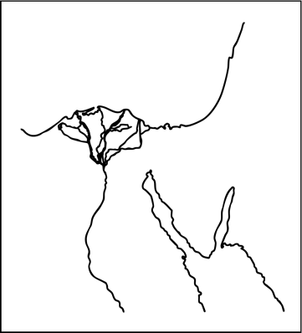

TENTATIVE TIMELINES
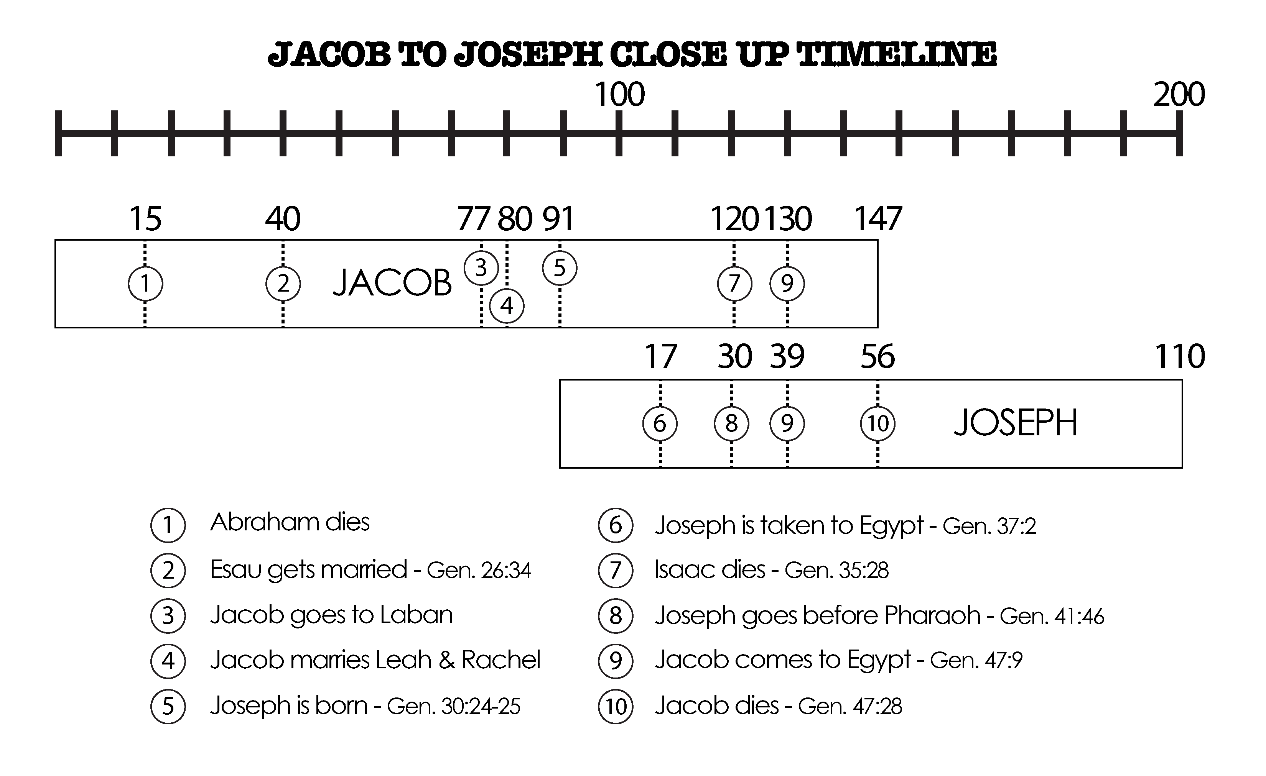
The following timelines are to show the chronology of events of the Patriarch in relation to each other.
