


Dear Young People,

The prophet Elisha was called likely right around your age. Amidst a wicked and adulterous generation, he grew up in a faithful family who instilled in him a love for God’s ways and a commitment to the truth.

As he ploughed his field after 3 ½ years of drought in the fertile fields of Abel-Meholah, an older rugged looking man approached. Placing his cloak upon Elisha he continued walking. Elisha recognized the older prophet and immediately ran after him.
From that point, Elisha made an outward public commitment to the service of the truth, sacrificing his farming equipment and putting his hand to the spiritual plough of sowing the still small voice of God’s word into the hearts and minds of the 7,000 in Israel who had not bowed the knee to Baal.

For several years thereafter he would minister to Elijah, the two developing a father-son relationship, until Elijah was taken up in a whirlwind. A double portion of Elijah’s spirit now rested upon the young man Elisha, as he willingly took up the mantle of the prophetic office. For the next 65 years he would be the head of the Sons of the Prophets and would minister in Israel extending God’s grace to faithful individuals in desperate situations.

As Elijah was a type of John the Baptist, Elisha stands in the record as a type of the Lord Jesus Christ.

This workbook cannot cover all the aspects of Elisha’s ministry but delve into several events in Elisha’s life that provide practical lessons and encouragement to us today, who live in a wicked and adulterous generation.

If you are a young lady or a sister, may the example of the Shunamite woman or the Widow inspire you.
If you are a young man or brother, may the example of the sons of the prophets stir your devotion to the things of the scriptures and truth, as they withstood the pressures from the world around them.

May our studies bring us closer to our Father and the example of our Lord and saviour. As we strive to seek first the Kingdom of God and His righteousness.

In the Master’s Name,

Bro. Darryl Rose
darrylandrita2015@gmail.com
CONTENTS
Introduction:
Discussion Group Breakdown | The Kings & Prophets of Israel & Judah Chart
Helpful Resources | The Ministry of Elisha Overview
Tips for Bible Study | The Miracles of Elijah & Elisha
Map of Elisha’s Ministry

Section 1: The Call of Elisha (1 Kings 19:9-21)
Section 2: The Departure of Elijah & Crossing Jordan (2 Kings 2:1-14)
Section 3: The Healing of Jericho’s Waters (2 Kings 2:15-22)
Section 4: The Two She Bears (2 Kings 2:23-24)
Section 5: The Widow’s Oil (2 Kings 4:1-7)
Section 6: The Shunamite Woman (2 Kings 4:8-37)
Section 7: The Return of the Shunamite (2 Kings 8:1-6)
Section 8: Death In The Pot (2 Kings 4:38-41)
Section 9: Bread of the Firstfruits (2 Kings 4:42-44)
Section 10: The Healing of Naaman (2 Kings 5)

Infographics & Further Information:
Farming 2 Kings 3
The Cloak Yahweh Hath Called for A Famine
The Sons of the Prophets The Syrians
Horses & Chariots of Fire The Timing of Naaman
2 Kings 6, 7, 8, 11

DISCUSSION GROUP BREAKDOWN
 | Discussion #1 | Discussion #2
Monday | Sections 1-2: The Call of Elisha / The Departure of Elijah / Parting Jordan (Pages 1 - 25)
Tuesday | Sections 3-4: The Healing of Jericho’s Waters / The She Bears (Pages 26 - 40) | Section 5: The Widow’s Oil (Pages 41 - 48)
Wednesday | Section 6 & 8: The Shunamite Woman / Death in the Pot (Pages 49 - 61, 70 - 77)
Thursday | Section 9 & 10: Bread of the Firstfruits / Namaan & Gehazi (Pages 78 - 105)
Friday | Section 7: The Return of the Shunamite (Pages 62 - 69) | Conclusion  (Page 105)

TIPS FOR BIBLE STUDY
Bible Study may seem daunting at first. Where to begin?
Step 1: Read, Read, Read... read the passage several times. Think it through. Even re-tell the story. Familiarize yourself with every detail.
Step 2: Ask Questions! Go verse by verse and ask questions that come out from the passage.
Step 3: Look up the meaning of key words using a concordance; or places or things in a Bible Dictionary.
Step 4: Look at the cross-references (TSK)
Step 5: Use other resources
Step 6: Summarize the principles
Step 7: Apply the lessons.

Helpful Resources
Christadelphian Books on Elisha:
Elisha – The Neglected Prophet by Bro David Wood (out of print)
Men of God by Stephen Irving
The Visible Hand of God by Bro. Robert Roberts
Elijah by Bro. Stephen Whitehouse
Elijah by Bro. John Martin
The Kings of Israel & Judah Study Notes by Bro. Jim Cowie
A Light Unto the Gentiles by Bro. Jonathan Cope (Naaman)
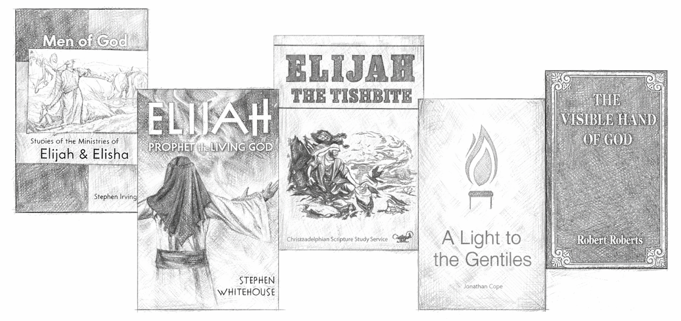

BIBLE STUDY RESOURCES:
Nelson’s Complete Book of Bible Maps and Charts
Journey Through The Bible by V. Gilbert Beers
Bible Dictionary
The EW Bullinger Companion Bible
Treasury of Scripture Knowledge (TSK)
Bible Study Tools App or Online – Try the Blue Letter Bible App

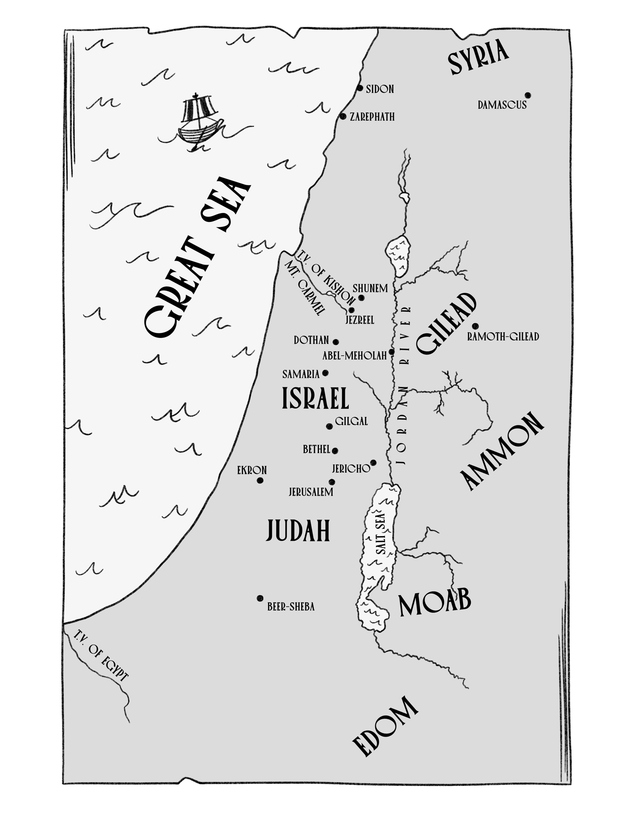
MAP OF ELISHA’S MINISTRY

Another similar map can be found on page 117 of the Nelson’s Bible Maps and Charts.
All illustrations drawn by Sis. Hannah Young.
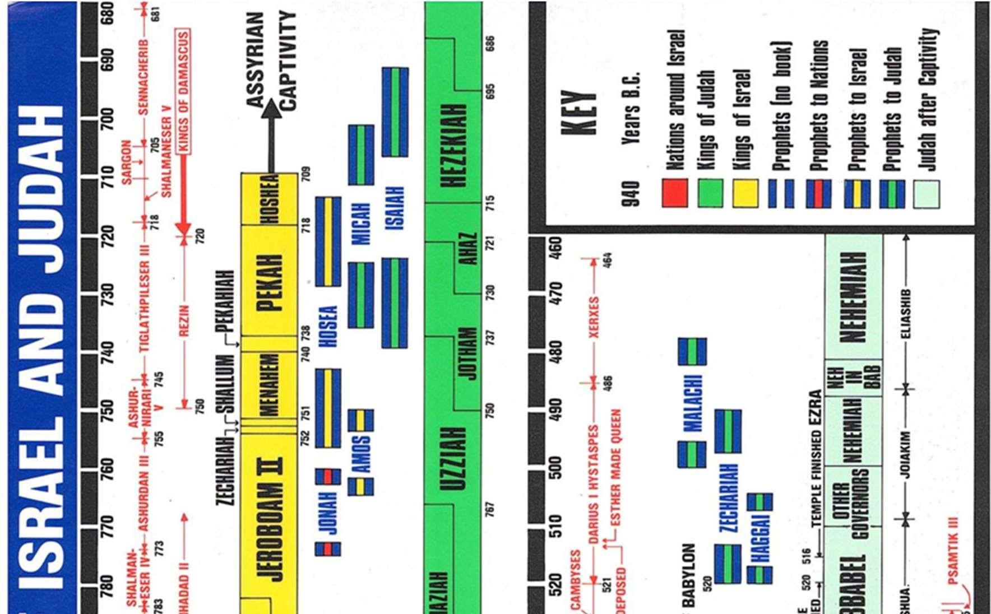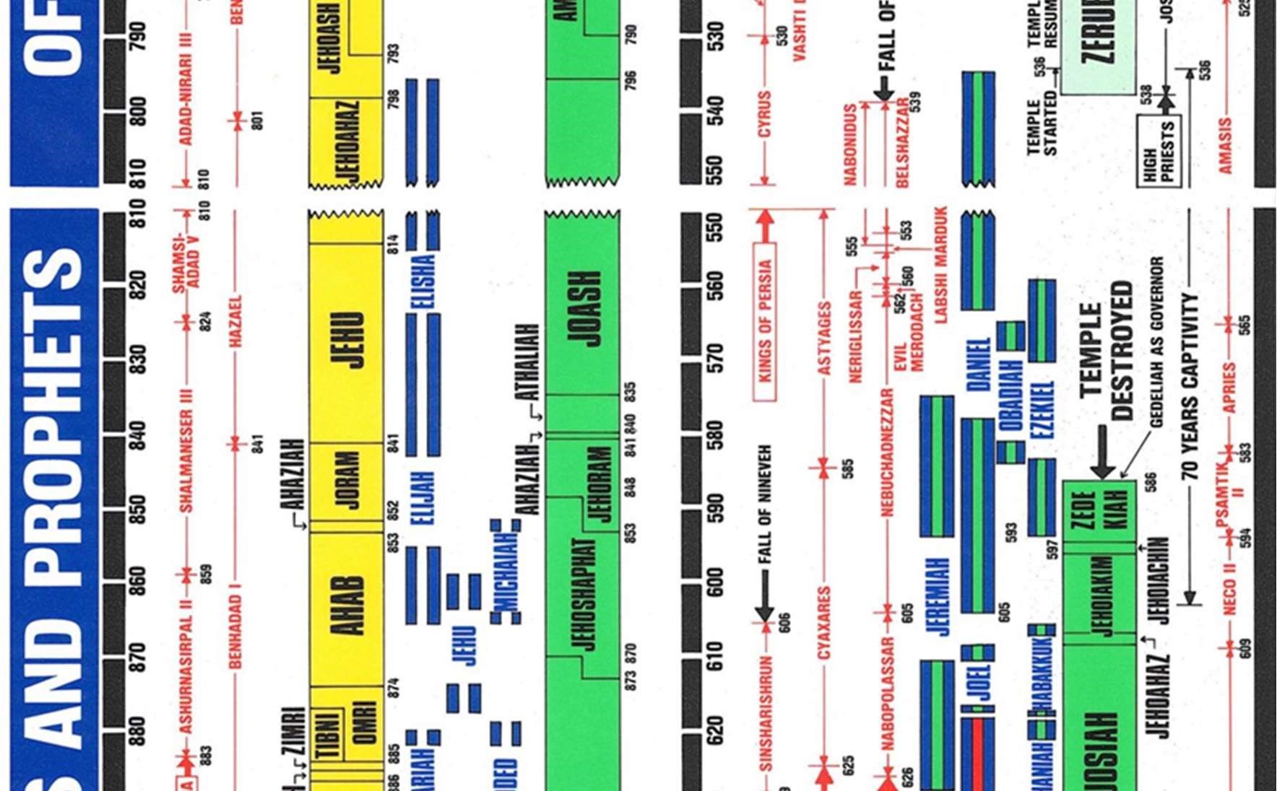

THE MINISTRY OF ELISHA
The ministry of Elisha from his calling to his death spans a range of ~65 years.
There is little in terms of time-markers in the Ministry of Elisha, leading some to suggest that events as recorded in scripture, may not be in chronological order. However, we suggest later in the workbook that they are.

Reference | Event | Location | Time
1 Kings 19:19-21 | The call of Elisha | Abel-Meholah | Late in the reign of Ahab
(1 Kings 20 – 2  Kings 1) | 7–10-year gap – Working alongside Elijah | Kingdom of  Israel | Ahab & Ahaziah
2 Kings 2:1-6 | Visiting the Sons of the Prophets | Gilgal, Bethel, Jericho | Ahaziah
2 Kings 2:7-12 | Elijah is taken from Elisha | Joran River | Ahaziah
2 Kings 2:13-15 | Elisha’s 1st Miracle: The parting of the Jordan | Jordan River | Ahaziah
2 Kings 2:16-22 | Miracle 2: The healing of Jericho’s waters | Jericho | Ahaziah
2 Kings 2:23-25 | Miracle 3: Elisha mocked on road to Bethel | Bethel | Ahaziah?
2 Kings 3 | Miracle 4: The Battle of the Moabites |  | Jehoram / Joram
2 Kings 4:1-7 | Miracle 5: The Widow’s Oil
2 Kings 4:8-17 | Miracle 6: The Shunamite Woman Promised a Son | Shunam
2 Kings 4:18-37 | Miracle 7: The Raising of the Shunamite  Woman’s Son | Shunam | 5-8 years later
2 Kings 4:38-41 | Miracle 8: Death in the Pot | Gilgal | Famine
2 Kings 4:42-44 | Miracle 9: Bread for a multitude | Gilgal? | Famine
2 Kings 5:1-19 | Miracle 10: The healing of Naaman
2 Kings 5:20-27 | Miracle 11: Naaman’s Leprosy falls on Gehazi
2 Kings 6:1-7 | Miracle 12: The Floating Axe Head | Jordan River
2 Kings 6:8-23 | Miracles 13: Opening the servant’s eyes  Miracles 14 & 15: Blinding the Syrian Army | Samaria
2 Kings 6:24 – 7:20 | The Siege of Samaria & Elisha’s Prophecy | Samaria
2 Kings 8:1-6 | The Shunamite Woman’s sojourn & restoration of all that was hers | Samaria | King Jehu
2 Kings 8:7-15 | Elisha anoints Hazael; Benhadad Murdered | Damascus
2 Kings 9:1-37 | Elisha sends his servant to anoint Jehu; Jehu defeats Joram & Jezebel
2 Kings 13:14-20 | Elisha’s Illness & Death |  | King Joash / Jehoash
2 Kings 13:20-21 | Miracle 16: Elisha’s Bones |  | King Joash / Jehoash

THE MIRACLES OF ELIJAH & ELISHA
In Bullinger’s Companion Bible, he suggests that there are exactly twice as many miracles Elisha performs, as opposed to Elijah, based on Elisha receiving a double portion of Elijah’s spirit (2 Kings 2:9). The following charts are reproduced from the CSSA adult notes.
When we come to consider 2 Kings 2, we will consider a deeper meaning of the “double portion” of God’s spirit which rested upon Elisha.

THE EIGHT MIRACLES OF ELIJAH
Miracle | Reference | Spiritual Significance
The shutting of heaven | 1 Kings 17:1 | Spiritual drought (Amos 8:11).
Multiplication of oil | 1 Kings 17:14 | Food for the godly amidst drought.
Widow's son raised | 1 Kings 17:22-23 | The resurrection.
Fire from heaven | 1 Kings 18:38 | Vindication at judgment.
Rain | 1 Kings 18:45 | Outpouring of Spirit (Joel 2:23).
Destruction of fifty | 2 Kings 1:10 | Rejection at judgment.
Destruction of fifty | 2 Kings 1:12 | Rejection at judgment.
Waters divided | 2 Kings 2:8 | Dominion over symbolic water (cp. Rev. 17:15).
THE 16 MIRACLES OF ELISHA
Miracle | Reference | Spiritual Significance
1. Waters divided | 2 Kings 2:14 | The mantle of Elijah rests on Elisha.
2. Waters healed | 2 Kings 2:21 | Healing through "the salt of the covenant" (Lev. 2:13; Num. 18:19).
3. Bears destroy mockers | 2 Kings 2:24 | Punishment of all mockers and rejecters of God.
4. Water in a barren land | 2 Kings 3:20 | God's providential care amidst a barren world.
5. Oil for the widow | 2 Kings 4:1 | An unending supply of God's Word to sustain those who trust in Him.
6. The gift of a son | 2 Kings 4:16 | Loving service yields a Divinely given seed.
7. Raising the dead son | 2 Kings 4:35 | Resurrection of the God-given seed.
8. Healing the food | 2 Kings 4:41 | To add to God-given food results in "death in the pot", but contentment with "our daily bread" gives health.
9. Bread multiplied | 2 Kings 4:43 | Even amidst drought, God will supply "the bread of life" to all who come to Him.
10. Naaman healed | 2 Kings 5:10 | Belief and burial in water cleanses from sin and leads to newness of life.
11. Gehazi smitten | 2 Kings 5:27 | To covet the riches of this world is to court the judgment of God.
12. Iron made to float | 2 Kings 6:6 | Those who are lost (the iron) can be recovered through the impact of the Cross (the stake cut down and cast into the water).
13. Sight to the blind | 2 Kings 6:17 | Faith enables God's people to see His providential care of them.
14. Syrians smitten with blindness | 2 Kings 6:18 | The same Providence operates to protect God's people from those who would destroy them.
15. Restoration of sight | 2 Kings 6:20 | It is only when we are led captive by God that wars will cease, and we will find true peace.
16. Life through death | 2 Kings 13:21 | Jesus Christ "through death, destroyed him that had the power of death" (Heb. 2:14) and contact with him results in resurrection.

SECTION 1: THE CALL OF ELISHA
Reading: 1 Kings 19:9-21

Background
Elijah went to Mt. Sinai believing he was the only one left in Israel who was faithful to God. But it was revealed there were 7,000 in Israel who had not bowed the knee to Baal. Amidst this remnant, there was one young man that God directed Elijah to find who was to be his successor.

- Read the passage over several times carefully. What questions come to mind? What observations? Read the passage from the perspective of Elijah. Read it again from the perspective of Elisha.


Abel-Meholah
- Locate Abel-Meholah on a map
- Using a Bible Atlas / Dictionary complete the table about Abel-Meholah:
Meaning:
What does this tell us about the place?
What tribe is it in?
General location:
Other references in scripture to this place:
You’ll notice that there are not many references in scripture to this place. It was of very little reputation. Elisha came from lowly beginnings, like our Lord Jesus Christ. Yet he came from a family that loved God and was faithful in Israel.

Elisha’s Family and Upbringing
Shaphat (meaning: “judged” or “he hath judged”) and his wife name their child
Elisha (meaning: “God is Salvation”). He was likely born during the reign of Omri
(1 Kings 16:16-29) and grew up in the reign of Ahab (1 Kings 16:30-33). Refer to the timeline chart in the introduction. Read the passages noted above about
the reign of these Kings.

- What does it tell us about Elisha’s family that they gave him this name? What would it mean for Elisha?

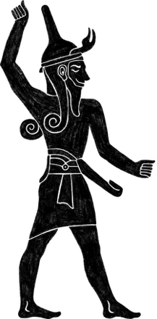
- Given how quick he is to respond to the call of Elijah in 1 Kings 19:20-21, what does this indicate about his upbringing?

Baal
Even in the midst of a wicked generation, we can take comfort knowing there is still a way to bring up children in the nurture and admonition of the Lord (Eph. 6:4). This was not only true of Elisha, but later in our studies it’s true for the Widow woman in 2 Kings 4, the Shunamite woman in 2 Kings 4 & 8, and the “little maid” in 2 Kings 5.

- What are some practical things parents can do to raise a godly seed? Consider Gen. 18:19; Deut. 18:19; Prov. 22:6; 2 Tim. 2:22; 3:15.

- Find a married couple in your ecclesia who have raised children that are baptized and engaged in the truth. Ask them what guidance they would give to raising a Godly seed through childhood and teenage years.

Elijah set off from Mt. Carmel to find this faithful individual. He knew the town, but he would have to ask people where to find him. Directed to Shaphat’s farm, Elijah soon came to find a man very different from himself, yet equally full of faith.

Ploughing With 12 Yoke of Oxen
There are different ways to interpret 1 Kings 19:19. Likely there were 12 pairs of oxen
(24 in total). From the rear position Elisha would oversee the 11 servants, ensuring the field was being ploughed in straight furrows. Elisha, likely in his late teens, was already a leader in his family. This ploughing and sowing of the fields were usually done during October / November.

- Consider how exciting this time was for Elisha and these servants. What had just taken place for the past 3 ½ years in Israel and what challenges would that have made for the family of Elisha given their occupation? (James 5:17-18)

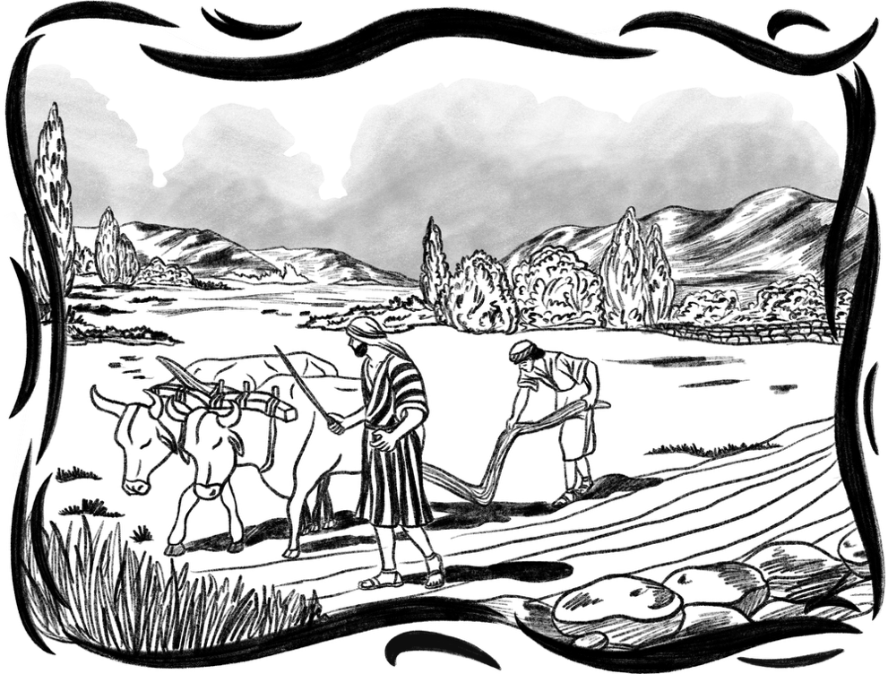

- Many times in scripture God uses a person's occupation to prepare them for a work to come, or at least to parallel the spiritual work they will engage in. How was this physical labour Elisha was found engaged in directly relevant to the spiritual work he was about to take on? (See Hosea 10:11-13 and consider the spiritual state of the nation under Ahab and Jezebel)

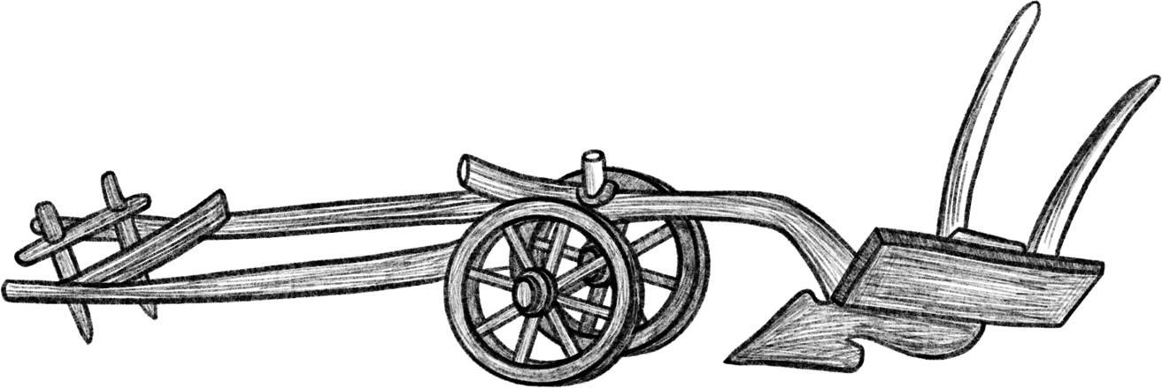

Sources: Farming | Journey Through the Bible by V. Gilbert Beers; Eerdmans’ Family Encyclopedia of the Bible

Rain and Harvest
“People’s lives depended on the rain. Storms that rolled across the land from the sea watered the crops growing in the fields, assuring a bountiful harvest.
In summer, rain rarely fell. Gentle showers marked the beginning of the winter months. If these ‘winter rains’ did not come as expected, the ground turned hard as stone. Plowing and planting were impossible, and in a few months famine arrived. Without a harvest, food became very scarce, and many people died of starvation.” (Beers, p144)


Yoke of Oxen
“When Elijah called Elisha to become a prophet, Elisha was plowing with 12 yokes of oxen. Two oxen were yoked together so that they would pull equally.” (Beers, p. 145)



Plowing and Plows
“Ancient plows were crude. The earliest were simply a light tree trunk with two strong branches forking at the end. Later, the ploughshare was developed.
This was a piece of wood carved into the shape of a large chisel and attached to the plow. It was the part which moved through the ground and broke up the soil. In the time of the Kings, ploughshares were made of iron.” (Beers, p. 145)


Ploughing and Planting
“In October / November came the previous ‘early rain’ after the long summer drought. From then till January was the time for ploughing and planting. The plough was usually a simple wooden stake with a handle and appoint of iron… it was attached to a yoke and drawn by one or two oxen. The farmer could hold the plough with one hand while the other held a stick for beating the oxen. Since it was light the plough could easily be lifted over any large stones. It left a furrow 3-4in/80-100cms deep. The seed (wheat, barley, flax) was scattered by hand then the plough was sometimes used again to cover the seed with earth. Occasionally branches were dragged along to smooth the ground, and a hoe used to remove weeds.” (Eerdman, p. 228)

Sources: Elijah’s Mantle | Journey Through the Bible by V. Gilbert Beers


The Cloak or Mantle
“Almost everyone owned a cloak, but most people had just one. Cloaks were similar to the outer coats of today, but much more versatile, and taken almost everywhere.
Most cloaks were made from animal hides, goat or camel hair, or from wool. Because it took so much time to make them, cloaks were valuable and were not thrown away until completely worn out. It was a common sight to see a cloak that had been patched many times.” (Beers, p145)

The Important Uses of a Cloak
“The mantle had no intrinsic power, any more than Moses’ rod; but it was a symbol of the power of God working through the prophet and his clothing, almost as if the inanimate clothing was charged with the energy of the prophet, derived of course from God Himself.” (David Wood, Elisha: The Neglected Prophet, p. 15

“A cloak was worn as protection against the burning sun, and for warmth in the cold night. But these were just two of its uses.

On a warm night, a cloak made a soft pillow. At a meal, it was laid on the ground and represented a special seat for an honoured guest.

A bundle of goods was carried home from the village in a cloak. A farmer tied his cloak into a bag, emptied his seeds into it, and planted his fields by hand. A cloak was also used symbolically. By spreading his cloak over a woman, a man was announcing that he would care for her. Throwing a cloak over another’s shoulders represented a transfer of power or position. Sometimes it meant a call to discipleship.
A cloak was sometimes given to a lender as a pledge for a debt. And when torn in pieces, a cloak symbolized great sorrow or grief, (Beers, p145).

Elisha Ran
- Elijah puts his mantle (the symbol of his Prophetic Office) upon Elisha and continues walking. Elisha drops everything and runs after him. What spirit does this demonstrate? (Look at how this Hebrew word for “ran” is used in Genesis and also consider when Elijah himself had run.)

Bro John Martin interprets 1 Kings 19:20 as follows: “Permission granted but consider the meaning of what I have done in the great privilege I have offered you.”

Elisha’s Sacrifice
Elisha returns, not to go back to his work, but to make a public declaration to his family, servants and friends that his old way of life has ended. He is heeding the master’s call.
- How does he make this declaration in 19:21. What specific actions?

We’re now going to explore two Bible echoes that help to shed light on what Elisha
is doing.
- There appears to be an echo to 2 Sam. 24:20-24 when David built an altar and made a sacrifice at the threshing floor of Araunah.
  - What similarities do you see?

  - What two specific offerings did David make (24:25) and what do they represent?

  - In Exo. 24:5 the same 2 offerings are made, and a fellowship meal was shared, before Moses and Joshua ascended Mt. Sinai (24:13). What promise was made at this time, and what could we infer is the promise Elisha is making? (Exo 24:5-8)



  - Joshua is referred to as Moses’ “minister” (Exo 24:13). The same word is used in 1 Kings 19:21 of Elisha who “ministered” to Elijah. Consider this interesting echo. What experience had Elijah just had similar to Moses? What other similarities can be drawn between Moses and Joshua vs. Elijah and Elisha? How does that broaden your understanding of the relationship that would develop between the two of them?

- Luke 9 is filled with several references and echoes to Elijah, and there is an obvious echo in Luke 9:61-62 to this event. Although it may at first appear to be contradictory to what Elisha did, Elisha’s request to return to his family was not an excuse.

  - What was the key lesson Christ was bringing out in this passage that was demonstrated by Elisha’s faithful response?

Another interesting connection is found in James and John’s request to bring down fire from heaven as Elijah did in 2 Kings 1. Christ rebuked them, instructing them that “the Son of man is not come to destroy men’s lives, but to save them” (Luke 9:56). This is what Elijah had to learn, and together with Elisha, they two would now set out to save the faithful remnant in Israel.

- Consider the practical lessons we can learn from Elisha’s example.
  - Are there things in your life that you have sacrificed for the sake of the truth?
  - Are there things currently in your life that are hindering your focus and service to Christ, that you think you should change?
  - What actions do you plan to take?



For the next 7-10 years Elijah and Elisha would work side by side. Elisha would learn as much from Elijah as Elijah would from Elisha. It was now their mission to search out the 7,000 in Israel who had not bowed the knee to Baal and instil within them the still small voice of God’s word. Elijah and Elisha together would establish the Sons of the Prophets, of which Elijah was their head.

THE SONS OF THE PROPHETS
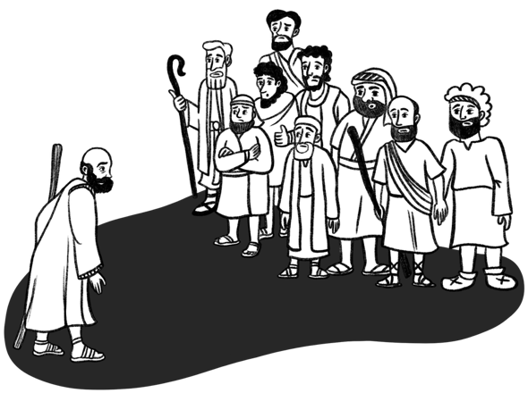
Modelled after the work of Samuel some 150 years before, Elijah and Elisha appear to have established these groups of ‘Bible Students’ in various locations throughout the Northern Kingdom (2 Kings 2).
As Samuel journeyed on a circuit year by year
(1 Sam. 7:15-17), Elisha also appears to be always on the move (2 Kings 4:9), likely visiting the groups of faithful. Imagine how special a time it was when
he showed up!

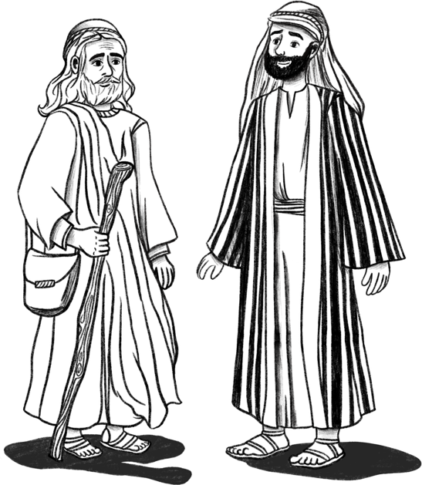
📖 Key References | 1 Kings 20:35; 2 Kings 2:1-18; 2 Kings 4:1; 2 Kings 4:38-44;  2 Kings 5:22; 2 Kings 6:1-7
💰 Poor, Yet Rich | The group members were likely not financially well off, as indicated in 2 Kings 4:1 and 6:5.  Their faithfulness to Yahweh and rejection of idolatry may have made finding employment challenging.  The time needed to dedicate to ‘ecclesial life’ and their families, would also mean sacrificing time used in pursuit of riches.
👨‍👩‍👧 Family Life | They had wives and children (2 Kings 4:1), who appear to be known to Elisha. Did the wives play a role in ministering to these brethren?  Did the children have a Sunday School?
🏠 Ecclesial Life | They met in ‘ecclesial halls’ (2 Kings 6:1). Sometimes, they would outgrow their halls and need to build larger halls.  Once decisions were made, God’s guidance and blessing was sought. (2 Kings 6:2) They worked and laboured together.  (2 Kings 6:2,5) In times of difficulty and trial,  they came together, finding encouragement  around God’s Word. (2 Kings 4:38)
📜 Elijah was originally the headmaster; a position passed onto
Elisha. (2 Kings 2:3; 4:38)

🐑 Elisha knew these men… he was their shepherd and they
the flock. (2 Kings 4:1; 4:42 cp Mk 6:34)

SECTION 2: THE DEPARTURE OF ELIJAH
Reading: 2 Kings 2:1-14

“He must increase, but I must decrease” (John 3:30)

The Journey from Gilgal to Jordan
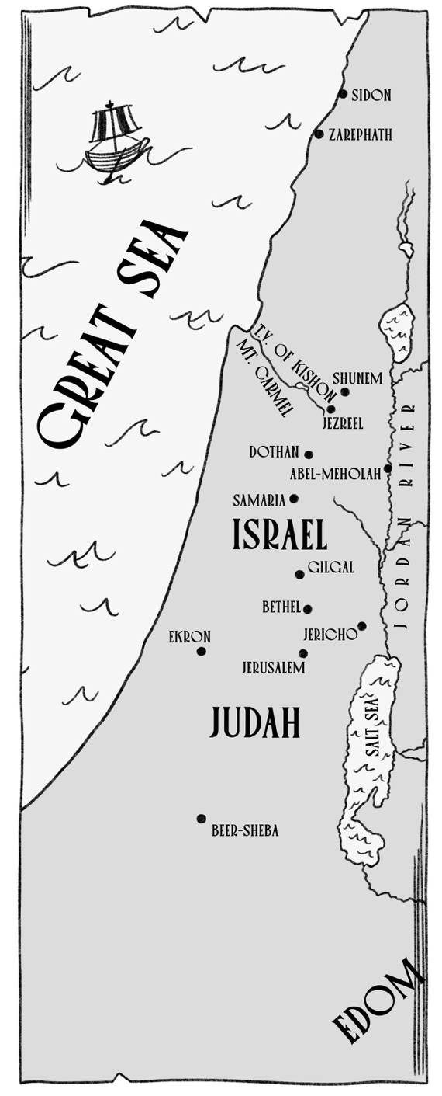
Elijah and Elisha will journey from Gilgal to Bethel to Jericho, before crossing the River Jordan. We’ll begin by looking at these 3 places.

In each place were a group of the Sons of the Prophets.

1. Have a look into these 3 places. Gilgal has some notes already provided.
Complete the notes for Bethel and Jericho.

📍Gilgal:
There are at least three different Gilgal’s mentioned in scripture. The one mentioned here (and in 2 Kings 4:38) is likely not the Gilgal near to Jericho that is most common in scripture. This is likely the one 7km north of Bethel, and 15 miles south of Samaria, located in the land of Ephraim.

- Note that they would “go down” to Bethel from here (2 Kings 2:2). Yet you would travel uphill from the Gilgal near Jericho.
- This location makes the route of travel much more logical, than starting at Gilgal, going all the way back up to Bethel, then back to Jericho again.
- If it was the Gilgal near Jericho, why didn’t they come to aid in the search of Elijah (2:15)?
- Elisha returns to Gilgal in 4:38, and the context would more highly favour the Gilgal in Ephraim, given its proximity to Baal-Shalisha (4:42).

Gilgal = A rolling – i.e. The cutting off of the flesh and the reproach of Egypt.
Likely modern day: Jiljilie

📍Bethel:
Look up Bethel in a Bible Dictionary or find cross-references to it. Write down some points about this place. Including...
  - Meaning of Bethel
  - What notable positive events happen at Bethel?
  - What notable negative events happens at Bethel?
  - What Bethel is called in Hosea 10:5 and the meaning of that name
  - What would life be like for the Sons of the Prophets in this city?

📍Jericho:
Look up the cross-references to Jericho in your centre margin or in Treasury of Scripture Knowledge (TSK).
  - What did God prophecy would happen to the man who attempted to re-build this city?
  - When was it rebuilt and what happened?
  - What one word could be associated with this city?


- Consider the words Elisha says to Elijah in 2 Kings 2:1-6 and the Bible echoes:
  - “As Yahweh liveth...” How many times is this used? You may find it useful to colour them in in your Bible. Whose words is Elisha echoing?

  - “As Yahweh liveth, and as thy soul liveth” there are 2 notable instances of this exact phrase being used in the life of David. Who said it to whom?

  - “I will not leave thee” whose words do these echo in scripture? (Hint: Use cross references or Treasury of Scripture Knowledge).

  - What do these Bible echoes from 2a, 2b and 2c indicate about the relationship Elijah and Elisha had developed over these years?


  - What other examples of close companionships exist in scripture where age doesn’t play a factor?

  - What practical lessons or implications are there for today?

- The Sons of the Prophets appear to be acutely aware that the time had come for Elijah’s departure. God was going to remove him from “Elisha’s head”. What does this phrase imply about Elijah’s role, and Elisha’s future role?

“Yea, I know it; hold ye your peace.”
“It was not a subject on which he cared to talk or think, still less to
be addressed by others. There are subjects on which the mind is very
tender, and can only grapple within silence with any satisfaction.
Elijah’s impending removal was of this nature to Elisha. Under Elijah’s
headship, he felt sage and strong. He was, as it were, a covering of God
to him. The idea of parting with him was most unwelcome. He knew
the parting was at hand: but he refused to hasten it by a single minute.
He resolved to stick by Elijah to the last available moment, and was
therefore deaf to all hints from Elijah himself, and sore to all
conversation on the subject.”

(Bro. Robert Roberts, The Visible Hand of God, p. 287, 1990 edition)

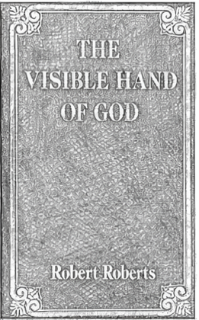

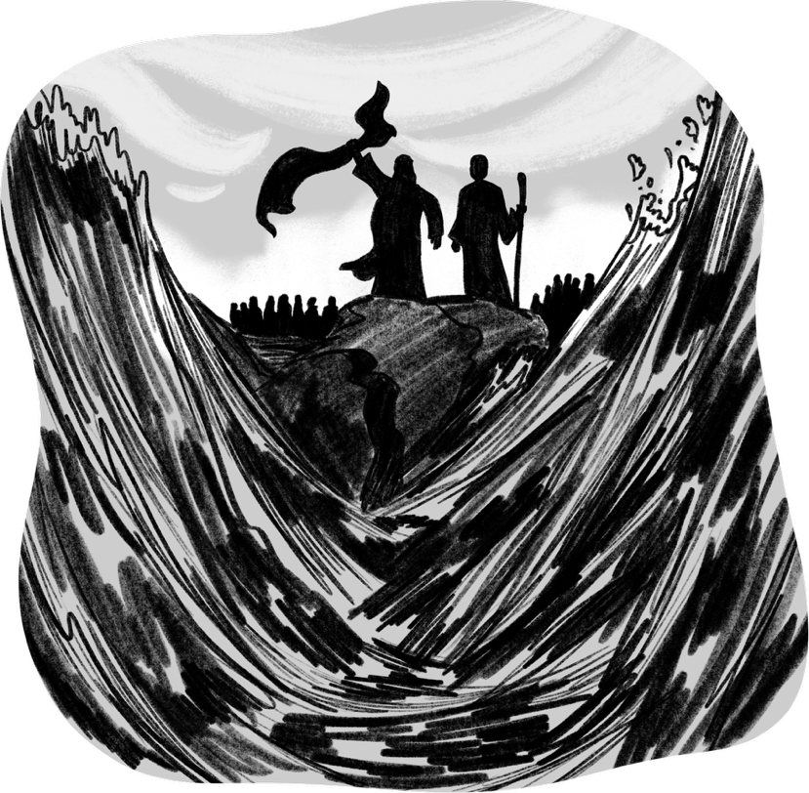
Crossing Jordan
This final miracle of Elijah is an evident
echo to Joshua crossing the Jordan River
on dry ground. In 2 Kings 2, a group of
faithful ones stand at a distance, as Elijah
and Elisha go ahead. In Joshua, Joshua and
the priests with the ark go ahead of Israel
by 2,000 cubits. We will return to this
echo shortly.

Elijah & Elisha’s Final Journey:
- There is an obvious echo to Abraham and Isaac in Genesis 22.
  - Complete the chart below by finding the corresponding phrase or idea and provide the passage. After completing the chart we’ll consider the significance.

Abraham & Isaac (Gen 22) | Elijah & Elisha (2 Kings 2)
 | “They two went on” (2 Kings 2:2,6,7,8,11)
Journey as a Father and Son… Isaac (fig of Christ), calls Abraham “My Father” (Gen.
22:7)

 | They talked to each other along the journey (2 Kings 2:11)
The voice of the angel comes between Abraham and Isaac as he is about to bring the knife down, parting the two of them. (Gen
22:11-12)

“Abraham lifted up his eyes and looked”, and saw an animal of God’s providing. A sacrifice under the old covenant. (Gen. 22:13) | Elisha sees in accordance with his faith (2 Kings 2:12 cp 6:17). Faith is a key component of the New Covenant.
The angel speaks to Abraham a “second time” (Gen. 22:15) | 2 Kings 2:14 -

  - How does this Bible Echo help to solidify that Elisha is a type of Christ?

  - How does this echo help us understand that Elisha’s ministry is going to teach us about the New Covenant?

A Double Portion:
- Knowing that Elijah is about to depart, Elisha requests, “let a double portion of thy spirit be upon me” (2 Kings 2:9). Some see this “double portion” of the Spirit in the fact that Elisha appears to have performed twice as many miracles as Elijah (See chart in introduction section). But there seems to be more to this request.

    - What is the echo to Solomon and what he asks for, and how does that help us appreciate Elisha’s request?

    - There are a number of links to Joshua in this passage, as we will consider shortly. What is “the spirit” that rested upon Joshua (compare Num. 27:18 and Deut. 34:9)?
Note that there appears to be a double portion of God’s spirit given to Joshua. That which he had initially, and that which was given upon the laying on of Moses’ hands.

    - How does this link with Moses & Joshua vs Elijah & Elisha help us to understand the request Elisha is making?

The idea of the “double portion” is also the idea of the right of the firstborn inheritance (Deut. 21:17). It was passed on to the Levites in Num. 3:12, and they became the teachers within the nation of Israel. This understanding helps us in 2 ways:

  - Elisha was requesting to be considered Elijah’s firstborn son… to inherit his work and his office as the prophet and to become the “head” of the Sons of the Prophets. This wasn’t a request made out of pride or ambition, but one of humble submission to his calling (1 Kings 19:16).

  - Being recognized as the firstborn, Elisha again foreshadows Christ who is the firstborn of the ecclesia of firstborn ones. (Col. 1:15; Heb. 12:22-23).

- Read 2 Kings 2:11 carefully. Many artist depictions show Elijah in the chariot of fire, being carried up to heaven. Is that what the verse actually says?



1st Principles:
Did Elijah go to Heaven,
God’s dwelling place?

- Many Christians believe that Elijah (and Enoch) never died but were taken to Heaven.
    - What scriptural passages would you use to refute this belief?
    - How would you explain what actually happened?
    - What is “heaven” referring to?
(Consider using Wrested Scripture if you get stuck)

HORSES & CHARIOTS OF FIRE

🐎 The Cherubim of Glory | Horses and Chariots are directly associated with the Cherubim in Ezekiel 1, and manifestations of Divine power and majesty.  Cherub = To ride… God is the rider, directing His forces.  In the first instance, it refers to the angelic host which God inhabits. (2 Kings 6:17)  But in the future age, it will be the company of the Saints who God will inhabit. (See below)
👑 The Glorified Saints | There are 3 references in scripture to horses and chariots at the time of Armageddon, representing Christ and the Saints pouring out God’s judgments upon Gog’s confederacy: Isaiah 66:15-16; Psalm 68:4,17; Hab. 3:8,12-13.  Christ and the Saints take on the work of the angels, and form God’s chariot that He rides into battle.  David referred to the Ark as the “Chariot of the Cherubim”  (1 Chron. 28:18… the ark, with its mercy seat and cherubim represent Christ and the multitude of the redeemed.  See also Zech. 6: 1-8
📖 References in Elijah’s Ministry: | - Fire on Mt. Carmel (1 Kings 18)  - Fire that consumes Ahaziah’s men (2 Kings 1)  While no horses or chariots are mentioned, it is thought that the manifestation of fire was directly associated with God’s glory, with some suggesting it came in the form of horses and chariots of fire.
📖 4 References in Elisha’s Ministry: | - Elijah’s departure (2 Kings 2:11)  - A mountain full (2 Kings 6:17)  - A frightening noise (2Kings 7:6)  - The King of Israel’s final words to Elisha (2 Kings 13:14)
🔥Fire: | - Associated with God’s glory and with the Cherubim:  Exo. 24:17; Ezek. 1:4; Num. 16:35; Isa. 65:15-16  Ultimately points to Christ &the saints in glory at Armageddon (Isa. 66:15-16; Ps. 68:17) God’s power will be fully revealed.
⚔️ In Contrast to Man’s Armies: | Exo. 14:9 – Egyptians; Deut. 20:1; Josh 11:9; 2 Sam 15:1 – Absalom;  1 Kings 20:1, 21 – Syrians; 2 Kings 6:14 - Syrians  Lesson: Psalm 20:7; Isa 31:1
“It seems that the presence of chariots of fire was the symbol of God being present with His spokesman, the man of God.” (Bro Stephen Irving, Men of God, p125)


“… We get a strong indication that this was a manifestation of the
omniscience and omnipresence of God (see also 13:14). Just as at
the beginning of the earthly ministry of our Lord at his baptism
there was Divine testimony and approval, so we see the manifestation
of the presence of God at the start of Elisha’s work… The whole topic
of angelic care and ever-present providence of God is too vast to
tackle here, but it seems to be a most important feature of Elisha’s
life and makes us wish that we could be more aware of this wonderful
unseen assurance, than most of us are in everyday life. Our walk
would be more confident and joyful, and we might be less prone to
fall into diverse temptations if we could only bear in mind more
persistently the abiding presence of the Lord.”

(Bro David Wood, Elisha: The Neglected Prophet, p17)

“Yahweh will not only be the invisible Rider of these chariots in the future, but He has already been so in the past. The saints must be vehicles of the divine will now, if they hope to be so in the future. The principle is revealed in the language of the Old Testament in relation to certain remarkable incidents. When Elijah was separated from Elisha, he was taken away by ‘a chariot of fire and horses of fire.’ This was an Apocalypse of angelic glory, and Elisha identified Elijah with it. He cried: ‘My father, my father, the chariot of Israel, and the horsemen thereof!’ (2 Kings 2:12). Elijah was the typical chariot and Yahweh T’zvaoth comprised the horsemen. The prophet had been guided and driven by Yahweh, and thus had comprised His cherubic-chariot in the midst of Israel.”

(Bro. HP Mansfield, The Cherubim: Divine Majesty in Motion)

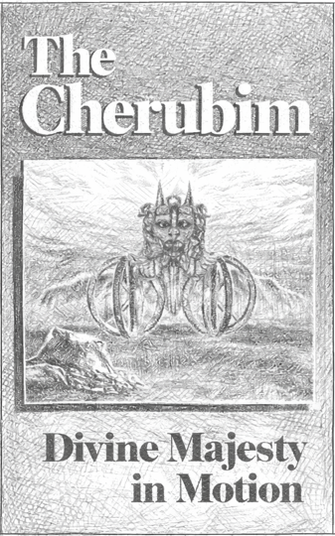


Elisha’s Response
Elisha rends his clothes in two. Rending clothes is
often used as a sign of mourning (Example: Gen.
37:34; Josh. 7:6; 2 Sam. 1:11). But this verse is very
specific… he rent them in two pieces. Here we have
another reference to “two” in this section of verses.

When the veil in the temple was rent in two after
the Lord’s death, it was done from top to bottom.
Elisha’s garment would be rent in similar fashion.
The rent veil marked the end of the Mosaic
Covenant, and the beginning of the New Covenant:
A “new and living way” have been opened up.
The rending of Elisha’s garment similarly marked the end of a phase in his life where he ministered alongside the one who’s ministry spoke of Judgment (Elijah), now to begin a new phase as he begins his ministry of grace, pointing to the work of the Lord
Jesus Christ.

There is possibly a further echo to Gen. 15 and the pieces of Abraham’s offering. The offerings were divided in two, and God passed between the pieces, as a symbol of the cutting of the covenant with Abraham. This was the Abrahamic covenant, symbolic of the New Covenant. God had passed between the two men… Elijah and Elisha… just as he had passed between the offerings. There are two pieces of the garment, just as there are two pieces of Abraham’s offering. This old garment was being destroyed to put on a new garment. Was Elisha making a promise to God at this time, further to the one that he had made at his calling?

These are just thoughts that you may wish to reflect on. Perhaps you might have
other connections that come to mind to help understand the spiritual significance
to Elisha’s actions.

References to 2 in 2 Kings 2
👴👦 2 men: Elijah and Elisha
🌊🌊 2 partings of Jordan River
🧵🧵 2 Pieces of Elisha’s garment
🧥🧥 2 times it says “mantle of Elijah that fell from him”
🔥🐎 2 references to the chariot and horses
✨✨ Double portion of Elijah’s spirit

Elisha’s First Miracle: Parting Jordan
This is a highly significant event that needs to be viewed in the whole context
of what has transpired. There are several aspects that point forward to the work
of our Lord Jesus Christ, who Elisha typifies. Joshua 3 & 4 is clearly being echoed.
Joshua was also a type of Christ.

- Consider Joshua 3:7-13.
  - What was to be the result of the miracle in Joshua’s day? (v7)

  - How is the result the same for Elisha? (provide a verse from 2 Kings 2).

  - How is the same result echoed when Christ comes to the Jordan (Matt. 3:16-17)?

- Joshua 3:10, what description of God is used by Joshua, that Elisha had used?

- Joshua 3:13, the priests bearing the ark of the covenant go ahead of Israel and the waters part. How did that point forward to Christ? (As Elisha typified Christ, we can see Elisha’s work is a priestly work)



- There are 2 crossings of Jordan. Two is often used in scripture in relation to the Old and New Covenants. The first parting of the waters was by Elijah, symbolic of the Old Covenant which was to vanish away (Heb. 8:13); while the second parting was by Elisha, symbolic of the New Covenant, who returned to the people (Heb. 9:28).
Both of these men are associated with the Glory of God in the chariots and horses of fire. How is Elisha’s journey at this time typical of the Glory of God in Ezekiel 11:23 and 43:2?

- What practical lessons can you take from this section in 2 Kings 2?

- Is there anything puzzling to you in this section you want to get clarity on? Or a key point you wish to share with others?

SECTION 3: THE HEALING OF JERICHO’S WATERS
Reading: 2 Kings 2:15-22
We return now to the City of Jericho. Go back to page 14 in the notes and refresh your mind on the City Jericho. As we read this miracle, we must keep in our minds there’s a curse associated with this city.

Elisha had been in the city at least 3 days and must’ve been acutely aware of the desperate situation that was happening. He partook in their sorrows. To the credit of the men of the city, they evidently believed Elisha had the power to do something to help and looked to him for direction.

A Desperate Situation
- It is helpful to read verse 19 in another translation, such as the NASB or ESV. How are the words “situation”, “naught” and “barren” translated?

Situation =

Naught =

Barren =

The bad water had resulted in an unfruitful land.

There are 3 phrases in verse 19 we will now explore, which elaborate on the spiritual state of the people in this city. We will work our way backwards through these.

“The Ground Barren”
- Look up the word “Barren” (Strongs # 7921 – “sakol”) and provide the meaning:

- Take a look at how the word is used in the following passages. Consider the context of these passages by reading the verses around them. What does this barrenness in Jericho suggest about the spiritual state of the people?

Passage where “sakol” is used | Reason for the barrenness:
Exo. 23:26
(read verses 20-26)
Hosea 9:12,14
(read verses 10-17)
Malachi 3:11
(read verses 7-15)

- Do any parables of Christ come to mind that involve the ground, barrenness or unfruitfulness? See if you can come up with at least 2. How do they help to elaborate on the spiritual state of the people in this city?

- How does the condition of the ground relate to the moral or spiritual state of the people living upon it? Consider Genesis 3:17-19 and Romans 8:19-23 (ESV or NASB)

- What is the “barren land” linked together with in 2 Kings 2:21 that would suggest this miracle should be seen in a larger scriptural context?

“The Water is Naught”
- There is an echo in this passage to Exodus 15. Complete the chart drawing the connection between these two events, either in similarities or contrasts:

Exodus 15 2 Kings 2
V2 – “He is become my salvation” | Elisha’s name means “God is Salvation”
V2 – “My Father’s God” | V12 –
V19 – Horses and Chariot
V19 – “went on dry land”
V22 – “three days” journey resulting in disappointment
 | V19 – “the water is naught”
 | V19 – The men of the city come to Elisha
 | V20-21 – Salt added to the water
V25 – “The LORD showed him a tree” | V21
V25 – | V22 –
V26 – “Hearkening to the voice of the LORD our God” | V22 – “according to the saying of Elisha which he spake”

- What is the key lesson that comes out from Exo. 15:25-26 for the people. Consider who the waters represent.

- Linking this back to the men of Jericho, how does this link shed further light on the spiritual state of the men of Jericho and what lessons were they to learn?

“As my Lord Seeth”
Although this phrase may not seem to amount to much at first glance, it needs to be seen in a wider context:
  - First, consider the spiritual state of the men of Jericho. They were spiritually fruitless and failed to appreciate the high and holy calling to which they had been called. They had put off the hearing of God’s Word. Their focus was on the present, temporal things of this life. What they could see with natural sight. They needed to elevate their mind to spiritual things… to look by the eye of faith and think on the things above.

  - Second, consider the wider message of this miracle: It’s about a people living in a cursed city, associated with unfruitfulness and death. It speaks of all those who live under the curse of sin and death, as shown under the Old Covenant. They need the healing of God’s word, provided through the means of the New Covenant in the Lord Jesus Christ.

The Old Covenant is associated with the temporal… the things which can be seen and touched (consider Hebrews 12:18 & Galatians 4:24-25); whereas the New Covenant is about looking at things with the eye of faith… the things which cannot be seen with natural eyes (consider Hebrews 12:22-24 & Galatians 4:26) and living by faith.

“While we look not at the things which are seen, but at the things which are not seen: for the things which are seen are temporal; but the things which are not seen are eternal.” (2 Cor. 4:18)

NOTE: The same principle comes up again in 2 Kings 6:17

- What practical things can you do, or do you do, to elevate the mind to spiritual things each day, so that you don’t become distracted by the cares and pleasures of this life?

Salt in a New Cruse
- Given the comments above under “As my Lord Seeth”, and considering Elisha as a type of Christ, what significance is there to a new cruse or jar (as opposed to an old one)? (Matt. 9:17)

- Salt has special significance in scripture. Consider the following passages and see what is being equated with salt:

Passages | What it represents
Lev. 2:13;
Num. 18:19;
2 Chron. 13:5
Matt. 5:13;
Mark 9:50;
Col. 4:6

“His disciples then, who show meekness, mercy, purity of heart, desire for righteousness, have the wholesomeness and the ‘savour’ that God desires.”
~Bro. John Carter, Parables of the Messiah, p. 100

“Salt is the guarantee of the unbreakable nature of a solemn agreement. It prevents corruption and putrefaction and helps to maintain health. It is a fitting symbol of another phase in the life of Jesus. His covenant with his Father was of life and peace and he was free from any taint of sin, abounding in spiritual health…”
“The meal offering affords many lessons…The first is of willing service. It must be…seasoned with the salt of sincerity and of keeping covenant with our God.”
~Bro. F. E. Mitchell, Offerings, Feasts & Sanctuary, p. 10-11

Salt is a preservative, keeping things from going bad…
It speaks of God’s faithfulness to His promises.

Salt provides savour, bringing out the flavour…
It speaks of God’s character: the covenant’s effect
on our life to ‘bring out the flavour’ of Godly
characteristics in our life.

Salt is associated with sacrifice…
It is only through the means of the sacrifice of Christ, and the sacrificing of the “old man”, that we can be brought into the bonds of the New Covenant and bring forth fruits unto righteousness.



- Who does Elisha credit for this miracle? What is the spiritual lesson and practical lesson we can draw from this?


The Process of Spiritual Healing
God heals the waters
Elisha gives glory to God
Elisha
completes
the work
Everlasting solution
Problem presented
Elisha speaks words of instruction
The people demonstrate obedience

- What practical lessons can you take from this section in 2 Kings 2?

- Is there anything puzzling to you in this section you want to get clarity on? Or a key point you wish to share with others?

SECTION 4: THE TWO SHE BEARS
Reading: 2 Kings 2:23-24
In these 2 verses is contained an account that has been troubling to some. It departs from the usual miracles of Elisha, focused on the extension of grace and salvation, to an outpouring of judgment more reminiscent of something seen in Elijah’s ministry. This account demonstrates that Elisha, and by extension the Sons of the Prophets, faced persecution and ridicule for their steadfastness to God’s truth. But it also demonstrates that God will not be mocked. “While He will demonstrate His mercy to all who will turn their hearts towards Him, God will also bring judgment upon those who turn aside from His precepts” (CSSA Notes, p64).

Bethel: Review your notes on page 14 regarding this place, and what this place was known for in Elisha’s day.

“By the Way”
- How do other translations translate “by the road”. At least a couple of the Lord’s parables pick up this idea of the pathway / road. What parables come to mind and what do they indicate about the character of these 42 that mock Elisha?

“Little Children”
- Some have been disturbed by the account of 2 bears eating 42 little children. However, upon closer examination of the words, these were likely full-grown individuals in their late teens / early 20’s who were fully accountable for their actions. Let’s explore these words.
  - The word “small” (Hebrew “Qatan”) is translated “lesser” (Gen 1:16), “younger” (Gen. 9:24, 27:15, 29:16) or “small” (Gen. 19:11). It is used of Benjamin in Genesis 44:20. How old was Benjamin around this time when the word is used of him?

  - The word “children” (Hebrew “Na’ar”) means “a young man”. Next to the references below where this word is used, note the individual it is used of and their approximate age at that time:

Reference Individual Approx. Age
Gen. 22:5,12

Gen. 37:2

Gen. 41:12

2 Sam. 18:5

  - The word “children” in verse 24 is Hebrew “Yeled”. How is this word used in Gen. 32:22 and 37:30?

Echo to Genesis 16 & 21
- Several words in this passage come up in Genesis 16 and 21. In the chart below, use a concordance to note where the words come up and who they are in reference to. Note: You are looking for the use of the Hebrew word in these passages… they may be translated into English differently.

Word Reference in Gen 16 or 21 Individual Referred To
“By the way” – Heb “derek”
(Strongs # 1869)

“Children” – Heb “Na’ar”
(Strongs # 5287)

“Children” – Heb “Yeled”
(Strongs # 3205)
“Cursed” – Heb “Qalal” (Strongs
# 7043)

Although a different Hebrew word, the idea of “mocking” comes up in Genesis 21:9.

- Read Galatians 4:22-31. Consider how the individuals noted in the chart above are referred to from God’s perspective. How does this help us to further understand the character of those who mocked Elisha?

- The ridicule Elisha faced was likely also experienced by the Sons of the Prophets in Bethel as well. As the servants of God, we can face ridicule and mocking today by those who walk after the flesh. What are some things we might be mocked for today, and what encouragement can we take to persevere? Do you have any specific Bible passages that help you?



Forty-Two
- There were 42 that were destroyed by the bears. Consider 2 Bible echoes to the use of 42.

  - Read 2 Kings 10:12-14.
    - Who were the 42 that were slain in this verse?
    - What were their characteristics? iii. Note the use of “in the way” in verse 12… same word as 2 Kings 2:23.
iv. Who was “the bear” in this passage that killed them?

  - Revelation 11:2 & 13:5 – A time period of 42 months is used.
    - What takes place during this symbolic time period?
    - In Rev. 13:10, what characteristic must the saints demonstrate to overcome?
    - What comfort is also provided in this verse?

Two She Bears
- Two she bears: Note the echo to Hosea 13:8. Although written decades after the time of Elisha, the words are still relevant.
  - How does the sin of Israel mentioned in Hosea 13:1-2 relate to Bethel, and what was the cause for this sinfulness (13:6)?

  - The bears are lumped in with other animals. Is there another Bible echo that would help us, at least in broad terms, to understand who these bears represent?

  - What is the judgment that is mentioned in this chapter (13:13-16)?

- What practical lessons can you take from this section in 2 Kings 2?

- Is there anything puzzling to you in this section you want to get clarity on? Or a key point you wish to share with others?

2 Kings 3: The Campaign Against Moab
“Here is Elisha the son of Shaphat, which poured water on the hands of Elijah.” ~v11

Summary:
- Moab rebels from serving Israel (2 Kings 1:1; 3:4-5)
- Jehoram (Joram), son of Ahab, becomes King in Israel (2 Kings 3:1-3)
- Jehoram (Israel), Jehoshaphat (Judah) and Edom unite to fight against Moab (3:6-9)
- The armies are to attack Moab from the south, and travel through the wilderness of Edom (3:8)
- They run out of water and guidance is sought from Elisha (3:9-12)
- Elisha calls for a minstrel (harp) to be played, then prophecies that God will miraculously provide water and give victory over Moab (3:19)
- The people are instructed amidst their thirst to dig ditches (3:16)
- Water fills the ditches in the valley without rain, and the Moabites mistake the red-tinted water for blood (3:21-22)
- Thinking their enemies have killed each other, the Moabites rush in and are defeated (3:23-27)

🏜️ Why Edom?
The King of Edom joins this campaign because at this point in history, Edom was subject to the Kingdom of Judah (1 Kings 22:47; 2 Kings 8:20-22)

👤 Why Is Elisha There?
We are not told specifically. We assume he was directed of God to go up with Israel at this time.

💧What’s the purpose?
God’s grace and salvation is seen again in this miracle. Grace is not only extended to Jehoshaphat (who once again found himself in a compromised situation), but the Kings of Israel and Edom would benefit too.

🎵 Why a Minstrel?
The playing of the harp was likely to direct the minds of these Kings to the spirit-word, through the playing of spiritual songs. For Jehoshaphat, this had special relevance. In an earlier battle with Moab, he had put the musicians in front of the army, recognizing God was in control and would provide deliverance. Was this a reminder to him of this, and a subtle rebuke for yet another ‘unholy’ alliance?
(2 Chron. 20:17-22)

The Process of Deliverance
Recognize need
Obediently labour in faith
Listen to the word
Humbly seek God
Deliverance!



Why Does Jehoshaphat Join with Jehoram?

This is the 3rd time Jehoshaphat joins with the King of Israel, when he shouldn’t have:
- King Ahab – 2 Chron. 18 (condemned in 19:2-3)
- King Ahaziah – 2 Chron. 20:35-37 (condemned)
- King Jehoram – 2 Kings 3

It’s been suggested Jehoshaphat may have mistaken Jehoram’s actions in 2 Kings 3:2 as a sign of true repentance. Perhaps he thought he could be a good example?
If so, he was mistaken.

SECTION 5: THE WIDOW’S OIL
Reading: 2 Kings 4:1-7
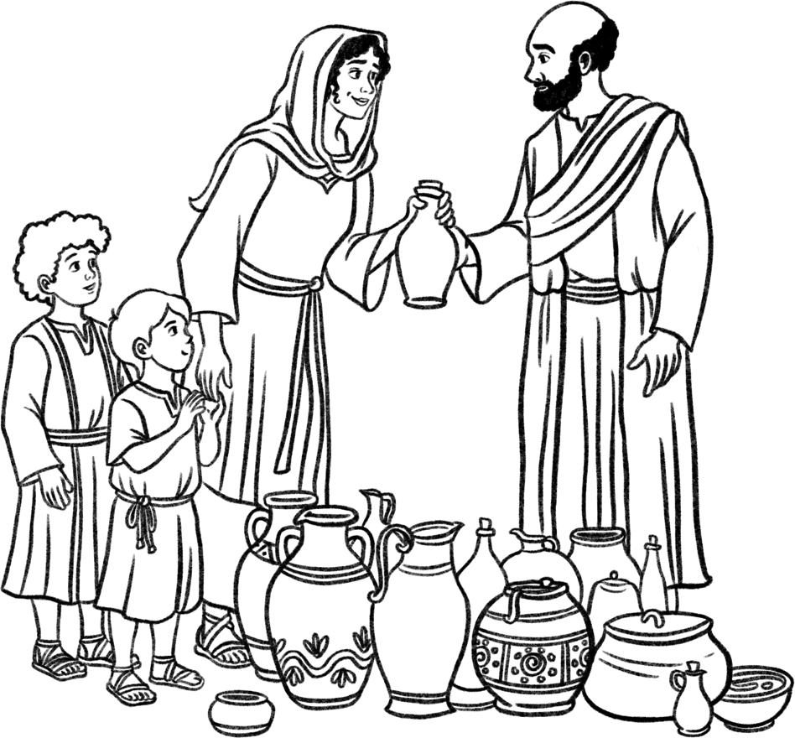
2 Kings 4 brings us into the
homes of two women in very different circumstances. One family is very poor, the other very rich. But both find themselves in desperate need and rely upon the grace of
God extended to them through
the Prophet.
These stories are heart-rending
and emotionally moving. They demonstrate the dependence we
all have upon God, no matter our circumstances. As you read these stories put yourself into the shoes of the various characters. How would you react and be challenged in
such circumstances?

Context
The Widow’s oil is the 5th miracle recorded in the ministry of Elisha. Further light is shed on the Sons of the Prophets in this account. No time marker is given; however, we are fairly certain this is in the reign of Joram / Jehoram (2 Kings 3:1).

The Widow and Her Family
This woman had been married to one of the Sons of the Prophets, and they had 2 boys who we could guess might be around 8-12 years old. Life was challenging in this family, as they had incurred a large amount of debt. The husband of this woman and father of the boys dies. It appears to be sudden, given no preparation had been made.

Let’s look at the details we are given and seek to develop a picture of what life was like for this woman and her children, both before and after the tragedy that struck this household. We want to step into the drama of the story to feel her desperation; to learn the lessons; to take encouragement and find strength.

- Similar to Elisha’s circumstances, this was a faithful family in Israel, amidst the apostacy all around. The Father was one of the Sons of the Prophets. It’s possible the mother helped in the service of this group (she was known to Elisha in 4:2). Perhaps the children attended a Sunday School of sorts.
  - Review the chart on review the Kings of Israel and Judah chart in the introduction to the workbook. Assuming this event did take place early in the reign of Jehoram, determine a timeline of when this couple possibly got married and had children. (Yes, there’s a bit of speculation in this… but it helps to get a picture of this family and the challenges they faced).

  - Review your answers to Section 1, questions 5 & 6. Develop a picture of what life would be like for this family?

  - The family was not financially well off. They were in a lot of debt and didn’t have much money. How does that further your picture of this family. What sacrifices would they have made?

- When the father dies, if you were the mother, what would be your reaction? What would be the natural (carnal) response? What worries would you have? What should the spiritual response be in such situations?

- If you were in the position of the boys, how would life now be different? What scriptural guidance might you follow?

- 2 Kings 4:1 – The woman cries to Elisha for help. There are 2 different titles given to the man who had died: “My Husband” and “Thy Servant”. How many times are each used, and which comes first? What does this tell us about this woman and her husband?

- She says that Elisha personally knew her husband, that he was a man who feared God. Consider the following verses about fearing God. How do they further expand upon our picture of this man. Psalm 112:1,5,7,9; 147:11; Mal. 3:16. Consider adding a verse of your own.

- She describes herself in 4:2 as “thine handmaid”. Who else in the OT is given this title. Perhaps this suggests a role she had of service within the “Sons of the Prophets” group. See Psalm 123:1-2.

- Sometimes we may have to make financial sacrifices for the sake of the truth and choose to live on a tighter budget. Give some examples in life today when we may choose to do this? Maybe this is taking place in your own family, or in another family in the ecclesia.

This is a fine balance sometimes. We should try not to live beyond our means. Brothers especially, need to think about providing for the family. While there are sometimes circumstances beyond our control, we should never willingly choose to become dependent upon others to provide for us financially. Scriptural principles indicate we are required to work to provide income (2 Thess. 3:10) and other family should try to help financially before the ecclesia is brought in to support (1 Tim. 5:16).
However, there are times when circumstances are such, living in debt is unavoidable. As appears to be the case for this family.

The Creditor:
- We assume the creditor was an Israelite. Was he following the law? (Lev. 25:39-42; Exo. 22:22-23). What New Testament principles come to mind? What practical lessons are we to take from this?

Elisha’s Questions
Elijah asks 2 questions. “What shall I do for thee?” and “What hast thou in thine house”. Both seem to be points of reflection. Before the provision of grace, the woman would publicly acknowledge that she was completely dependent upon Elisha for salvation; and that she was dependent upon God’s mercy as she was unable to repay the debt. Before we can receive of God’s mercy and grace through entering the waters of baptism, we must acknowledge the same.

- She had sold everything in her house except for one item... the oil. Practically speaking, this oil would be used to provide food (1 Kings 17:12) and light within the home. Spiritually, what does oil represent and why was it important it not be sold? (Exo. 25:6; 27:20; Prov. 23:23)

Instructions Given
Borrow: This word means “asked”. It can mean borrowed with an intent to return the item (as in 2 Kings 6:5 with the axe); but it can also be used with no intention of returning it (Exo. 11:2).

Collecting these empty vessels would require a lot of work and faith. Salvation requires effort on our part... not that we earn it... but God expects us to put in effort and to be people of action.

“Borrow not a few”: There’s a contrast here to the end of Elisha’s life.... 2 Kings 13:18-20, when Jehoash was instructed by Elisha to smite the ground and was condemned for only smiting a few times. God’s grace would not be extended where a half-hearted effort is only put in.

“She went from him”: Contrast Namaan’s initial reaction in
2 Kings 5:11-12, who ridiculed what Elisha had asked him to do.
This woman left not doubting, ready to do what Elisha
had instructed without question.

“Shut the door upon her and upon her sons”:
Is there an echo to Noah and the ark (Gen. 7:15-16)?
This little home in Israel becomes an ark... a type
of the household of faith... where God’s grace
would be outpoured to those who are therein
and have shut out the world.

“She poured out” – see the echo to Isa. 44:3

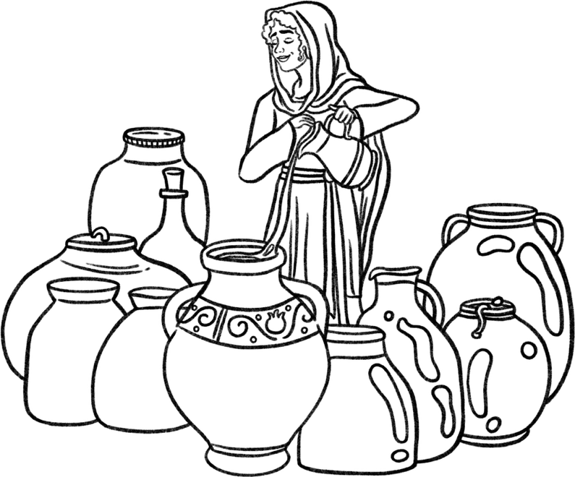

Involving Her Children
Notice how her children got involved in this activity. They were equally in a desperate situation as she. She didn’t try to shield them from this reality. Rather, she involved them in the work of salvation. It’s important that children grow up being involved in the work and service of the truth and helping out around the home. This teaches them responsibility both in the home and ecclesia.

- What are some practical ways children can help out / assist in the ecclesia?

- What is a way you as a young person contribute to the work of your ecclesia?
Are there ways you could contribute more?

- The vessels are filled up with oil, provided by God... His word, truth, and principles. What do the empty vessels represent? (see 2 Cor. 4:6-7). Consider the application to today. What’s the significance of the vessels being empty?



2 Kings 4:7 – Notice how she does not presume what to do. She goes back to Elisha and seeks direction.

The Spiritual Type
The creditor in this story compares to King Sin. We are all under the bondage of King Sin and in need of release. Do we see that need as desperately as this woman saw it?

It’s a debt that we cannot repay. Only by God’s grace through forgiveness can we find salvation. But He requires we first acknowledge our circumstance and our dependence upon Him. We must work out our salvation. We cannot stand idle.

A note of caution: We must be careful not to carry the type in this miracle too far. The Lord Jesus speaks a parable in Luke 7:41-42 about a large amount of debt. He points out that the debt is forgiven. Forgiveness implies wiping it out. It is not repaid by someone else.

Although the woman in this story is able to repay the debt to the creditor by God’s grace, that is not the case with our sins. Apostate Christendom today teaches that Jesus paid the debt we owe... that is false doctrine. Our sins are forgiven... not paid off (see ‘The Blood of Christ’ by Bro. Robert Roberts).

- What lessons do you take from this section? What is one thing you could apply to your life today?

- What further questions do you have about this section for discussion groups?

SECTION 6: THE SHUNAMITE WOMAN
Reading: 2 Kings 4:8-37
“Women received their dead raised to life again…” ~Hebrews 11:35

The story of the Shunamite woman is found both here in 2 Kings 4 but continues in 2 Kings 8. It takes place over the space of at least 15 years and therefore overlaps the timing of other miracles in Elisha’s ministry.

This woman in some ways completely contrasts the woman just presented to us earlier in the chapter. The Shunamite is a woman of wealth and importance. And yet she too has faced heartbreak and finds herself equally in need and dependent upon the grace of the Prophet Elisha.

- Look up the city of Shunem in a Bible Dictionary and locate it on the map. What do we know about this place?
  - In what tribe of Israel was it?
  - What valley did it overlook and what was taking place there at this time?
  - How far is this city from Mt. Carmel?
  - What other events occurred here in the past?


- The woman is noted for being a “a great woman” (4:8). The NET translates this word as “prominent”, while the ESV says “wealthy”. Not just in material things, but spiritually as well. Who are some other faithful Bible characters who were also blessed with wealth?

Note: Being blessed with material wealth is not a sin, but we must use these blessings to the glory of God. We’ll see how this woman used her wealth to the furtherance of the truth.

- The woman notices that Elisha passes through Shunem “continually”. Elisha was always on the move! Not only is this woman observant, but she was also hospitable. She “constrained” him to eat bread. The ESV and NASB say “urged”, while the NET says “insisted”. The Treasury of Scripture Knowledge says, “she lay hold on him”.

  - Use cross-references or the Treasury of Scripture Knowledge (TSK) to find 2 other people in the New Testament who did the same.


  - Based on these examples, and what we know about the woman, was this just about giving people a meal, or was there more to these invitations? Think of a deeper spiritual motivation and desire.

  - You may not yet have your own home, but when you do, how can invitations to share a meal in your home with other members of the ecclesia have a spiritual benefit? What would you, as the host, need to do to ensure this happens?

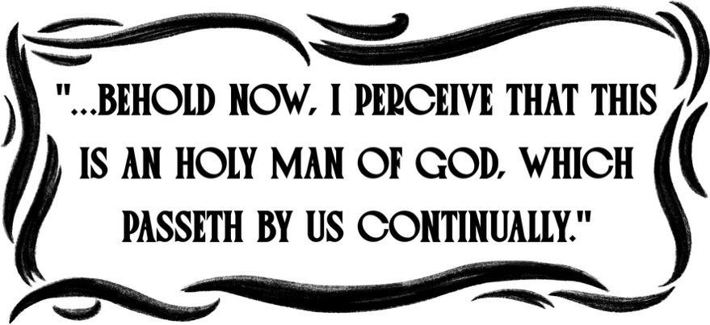

- Her observance is furthered as she notes that Elisha is a “holy man of God”. What was it that set Elisha apart? What do people see in us? How could we be noticed by others for holiness?

A Note About Her Husband
Before we proceed further, we need to address the husband of the Shunamite woman. He is presented in the record as not taking any initiative, perhaps a bit uncaring. He is certainly not the focus of the record. However, this could just be the way the scriptures wish to portray him. Consider what we do know about the man:
- Although he is described as “older”, he is still industrious. He builds the room for Elisha on the side of their house. Years later he is still working out in the field. He commands servants. He and his wife have both had to face the trial of barrenness.

- Notice that the Shunamite woman always honours her husband. Although she comes up with ideas, she NEVER moves without receiving the blessing
of her husband, even at risk of him saying no!
We must not be too critical of the husband. He is not the focus of the record. Normally in a marriage relationship, the husband is a type of the Lord Jesus Christ. But in this account, Elisha is the type of Christ. The husband is therefore put in the background and given little attention, in order that Christ and the ecclesia might
be seen in type through the interaction of Elisha and the Shunamite woman.

A Room for the Prophet
- There are different ideas about this room. Regardless, it was a room with a separate entrance.
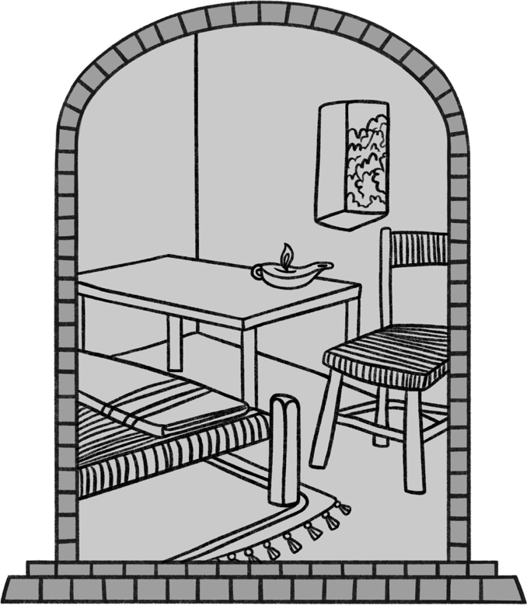
- How does the ESV and NET translate
“little chamber” (KJV)?

b) What does the Treasury of Scripture Knowledge say about this room?
(2 Kings 4 (KJV) - Now there cried a certain www.blueletterbible.org/kjv/2ki/4/1/t_corr_317010)

c) Find out where the “little chamber” comes up in the life of Elijah?

- Four items are placed in this room. They have practical application to provide the prophet with rest and refreshment; however, there is also deeper spiritual significance to these items that point forward to Christ as the King-Priest. Complete the chart.

Item | Practical Application | Spiritual Significance
Bed | Sleep / Rest: Elisha required sleep and rest on his journey. | Psalm 149:5 – the marriage bed… ie a reference to Christ and the Saints united as a husband and wife.
Table

Stool |  | The word is usually translated “throne” - a Kings throne
Candlestick

The Promise of a Son
- Elisha asks the Shunamite Woman if there’s anything that could be done for her in thankfulness for her generosity and hospitality. She responds, “I dwell among my people”. The implication being, she was content with what she had, and dwelling among people of like faith. She had not provided these things to Elisha expecting anything in return.

    - What could she have asked for or received, based on Elisha’s offers?

    - Are there times in our work in the truth when our motives may not be pure? Have you ever done some work in the truth, or shown hospitality, expecting or desiring something in return? (think of immaterial things, such as recognition or praise)

    - In a materialistic age where success is measured by how much one has, what level of education one achieves, or how high they can climb the corporate ladder, how can we learn to be content with the things we have? (Phil. 4: 11-13; 1 Tim. 6:6-8; Heb. 13:5)

    - What kind of people do we seek to surround ourselves with? Is our desire to be around our ecclesial family and those who love the truth? How do we make this happen?

- How does Elisha’s words in 2 Kings 4:16 echo the words to Sarah in Gen. 17:21? What did Sarah need to bring the promise to fulfillment? (Heb. 11:11)

Note: The Shunamite Woman’s words in 4:16 do not necessarily represent a lack of faith. She and her husband had endured a great trial of faith early in their marriage being unable to have children. Being a spiritual woman, she would have thought about other women in similar situations but also come to learn that the blessing of children is according to the will of God. Having accepted God’s will she moved on with life. But now all the emotions were being stirred up in her mind once again. Hence her words “do not lie unto thine handmaid” or “do not give me false hopes”.


- There are times in life when it can be difficult to accept the will of God. In such times, we may turn inwards or even rebel against God in response. Some people have left the truth because they couldn’t accept God’s will. How can we maintain a spiritual perspective in such situations?

A Day of Tragedy
The Shunamite Woman was blessed with a child, and now the record jumps ahead 7-9 years into the future (1 year for conception, and we assume the child is now 5-8 years old). We can imagine how grateful this husband and wife were every day for the child. This faithful woman would teach her child the promises of God, and we can picture Elisha watching the child grow as he continued to find rest at this home on his travels.

But the woman’s faith would be tested again through one of the greatest trails a parent may ever have to endure. But her faith shines through and it’s her response in this instance that gains her recognition in Hebrews 11.

We propose the child is between the age of 5-8 years old, as he’s old enough, he can go out to the field on his own; but still not so old as to sit on his mother’s lap.

- Consider the timing of this miracle – the time of harvest.
    - What spiritual lessons would the child learn from his parents about the field? Consider Deut. 24:19, Lev. 23:22, Gal. 6:7-8. Add more if you wish.

    - What was the harvest time symbolic of that connects well with this account? (Matt. 13:39, 1 Cor. 15:23)

The child complains to his father “my head, my head”. Looking at the symbology of this account, Elisha is a type of Christ who will raise up this child to walk in newness of life. The child is literally raised up in the time of harvest, symbolic of our resurrection. The child represents us in this story, and the need we are in.

- What is the head symbolic of, and how is that related to death and the need we are in?

Today, the loss of a child when they are young before they have been baptized is heartrending and can be very difficult to accept.

Her Faithful Response
- What gave the Shunamite woman confidence that Elisha could help in this time of need? Consider whose actions she was mirroring when she laid her dead son on Elisha’s bed. (Look at cross references and consider Hebrews 11:35)

- She “shut the door” (2 Kings 4:21) of the prophet’s room. The record goes out of the way to tell us this, and it’s emphasized again in verse 33.
    - What previous miracle had been performed by Elisha with a shut door?

    - Refer back to the notes in this workbook to that incident. What does the shut door signify?

- She now seeks blessing of her husband to go on this journey. We noted earlier that her husband is in the position of leadership, and her request could have been denied. It’s interesting the record doesn’t indicate she actually told her husband what had happened!

    - What does this indicate about her faith? (cp. Matt. 22:31-32)

    - What does the husband’s response in verse 23 suggest about this family’s routine?

The Journey to Carmel:
The journey was about 40 miles round trip to Mount Carmel. This also suggests that Mount Carmel was where Elisha made his home in Israel, not without spiritual significance from the days of Elijah.



- In verse 27, it had been hidden from Elisha what had transpired at the Shunamite’s home. How does this contrast 2 Kings 6:12? How was this a test for Elisha’s faith as well?

Bullinger’s Companion Bible suggests her coming to Elisha is the centre of a chiasm:

v. 8-17 - Son given
v. 18-20 - Son’s death
v. 21 - Elisha’s bed
v. 22-24 - Her mission to Elisha
v. 25-27 - Her arrival
v. 28-31 - Her conversation with Elisha
v. 32-33 - Elisha’s bed
v. 34-35 - Son raised
v. 36-37 - Son restored

- Whose words does she use in verse 30 when speaking to Elisha?

Raised To Newness of Life
- Elisha sends Gehazi with his staff to awaken the child. What other miracles were performed in scripture through the use of a staff or something else that either belonged to a Godly individual or had come in contact with the Godly person? (consider TSK cross references)

- The record would seem to indicate she knew that her son could not be raised by Gehazi carrying Elisha’s staff. What past events would indicate this? And as this event points to Christ, why could the child not be raised through use of a proxy (such as the staff)?

- Coming to the house, Elisha finds the child dead upon his bed. The process to awaken him was not easy, nor immediate… it was an agonizing process involving prayer, walking to and fro, and laying upon the child.
    - How does this echo Christ’s work of redemption? (Heb. 5:7)



    - What’s the spiritual significance of laying upon the child… mouth to mouth, eyes to eyes, hands to hands? How does this relate to our relationship with Christ if we are to find newness of life in him?

    - The child sneezes 7 times. An echo perhaps back to the 7 prayers of Elijah in 1 Kings 18:43-44. What might the significance of this be?

- Read v37 and comment on the order of the events. Is her actions the natural response or spiritual?

“In the face of tragedies like this many of us would have lost faith, harbouring bitter thoughts and resentment, and wondering why God should allow such things to happen to faithful servants. It is hard, in similar circumstances, to view such calamities as ‘chastening’ by which we should be rightly exercised. We know very well all the Scriptures that bid us boast not of tomorrow, as we know not what a day brings forth; and yet, when the clouds of sadness come over all our sky in the noonday, we can feel forsaken and rebellious. Yet it
is precisely at these times that we need the faith which we ought to have nurtured in happier days; we need the company and comfort of the greater Elisha every step of the way.” (Bro David Wood, Elisha: The Neglected Prophet, p 47-48)

- What lessons can we learn from this section?

- What further questions do you have about this section for discussion groups?

“Yahweh Hath Called for a Famine”
The “dearth in the land” in 2 Kings 4:38 is most likely the same famine Elisha predicted in 2 Kings 8:1, that would last for 7 years. This famine would likely extend through the remainder of the reign of Jehoram and into the reign of Jehu.

⏳ A Possible Chronology
2 Kings 4:8–17
2 Kings 5–7
2 Kings 4:18–37
2 Kings 4:38–44
2 Kings 8:1–6

⚖️ Purpose of Famine
“When the land sinneth against God by trespassing grievously, then will I stretch forth Mine hand upon it, and will break the staff of bread thereof,
and will send famine upon it…”
Ezekiel 14:13
Leviticus 26:26-27
2 Samuel 21:1

🌈 God’s Promise
“Behold, the eye of the LORD is
upon them that fear Him, upon them that hope in His mercy; to deliver their soul from death, and
to keep them alive in famine.”
Psalm 33:18-19

🌾 Spiritual Significance of Famines

Genesis 3 - The earth was cursed as a result of sin entering the world. The physical creation reflected the moral condition of mankind.
Romans 8:22 - The earth is personified as groaning because of immorality, and longing for the day when her release will come.
A famine on the land is often associated with the wicked and immoral condition of man.
Today, as the morality of mankind
descends further from God’s standards,
the physical creation groans more and more with increased natural disasters

📖 Famine in Scripture
Abraham – Gen 12:10
Isaac – Gen 26:1
Joseph – Gen 41
Ruth – 1:1
David – 2 Sam 21:1
Elijah – 1 Kings 18:2
Elisha – 2 Kings 4:38; 8:1; 7:4
Zedekiah - 2 Kings 25:3
Neh 5:3
Acts 11:28



SECTION 7: THE RETURN OF THE

SHUNAMITE WOMAN
Reading: 2 Kings 8:1-6

Background
2 Kings 8:1-2 appears to follow close on the heels of the events of chapter 4
and likely align with the dearth of 4:38. 2 Kings 8:3-6 takes place 7 years later.

After facing a trial of not being able to have children, followed by a test of faith believing that through the prophet they could have a child, and the greatest trial in the death of their son, this couple would be tried three more times: First, leave their home and all that was familiar to them; Second, face whatever difficulties were to await them in the land of their sojourning and not to become too comfortable; and third, upon their return home, to find that squatters had taken over their inheritance.

Amidst these trials the Shunamite woman likely also faced the death of her husband, for there is no mention of him upon their return at the end of the seven years.

The Shunamite woman will again show a steadfast faith and a love for her God
and His inheritance.

Elisha’s Instructions
- Why does Elisha provide the instructions to the woman, and not to her husband since he is the head of the family? Think again about the symbology of who the characters represent.

- Put yourself in the shoes of this woman and her family being given this request. It was not easy. What questions would come to mind? What concerns? How would you face such a situation?

- Have you ever had to do something for the sake of the truth that was difficult, challenging or brought a lot of uncertainty? (If not, are you aware of others that have faced such situations)

We picture the woman, her husband, her son and perhaps others of her family
or servants leaving behind the family property. They’ve packed up all the things they will take with them, prepared the home for a long departure. As they set off down the road she remembers all the fond memories had there: Elisha passing the home and the little room they built for him; the meals shared around the table in the presence of the prophet; the birth of their promised son; raising that son; the tragedy that struck the family and the joy of receiving a son revived from
the dead.

Where to Sojourn?
- Where would her mind go in scripture when told there would be a 7-year famine? When had this happened before and to who?

- It was not to Egypt that she would go. The family sojourns in the land of the Philistines. Perhaps she thought of another echo in the same part of scripture to know where to go. Read Genesis 26:1-6, 12-14.
  - Whose example was she following? What similarity did this person have with her son?

  - What lessons would she learn from this person’s example about how she should live among the Philistines?

- She “sojourned” in the land of the Philistines.
  - How does this word relate to the characters referred to in questions 4 & 5? How does this further our understand of how the family would live for the next 7 years? What mindset would they have to maintain? (Exo. 6:3-4; Hebrews 11:9-10, 13-16)

  - How do the same principles relate to us today? (1 Peter 2:11-12)

  - Provide specific examples of how we can be strangers and pilgrims in our school or workplace, in our home, in relation to politics, etc.

- Upon returning to the land 7 years later, she finds that her home has been taken over by squatters. It is now necessary for her to cry unto the King for her house and for her land. She loved her inheritance. Who else in scripture had a love for their inheritance and refused to give it up?

Who was “the King”?
- To make this determination, we must gather the facts and build a timeline. Answer the following questions and then build out a timeline.
  - How long did Jehoram/Joram reign? (2 Kings 3:1)

  - Who succeeded Jehoram and how long did they reign? (2 Kings 10:36)

  - Draw the timeline of the Shunamite woman noting the following events:
    - Noticing Elisha and inviting him into their home
    - Building a room for him, and his prophecy that she would have a child
    - Conception and Pregnancy
    - Birth of the boy
    - The boy to grow to about 5-7 years old
    - His death & resurrection
    - Instructions given to leave her land
    - 7 years of sojourn
    - Return to the land & making her plea to the King

  - Who is most likely the King?

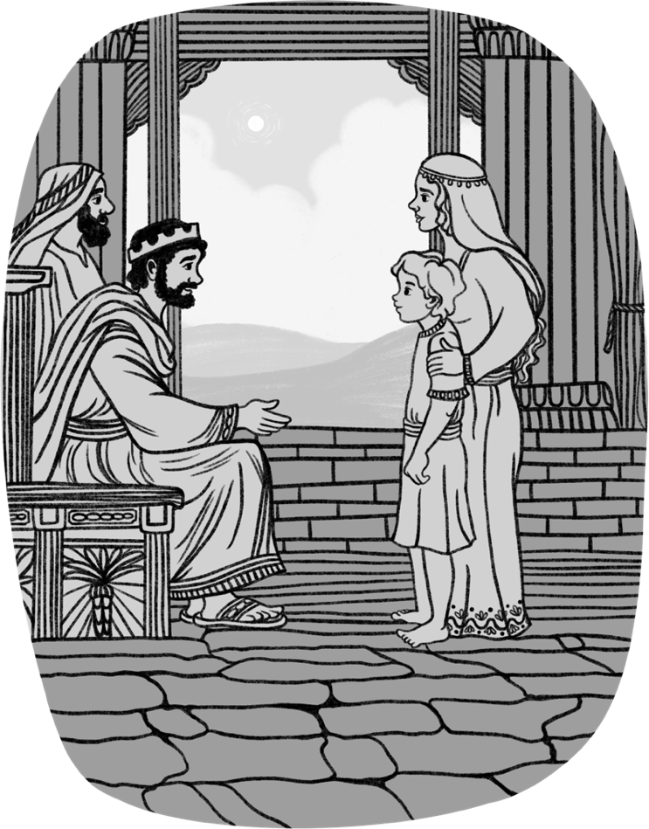
Divine Providence
We can imagine the trepidation she must have felt as she made her way to Samaria to make this plea to the King. Her prayers must have ascended first to God to give her the words to speak and to bless her request. Yet unbeknownst to her, God was already at work preparing the King for her coming! This is surely a great act of divine providence recorded in the scriptures. At the very moment of her arrival, the King had just been speaking to Gehazi about the acts of Elisha, and Gehazi had just been recounting the raising of her son!

- Reflect upon your life.
Do you take every matter in prayer to God? Can you think of a time in your life when you could see the Father’s hand at work, directing your steps? (Perhaps if you can’t, you might want to ask an older brother or sister in the meeting for an example in their life).

- The King not only blesses her request but orders that she was to be restored “all that was hers, and all the fruit of the field since the day that she left the land, even until now”. What a blessing! Consider the echo in Matthew 19:29 and compare the hundredfold blessing to Gen. 26:12 which we noted earlier. What lessons can we take from this?

- Are there other lessons we can learn from this section?

- Consider the two accounts of the Shunamite Woman, and how they type the two advents of Christ. To see this more clearly, consider the Shunamite’s Son as the type of Christ.

2 Kings 4 – Type of Christ’s 1st Advent | 2 Kings 8 – Type of Christ’s 2nd Advent

- Are there other questions or observations from this section you have?

SECTION 8: DEATH IN THE POT
Reading: 2 Kings 4:38-40
The next 2 miracles to appear in the record are only a few verses long. Yet full
of significance.
Both occur during the famine mentioned in 4:38 and take place at Gilgal.

What phrase in v41 and v43 links the 2 miracles together?

Location: Gilgal – Likely the same as 2 Kings 2:1, just to the North of Bethel
(see map in the introduction to the workbook)

A Time of Famine: The whole miracle must be viewed in the light of the famine:
- Food was scarce, ingredients hard to find
- Nothing must be wasted
- A huge disappointment if the whole stew had to be thrown out. Tempers could flare.

Things to Ponder:
- If this is the same famine as mentioned in 8:1, why is the Shunamite woman told to go sojourn somewhere else, yet the sons of the prophets were not?

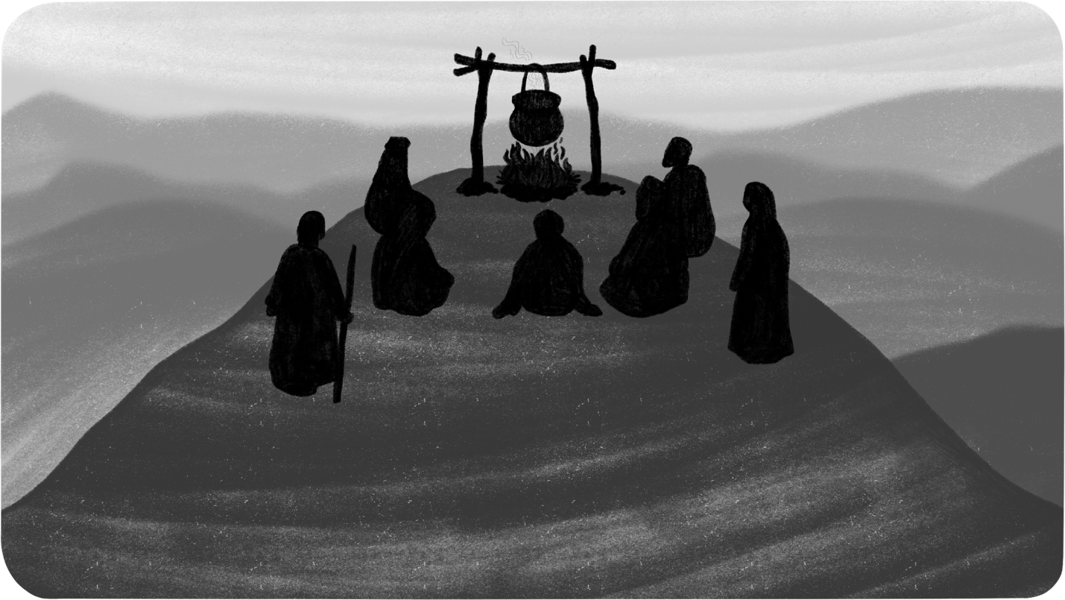
Sitting Before Elisha (4:38):
- What examples do we have of others sitting at the feet of someone, learning the word? (Hint: Use the Treasury of Scripture Knowledge to find good cross references)

- How does this expand upon or confirm our understanding of Elisha’s role amidst the Sons of the Prophets?

- In this time of hardship, what did the Sons of the Prophets continue to do? (Heb. 10:23-25) What is the lesson for us today.

At this time of famine when the literal bread was scarce, there was no famine of the spiritual bread amidst this group (cp. Amos 8:11-12), for they recognized the principle that man does not live by bread only. (Deut. 8v3)

“Put on the large pot and boil stew for the sons of the prophets” (NASB)
  - Just as Christ saw the need of providing some physical nourishment to the people after they had been spiritually fed, here Elisha foreshadowed that pattern.
  - His servant → presumably Gehazi

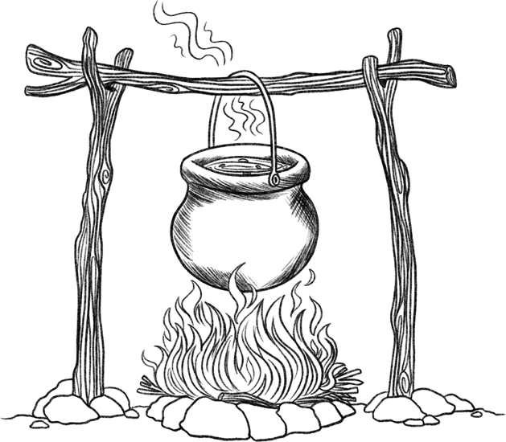

- In Ezekiel 24:1-14 a parable is given about a pot and the scum therein. What does the pot and its contents represent in this passage?

Using the principle of Ezekiel 24 and applying it to Elisha’s day, the pot of stew can be seen as symbolically representing the company of the Sons of the Prophets... this little ecclesia.

“One Went Out” (5:39)
  - Who is this “one”? Was it another servant who was present? Was it one of
the Sons of the Prophets who got up and left the group, in order to ‘help’ contribute to the pot?
  - Note that “one” is used of the Sons of the Prophets in 2 Kings 6:3, 5

- The original intent of the search was to gather “herbs”. Look up this word in Strongs. What does it mean? What is it associated with in Isaiah 26:19?

In contrast, he found wild gourds.
The Treasury of Scripture Knowledge has this to say:
“The word pakküôth, from peka, in Chaldee, to burst, and in Syriac, to
crack, thunder, is generally supposed to be the fruits of the coloquintida, or colocynth; whose leaves are large, placed alternately, very much like those of the vine, whence it might be called a wild vine: the flowers are white, and the fruit of the gourd kind, of the size of a large apple, and when ripe, of a yellow colour, and a pleasant and inviting appearance.
It ranks among vegetable poisons, as all intense bitters do; but, judiciously employed, it is of considerable use in medicine. It is said that the fruit, when ripe, is so full of wind that it bursts, and throws its liquor and seeds to a great distance: and if touched, before it breaks of itself, it flies open with an explosion, and discharges its foetid contents in the face of him who
touched it.”

- The idea of “wild” fruit comes up in Isa. 5:4,7 and Jer. 2:21. Look up each passage. What does it symbolize?



  - “His lap full” = “enough to fill up the fold of his robe” (NET)
  - “For they knew them not” = “not knowing they were harmful” (NET)
The contributions of this “one” were likely innocent. We do not get the impression
he was intending to poison the stew. He saw something that looked pleasant to the eyes, and a lot of it, he brought it back, and without asking anyone’s advice, simply shred them into the pot.
Lesson: Sometimes something might be brought into the ecclesia rather innocently... a new idea or activity. There may be nothing seemingly wrong with
it on the surface, but the long-term consequences could be deadly. It is always
good to pass new ideas by more experienced brethren to get their thoughts.
Remember: you may not always agree with their assessment, and one ecclesia’s assessment of a matter may differ from that of another. We mustn’t become discouraged in such circumstances. Some may be more cautious about things
than others or have different experiences. The motivation is simply to ensure
nothing comes into the ecclesia that could have unintended consequences.

- Upon reflecting on the above statement, can you think of any scriptural examples where something seemingly innocent was brought into the ecclesia, that had long-term deadly consequences?

“Just as this miracle is set in a time of famine, so we live at a time of famine of the hearing of the Word of the Lord. Men and women are still digesting the poisons of falsehood, and are feeding off the wild vine of humanism, evolution and materialism and the deadly gourds of wrong beliefs and principles.”
(Bro. David Wood, Elisha The Neglected Prophet)

“They Cried Out”
- Look up the following passages where this word is used. How would you describe
this “cry”?
Passage | What is the “cry”?
Gen 41:55
Exo 14:10
2 Kings 4:1
2 Kings 6:5
2 Kings 8:5
“The righteous cry, and the LORD heareth, and delivereth them out of all their troubles.” (Psalm 34:17)

“Bring Meal”
Everyone, the whole ecclesia, was affected by the poison in the stew. Now everyone in need of healing is going to be involved in the divine outpouring of grace in the healing of this pot. We have seen this pattern before in Elisha’s miracles: those in need are required to do something. Not to earn their salvation, but to be involved in the work of their salvation.
A simple solution. Just like the addition of salt to heal Jericho’s waters (2:20) or a stick thrown into the water to recover the axe head (6:6), here meal would be added to a pot of stew. Cp 1 Cor. 1:27.

- How would this act of bringing meal demonstrate faith? (especially at this time)

- In considering a big picture application of this miracle, consider Romans 5:18 and how it relates to these events?

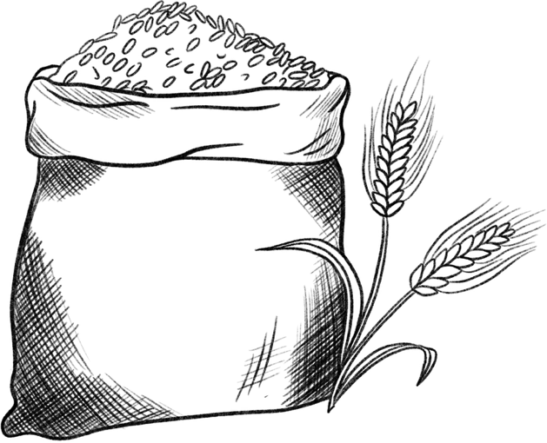

- What lessons can we learn from this section?

- What other questions do you have?

SECTION 9: BREAD OF THE FIRSTFRUITS
Reading: 2 Kings 4:42-44
As noted previously, this miracle needs to be viewed as connected to
the previous miracle.
Where the death in the pot miracle spoke of the weakness of the flesh, sin and death, and the necessity of a saviour; the Bread of the Firstfruits will speak in symbol of those who the saviour would redeem through the power of the Word and resurrection.
The character of the saviour and those who he will redeem are seen in the faithful man from Baal-Shalisha.

The 3 Individuals in this Passage Are:

1.

2.

3.

(Look up the word “servitor” and suggest who this might be)

Baal-Shalisha:
Tribe: _______________
Likely the same as Shalisha = thirds
- It lay in the 3 tribal areas of Benjamin, Ephraim and Manasseh
The one other place “Shalisha” is mentioned in scripture, where it is associated with that which is lost:
_________________________
“Baal” was likely added to the name of this place to associate it with idolatry.
Located 4.5 miles from Gilgal
The Man of Baal-Shalisha
- The man who comes from Baal-Shalisha, had sown and reaped in a time of famine and drought. He was obviously blessed by God. Compare Gen. 26:1-6,12. Drawing parallels between this man and Isaac, what can we infer about the character of this man and how God viewed him?

- This man takes of his provision and presents it to “the man of God” and those who are with him. This is not what one would naturally do if they received a plenteous crop in time of famine! What does this say about this man and what lessons can we learn? (Compare Prov. 3:5-10)

- This man is unnamed in the record. What might this infer practically about his character? In not naming him, how is the record able to link this man and Elisha together? (How is Elisha referred to in this passage).

In symbol, both “a man” and “the man” in this verse foreshadow the Lord Jesus Christ in character and work. The echo to Isaac in Gen 26 further emphasizes this, for Isaac is presented in the Genesis record as a type of Christ (Gen 22 – the offered son; Gen 24 – the husband). By extension, the character of this man is one we all should seek to follow.

This man of Baal-Shalisha stands apart from those in his hometown, for he was neither lost, nor a worshipper of idols. He humbly and selflessly submits himself to God and earnestly desires to further God’s work with Elisha and the Sons of the Prophets, amidst an idolatrous nation.

Bread of the Firstfruits:
To further appreciate what this man from Baal-Shalisha was doing, and the symbolism of this miracle, we need to trace back this phrase “bread of the firstfruits” and what it was associated with.

- This phrase is only found elsewhere in Lev. 23:15-22. What feast is being referred to in this passage? What is this feast called in New Testament times? (Acts 2)

- As part of this feast, the bread was to be presented to the priest. Yet at this time there were no faithful priests left in the Northern Kingdom! Why is it fitting that he should bring it to Elisha? (Think who Elisha typifies. Compare Acts 2:22,36)

- At this feast, two wave loaves were to be offered, representing Jew and Gentile. How does the preaching of Peter on the day of Pentecost anticipate the gospel message going to both groups? (Acts 2:21)

- Who are referred to as the “firstfruits” in James 1:18 and Rev. 14:4? By what means did they attain this position as firstfruits? (James 1:18; Rev. 14:1)

- In Lev. 23:22, what group of people were specifically to be remembered at this time as they reaped the fields? How did this man of Baal-Shalisha do exactly this?

- Now consider the teaching of Pentecost in Deuteronomy 16:9-12. Comment on how these things played out the events of this passage in 2 Kings 4 and practical lessons for us.
Deuteronomy 16 | 2 Kings 4 | Lessons for Us
16:10 – How much bread was to be offered? | This man freely brought his offering of bread. | See 2 Cor. 9:7
16:11 – Where was this to be brought? | Jerusalem may not have been accessible to those in the North. Regardless, this man saw a type of the greater ecclesia in the company of Elisha and the Sons of the Prophets, who would be assembled on Mt Zion in the future (Rev. 14:1) and make up the New Jerusalem. | See Acts 2:41-47
16:11 – With what spirit was the offering made? And who was involved? |  | See Acts 2:41,46-47
16:12 – What were they to remember on this occasion? |  | See Acts 2:42,46
The Work of Christ Typified:
- The bread symbolizes a body made up of many individuals (1 Cor. 10:17),
but also speaks about the Word of God (Deut. 8v3).

- The feast of Weeks (Pentecost) is directly linked in the scriptural record with the feast of firstfruits, which symbolizes Christ’s resurrection (1 Cor. 15:20).

- The two wave loaves speak of the multitude of the redeemed in Christ, both Jew and Gentile, who have been born again and renewed in spirit and mind through the working of God’s word, to the end that the Father’s name is written on their foreheads.

- The bread of the firstfruits was made with leaven (Lev. 23:17), for unlike their saviour, we do sin; and this bread was offered alongside many other animals for burnt, sin and peace offerings. Through the forgiveness of sins, both Jew and Gentile have been reconciled to God (Eph. 2:1415).

- The feast of Pentecost was the only feast where peace offerings were mandatory. Peace offerings were made of male or female lambs and didn’t need to be perfect. They symbolize us, and the peace we have received in Christ through the forgiveness of sins.

The Feast of Firstfruits | The Feast of Weeks (Pentecost)
Barley | Wheat
No Leaven | Leaven

The offering of the man of Baal-Shalisha was not exactly that required in
Leviticus 23. There were no animals offered, and the loaves of bread were made of barley rather than wheat. But the record evidently wanted us to see the connection to the Feast of Weeks for what the bread symbolized on that occasion.

Other Considerations:
We won’t ask questions about these things but will put them here for contemplation.
Why 20 loaves? Could this symbolize 2 groups of 10... 2 complete groups?
Why did he bring Barley loaves and not wheat? Is barley all that could grow at that time? Are we meant to see a link to the Feast of Firstfruits? Note: This is the same as the feeding of the 5,000.
The phrase “full ears of corn in the husk” is translated in other translations as “fresh grain in his sack”, where “ears” in the KJV is considered to be ears of grain, rather than corn. This would align it with the Feast of Firstfruits and the barley grain offered on that occasion.

- What further questions do you have about this miracle?



- What lessons can we take from this miracle?

The Challenge of the Chronology: 2 Kings 5-7
The timing of the events in 2 Kings 5 has posed many questions and
challenges, particularly as it relates to Elisha’s servant Gehazi. At the end of chapter 5, Gehazi “went out from Elisha’s presence a leper as white as snow” (5:27). Yet Gehazi shows up again in the court of the King in chapter 8:4. This has led some to suggest that the events are not in the correct chronological order, while others have put forward that Gehazi found repentance and was healed of his leprosy.
Let’s weigh the evidence!

The King of Syria
There is no indication in the record of 2 Kings that either the Syrian King or Naaman (his top general) knew about the prophet in Israel. Elisha’s words in 2 Kings 5:8 seems to confirm this. This Syrian King is most likely one of the Benhadad’s in Elisha’s ministry, as Hazael knew Elisha from the beginning of his reign (2 Kings 8:7-15), likely being anointed by him (1 Kings 19:15).
Supposing 2 Kings 5-7 are in chronological order, Benhadad is confirmed to be the King in 2 Kings 6:24. We suggest chapter 5-7 are in chronological order, as there are connections between them:
1) The Bands of Syria
The word “companies” in 2 Kings 5:2 is the same as “bands” in 6:23, linking these 2 chapters together.
After 6:23, the companies / bands (marauders) of Syria came “no more into the land of Israel” (6:23). Tactics changed to favour full-on warfare!
2) The Servant of the King of Syria
How does the servant to the King of Syria in chapter 2 Kings 6:12 know who Elisha was and that he has omniscient powers?
We suggest this was based on the events of chapter 5.

Contextual Similarity Between Chapters 5 & 6
2 Kings 5 | Similarity | 2 Kings 6
5:5-7 | King of Syria vs King of Israel | 6:8-12
5:2 | Syrian “companies” | 6:23
5:4 | Servants of the King | 6:12
5:8 | The Man of God | 6:12,15
5:20 | Servant of Elisha | 6:15
5:7-8 | King afraid | 6:11
5:26 | Omnicient Power | 6:12
Which Benhadad? There are two Kings by that name in Elisha’s ministry: Benhadad II or Benhadad III.
Option 1: Benhadad II
Early in Elisha’s Ministry, in the reign of Joram / Jehoram
This is the much more likely scenario.
Events happen chronologically, generally where they appear in scripture. We’ve already suggested a slight alteration to the chronology on page 62.
Benhadad II doesn’t seem to know who Elisha is in chapter 5, but is clearly aware of him by chapter 8. He calls for Elisha when he is sick! This would be based upon his interaction with Elisha in chapters 5 and 6.
The King of Israel would be Jehoram, who although he had met Elisha in the events of 2 Kings 3, had been left unimpressed by these events, and in fear of the King of Syria (2 Kings 5:7). King Jehu (his successor) was not a man of this character.
Gehazi would be a relatively young man when afflicted with leprosy. This seeking out of material wealth seems much more fitting for a man with many years ahead of him, rather than an old man with not many days left to live.
Option 2: Benhadad III
Late in Elisha’s Ministry, in the reign of either Jehoahaz or Joash/Jehoash.
Benhadad III was successor to Hazael, mentioned in 2 Kings 13.
This would make Elisha an old man in his 80’s, and Gehazi likewise an older man, yet rather fit given that he is “running” after the chariot of Naaman (2 Kings 5:21).

The only reason for suggesting Benhadad III is for 2 reasons:
- The Syrian’s were an adversary to Israel in those latter years (2 Kings 13:3
- The King of Israel’s fear of the Syrian’s would fit the character of these Kings
- If 2 Kings 6 does follow after 2 Kings 5, then the King Joash’s mention of the “horses and chariots of Israel” is a direct reference to what Elisha’s servant saw in 2 Kings 6:17

The Syrians
Sources: The Syrians | Journey Through the Bible by V. Gilbert Beers Nelson’s Complete Book of Bible Maps and Charts
- Also known as the Armenians
“The Syrians were military rivals of Israel from the time of Saul (1 Sam. 14:47) until Syria was overrun by the Assyrian empire in 732 B.C.”

- Syria = The Highland
- Capital City = Damascus
- Cruel in Battle → 2 Kings 8:12; 13:7

Kings | Dates Scripture References
Hezion (Rezon) | 990-930 B.C. | 1 Kings 11:23,25; 15:18
Tabrimmon | 930-885 B.C. | 1 Kings 15:18
Ben-Hadad I | 885-860 B.C. | 1 Kings 15:18,20
Ben-Hadad II | 860-841 B.C. | 1 Kings 20; 2 Kings 6:24; 8:7,9,14
Hazael | 841-801 B.C. | 1 Kings 19:15,17; 2 Kings 8; 9:14,15; 10:32; 12:17,18; 13:3,22,24,25
Ben-Hadad III | 807-780? B.C. | 2 Kings 13:3,24,25
Rezin | 780?-732 B.C. | 2 Kings 15:37; 16:5,6,9  (cf. Isa. 7:1,4,8; 8:6;9:11)
Table reproduced from Nelson’s Complete Book of Bible Maps and Charts–p126
Note: Depending on the resource used, dates may slightly differ, and some would suggest Ben-Hadad I and II were the same King.
“There was good reason why Syria and Israel were always locked in a power stuggle. Damascus, Syria’s capital, wanted to increase its trade, but Israel controlled all of the important caravan routes to the southern countries of Egypt and Arabia. On the other hand, Israel’s trade to the north was limited due to the strategic location of Syria’s capital. Through Damascus ran all the vital trade routes from the wealthy countries of Mesopotamia. When Ahab defeated Ben- Hadad for the second time, he forced the Syrian king to allow Israelite traders into Damascus.” (Beers)

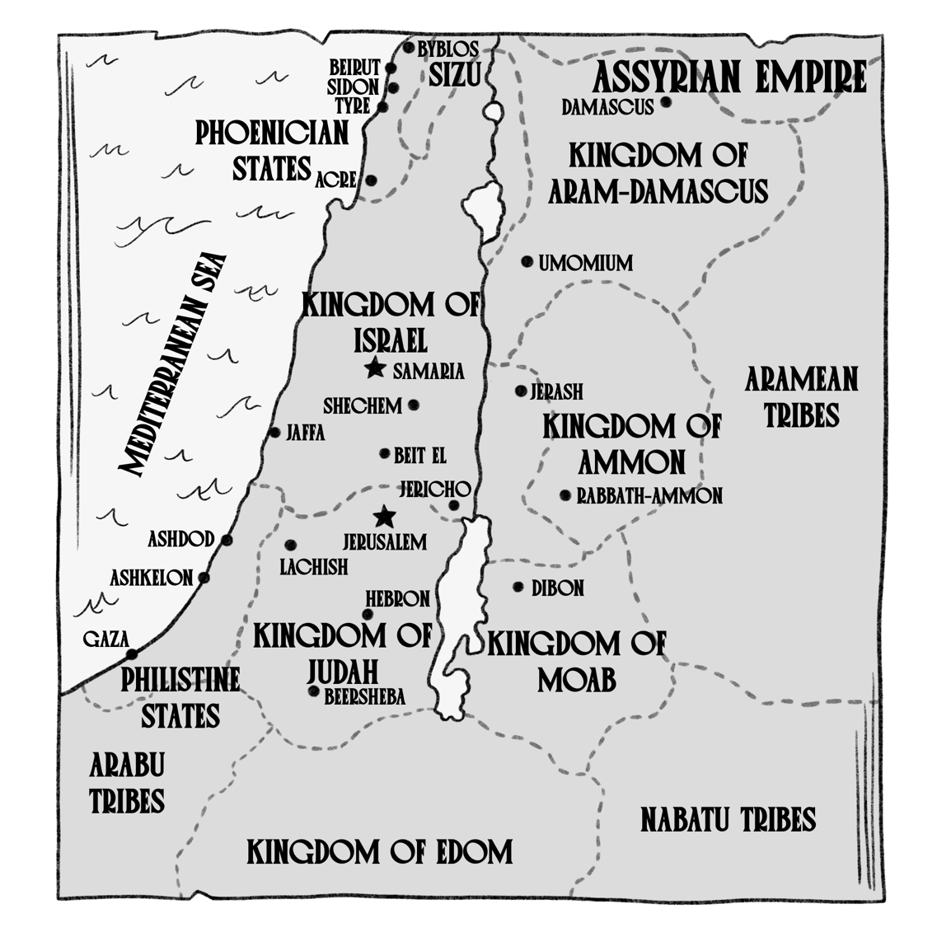

Approx. 800 B.C.
Rimmon – god of Syria
“In other parts of Syria and Canaan, probably this same god was called Baal or Hadad, and is known as the god of storms and rain. Rimmon was simply a local name for this popular god that was worshiped throughout the Middle East. The god is usually pictured as a thunderbolt or a bull.” (Beers)

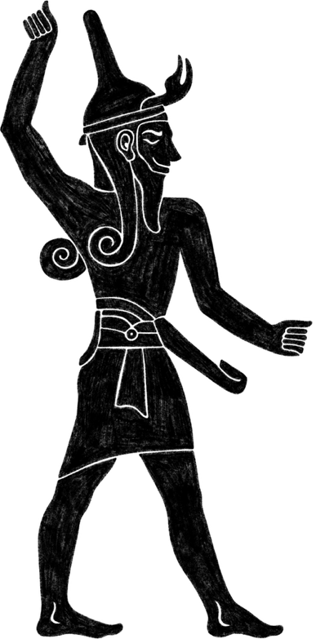

SECTION 10: THE HEALING OF NAAMAN
Reading: 2 Kings 5

Characters:  1. There are at least 8 or 9 characters in the story of Naaman. List them. | New Testament References:  - What passage in the NT mentions Namaan and in the context of this reference, what quality did he display allowing the healing, in contrast to the people of Jesus’ day.  - What healing of Jesus involved lepers, and how does one of the characters in that account bare similarity to Naaman.

Leprosy
“A vile fleshly disease, causing suffering, separation and death: surely this speaks, in symbol, of sin” ~ Bro. Jonathan Cope, A Light Unto The Gentiles, p169

"Leprosy is as repellant to us as sin must be to the Lord" ~ Bro. David Wood, Elisha the Neglected Prophet, p58
“A person with leprosy was often driven from town and forced to live in caves or ‘leper’ villages. This seems cruel, but it was the only way a community thought it could protect itself against the disease. Until healed, a person with leprosy lived as an outcast from society, not hated, but greatly feared.” ~ Beers, Journey Through
The Bible


Naaman – His Position & Family:
Name means: Pleasantness
Position: Captain of the Host / Army Commander
Noted For Being:
- A Great Man with his master / in the view of his master
- Honourable = distinguished or exalted
- A Mighty Man in Valour
- Who are some notable men in Israel’s history that held this position of “Captain of the Host”? (This might give you the sense of the duties Naaman would have, his role and close relationship to the King)

- Who else in scripture is noted as being a “mighty man of valour”?

- Who else in scripture is noted as being “a great man”?

- As Captain of the Host, what did part of his job entail in service to the King? (5:18)

- Was he an approachable man by his servants, even in times when he was angry? How did they address him? Did he respect the advice of the men he had the charge over? (5:13-14)

- What impression do you get of Naaman by how the little maid cared for him, despite the fact that he was the enemy? (5v3)

- Was he a man who showed gratitude and cared for others? (5:15,23)

- Was he stubborn or teachable? (5:15,17)

- Despite many positive character traits, he still did exhibit anger and wrath in 5:11-12. This characteristic would need to be worked on. Given his position as army commander, the luxuries he was accustomed to, and perhaps the “prophets” he was accustomed to at home, is his anger completely unreasonable from a natural perspective?

- What New Testament soldier might we compare Naaman to? (Acts 10:1-2)

- If someone were to assess your character, what positive things would they note? What characteristic(s) might you need to work on?



“By him, the LORD had given deliverance unto Syria” (5:1)
There are many times in scripture God uses a foreign army to bring judgment upon His people for their waywardness. Consider Isa. 10:5-7,12. God would use the Assyrian army to judge His people. Yet He still holds them accountable for their actions and will bring judgement upon them.
This is a theme explored more in the prophecy of Habakkuk.

- It is suggested by Josephus that Naaman was the one in 1 Kings 22 who killed King Ahab. Supposing this is true, what is the word for “at a venture” in 1 Kings 22:34, how is it most commonly translated and how does that fit with the character of Naaman?

The Little Maid & Her Providential Witness
“Little”: This word does not necessarily mean she was little in age but could also denote one of little or lesser significance. This word is used of Benjamin in Gen. 44:20 when he was in his 30’s.
“Maid” = damsel
- Who else in scripture is referred to as a “damsel”?

Put yourself in the shoes of this girl, as her village is suddenly attacked. She hears the screams of horror as her neighbours, and perhaps her friends, are slain. She’s suddenly captured and carried off to a foreign land. What about her family? Were they still alive? Did they see her carried off? Did they know what happened to her? Would she ever see them again?

- It is not unreasonable that as she is carried off, she thought of another young man in similar circumstances… Joseph. Complete the chart drawing parallels between this Little Maid and Joseph.

Little Maid – 2 Kings 5:2-4 | Joseph
Suddenly became a captive (5:2)

 | Came into Potifar’s Service Came into the Jailor’s Service
 | Declared his faith to those around
Cared for the well-being of her master

She was trustworthy

Through her faithful witness, a man found repentance and salvation.

- What would she learn by thinking upon Joseph and his example? How would she conduct herself? What would be the natural way to react in such a situation?

- In circumstances where we might feel we have been wronged, or unfairly treated, how should we react?

- Asides from Miriam’s leprosy (which was healed by God), there is no other example in scripture of a prophet healing leprosy, let alone a gentile’s leprosy! What does this reveal about the faith of this little maid?

- Just as there was a purpose to Joseph’s trials, so too there was for this little maid. God had evidently brought this little maid to Syria for a reason... to bring salvation to Naaman, and presumably his household.
Read through 2 Kings 5:1-14 and note all the things that providentially worked for good, one after the other, to bring salvation to Naaman. (Think about all the things that could’ve gone wrong along the way, where Naaman would never have entered the Jordan River)



He (God) was using the ways of providence to manipulate circumstances to bring someone into the orbit of His salvation” - Bro. Stephen Irving, Men of God, p165

Verses 5-6: It’s curious that although the little maid had clearly said Naaman should go to the prophet in Israel, he goes rather to the King of Israel.
Verses 7-8: Note the contrast between “the man of God” and “the King of Israel”. The King of Israel is a man of flesh, with no regard for the things of God. He had certainly met “the man of God” previously (2 Kings 3), yet it left no lasting impression upon his mind. The prophet with the power to heal, did not even come to his mind. Rather, he retreats into fear (cp Jer 36:24), instead of turning to God (cp 2 Kings 19:1).
Verse 9: Naaman would find no healing in the King’s palace, but rather in the humble presence of the “man of God”. The wise men in Christ’s day (Matt 2) would come to appreciate the same lesson.
Verse 9: Note the mention of “the horses and chariot”, a theme in Elisha’s ministry. Yet Naaman’s horses and chariot were powerless to save against the enemy of sin and death.

19. When Naaman eventually makes it to Elisha’s house, Elisha chooses not to come out and speak to him face to face. Naaman was evidently offended and not accustomed to being treated this way. What was the purpose of Elisha not coming out of his house? (think about what this accomplished in verses 11-14)

A Spiritual Type of Baptism
- Looking at Elisha as a type of Christ, and Naaman as a type of each of us, how is it appropriate that Naaman did not see Elisha until after he was healed?

- What things did Naaman have to realize and acknowledge before he entered the Jordan River that are similar to what we need to recognize before baptism?

- Why the Jordan River? Consider its significance... where the water travels from and to.



Naaman had a pre-conceived idea of what was necessary for salvation and
initially mocked the method whereby it would be achieved (2 Kings 5:11-12).
But salvation required obedience to the way prescribed.
It is no different today. Baptism is a command from God. It must be submitted to in order to have our sins forgiven and to receive the hope of eternal life. We cannot make up our own way or twist the method to suit our needs.
For Naaman, it required washing 7 times in the Jordan River (5:14). It couldn’t be another river. It couldn’t be 5 times or 6 times. Today, it must be a full immersion in water after coming to an accurate knowledge of the things concerning the Kingdom of God and the name of Jesus Christ.
Just as Naaman’s was a public declaration of submission and obedience in the presence of his servants, so too, baptism is done publicly before the whole ecclesia wherever possible.
Like we mentioned in an earlier miracle of Elisha, we need to be careful we
don’t carry the type too far or draw wrong conclusions.
Naaman was physically cleaned of his disease and his flesh made like that of a little child. Baptism spiritually cleanses us by providing us a clear conscience through the washing away of all our sins (our personal sins we have committed). But the flesh itself does not require cleansing or forgiveness. Rather, it will be put off and changed following the judgment seat of Christ, at which time “this corruptible must put on incorruption, and this mortal must put on immortality” (1 Cor. 15:53).

A Change in Character
- Naaman returns to Elisha after being healed. The healing of Naaman seems to be alluded to in the New Testament (Luke 17:11-19). What parallels can we draw to Naaman and what lessons / principles were being taught?

Note the change in Naaman’s attitude and conviction:
“Behold, I thought…” (5:11) “Now I know…” (5:15)

- Elisha refused the gifts of Namaan. Those gifts consisted of silver, gold and raiment. On the surface, what lesson or principles can be learned? Perhaps also consider that silver = redemption, gold = a refined faith, raiment = a covering for sin and works of righteousness.

- In Verse 17 Naaman asks for two mules’ burden of earth. A strange request on the surface. Compare Exo 20:23-24.
  - What is this request associated with?

  - What was the commandment God gave of what Israel should not do?

  - What words in these verses would have particular relevance to Naaman, knowing his prayers would be heard back home in Syria?

Naaman’s Troubled Conscience
Namaan now addresses a problem that he knew would arise when he returned home. His conscience was bothered. How could he perform his duty to his master by going into the temple of a false god, while remaining faithful to Yahweh?
There are times in life today when someone may choose to be baptized and they now find themselves in a compromised situation. They may have to leave their job or change the way they live in a dramatic way.

- Are there things you or someone you know have had to give up for the sake of the truth? Or are there times when your conscience might have bothered you? Have you brought these things to God in prayer?

It is important to note that we do not have the outcome to this dilemma specifically spelled out in scripture. Did he quit his job? Did God intervene in some way? Was he relieved of this service? It’s possible. Consider the fact that
in 2 Kings 6-7 Naaman is not mentioned and it seems unlikely he is there.

“Those who like to make these words of Naaman an excuse or a cover-up for doubtful practices or habits do less than justice to Naaman’s faith. He was more openly honest than many would have been, and his conscience was already sensitive. It is possible that the hand of the Lord would later rescue him from
this difficulty. Or it may be the King of Syria, who obviously felt highly of Naaman, was appealed to on his return, and that Naaman was excused from such duties.
Do not let us underestimate what the Lord can do, if the heart of His servant is fully set toward that which is right...Elisha was confident that if Naaman needed further Divine help in such a situation it would be forthcoming, and Naaman would be saved from any position of apparent compromise. It may be that we also need to more trusting in the ways of Providence when we so readily pray for guidance
and perhaps fail to recognize it when it comes.”
(Bro David Wood, Elisha: The Neglected Prophet, p64-65)

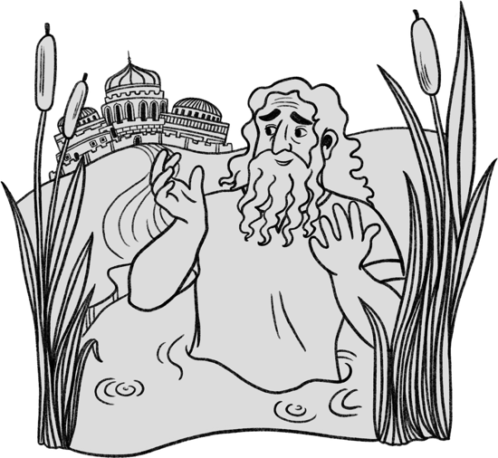
Key Lessons from Naaman
27. There are many lessons to be learned from the story of Naaman. Below is a list. Add to it if you have more lessons, and comment upon what we can learn regarding these things.
- God’s Providence
- God’s Calling & Prerogative
- Our attitude in the midst of hardship and adversity
- The power of declaring our faith
- Cleansing from sin & death is only provided through the saviour on God’s terms
- Salvation requires faith and obedience from a humble and contrite heart
- The power of God’s word to save can be stopped by faulty reasoning and pride
- The obligations after baptism and the power of a troubled conscience
- God uses foreign powers to humble His people

Gehazi's Greed
“If the story of Naaman is a wonderful demonstration of God’s grace and mercy; the story of Gehazi is its sombre counterpoint.”
(Bro Stephen Irving, Men of God, p179)

- Consider Gehazi’s words:
  - “my master hath spared” – what did Gehazi fail to appreciate?

  - “this Syrian” (2 Kings 5:20). What did Gehazi fail to see? Can we be guilty of the same today?

- Whose words does Gehazi use in verse 20, invoking an oath as it were?

“Little did Gehazi appreciate that through a casually spoken oath,
he was declaring the reality that the living God would hear every falsehood he uttered; that the living God would see his every action and would know his every false motive” (Bro Stephen Irving, p180)

- Gehazi spins a web of lies to achieve his goal and cover his tracks. What lies does Gehazi tell throughout verse 20-25?

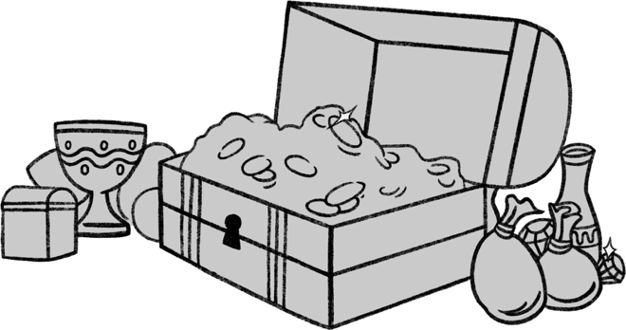

The Spirit of Generous Giving
- Naaman demonstrates great generosity.
He “urged” Gehazi to take these things, even
insisting on taking a double portion.
  - Although this Hebrew word isn’t used, where have we seen this same generous spirit earlier in our studies?

  - What was the motivation for Naaman’s great generosity?

  - Look at the New Testaments passages of how the 1st century brethren were instructed to give to those in need, and the motivation for that giving. (1 Cor. 16:2; 2 cor. 9:7,15; Rom.15:26-27) How does that apply to ecclesial life today?

The Pursuit of Riches
- Gehazi’s actions are similar to Achan, Judas and Ananias & Sapphira. He was driven by greed, riches and the pursuit of material gain. What are some verses elsewhere in scripture that speak about this spirit? What are some verses we could keep in mind to counter this spirit?

- Consider the list of things Elisha brings up in verse 26 that are focused on material gain. He starts with money and garments… 2 things Gehazi had just pursued. Suggest why he might have added olive yards, vineyards, sheep, oxen, menservants and maidservants to the list?

- Gehazi, like Judas, had spent much time in the presence of his master, yet had been left unimpressed. His heart had not been changed. There is a danger today that we can come into the presence of our master through the reading of the word, attending the meeting, etc. and yet fail to have his character impressed upon us. What steps can we take to avoid this?



A Type of Christ
Judgment is poured out upon Gehazi for this spirit of greed and selfishness. Elisha delivers this verdict, just as all judgment has been given unto the Son.
It has also been suggested a greater type of judgment is foreshadowed.
Gehazi is a Jew who rejected God’s anointed and is judged by being cut off; he despised the gospel message going to a Gentile. Naaman, a gentile, is shown grace and responds generously to it. However, the fact that Gehazi is later recorded as being in the presence of the King (2 Kings 8), might just typify the repentance and deliverance that will be afforded to the Jewish people when they are brought to recognize and appreciate their saviour.

Divine Omniscience
35. We learn something about Elisha’s prophetic power. His spirit went with Gehazi… he knew exactly what had happened!
  - Where else in Elisha’s ministry will this power be witnessed again?

  - What verses show us that Christ had this same power?

  - This is a Divine attribute of God. What verse proves God sees and knows everything and we cannot run or hide from His presence?

  - How can we maintain a consciousness to the fact that our God, Christ and the angels are ever present and see our actions?

IN CONCLUSION…
It would not be possible to cover all aspects of Elisha’s ministry in this workbook. However, we have provided some supplemental sheets with a summary of some of the other miracles and events in Elisha’s life, which might be further covered at the conference.

Hopefully, having done this study of Elisha, you will come away with a greater appreciation for this prophet: who his was, those he ministered to, and how he was a type of our Lord Jesus Christ.

Throughout this study we have been impressed with:
- Elisha’s faithful family and immediate response to God’s calling
- The work of Elijah and Elisha establishing the Sons of the Prophets throughout Israel
- The love those brethren had for the study of God’s word
- The joy Elisha brought to many who were in desperate situations
- God’s gracious and loving care toward all who trust in Him
- God’s providence in bringing others to the truth
- The gospel message preached unto the gentiles

What are some of the most impressive lessons you will take away from this study?

We look forward to discussing these things further at the Youth Conference, this summer, God willing.

APPENDIX
The following pages provide some commentary on sections of Elisha’s ministry that were not covered in the workbook questions.

THE FLOATING AXE HEAD
2 Kings 6:1-7
Key Theme: Recovering That Which Is Lost

The Context
The placement of this account is interesting given that the main theme is the recovery of that which is lost. Note how the chapter begins with “and” indicating some kind of link to chapter 5. Chapter 5 ends with a man who is lost: Gehazi. Chapter 5 also showed us how a lost gentile had received new life after washing in Jordan.

A New Dwelling Place
This group of the Sons of the Prophets had outgrown their dwelling (meeting) place. A plan is proposed to Elisha for his blessing, which is received. They would dismantle their existing dwelling, carry the timber to Jorden, where they would cut down additional lumber to construct a larger building.

“Let us make us a place” (v2) - Contrast Gen. 11:4. They were working together to build something to the glory of God, after receiving God’s blessing.


The Jordan – A Place of Significance
- Where Namaan’s leprosy was cleansed – Salvation to Gentiles (5:14)
- Where Elijah & Elisha crossed & Elisha performed his first miracle and was magnified (2:8,14)
- Where Joshua led Israel to the promised land and God was magnified (Josh. 4:24)
- Where Jesus comes to be baptized and is magnified (Matt. 3:13-17)
- The waters of Jordan signify the journey of all mankind, as they meander in serpent-like fashion down to the sea of death. The waters will be reversed in the Kingdom age.



A Borrowed Axe
The Sons of the Prophets were not financially well off. He had to borrow an axe. There was an obligation under
the law to return it (Exo. 22:14-15).
Axe construction was primitive in those days. Even the law made provision for the axe head flying off (Deut. 19:5). Fortunately, in this case, nobody was killed!

Alas, Master!
How often those in desperate circumstances turn to Elisha for help. This might seems a small matter in relation to the plight of others (Widow woman, Shunamite, Namaan). Yet we can take comfort that our God is gracious, and hears our cries, even in the small matters.

Spiritual Significance
There are commentaries which suggest that drawing spiritual significance from this event is a bit of a stretch. The present workbook writer disagrees. Scripture is full of types and shadows pointing forward to Christ, and especially in the ministry of Elisha. This does not take away from the simple lessons to be observed on the surface but adds depth and richness to the account.

Event | Spiritual Significance
Every man taking a beam (v2) | Each one taking up his cross
Elisha takes part in this work (v3,6) | Christ would partake in our sorrows (Isa. 53:4) and share in our condemned state. If he had not, there could be no help.
The axe head accidently flies off (v5) | The condemned state which we find ourselves in is our misfortune, not our crime.
Iron axe head sinks to the bottom of Jordan (v5) | Iron is often associated in scripture with the armies and strength of flesh.
The man cries to Elisha (v5) | He recognizes that of his own strength he cannot recover the lost axe head. Only through the gracious work of the saviour could the axe head be recovered.
Elisha cuts down a stick (same word as v4 – a beam of wood) and casts it in Jordan to make the iron swim (v6) | Like the stick Moses cast into the waters of Marah (Exo. 15:23-26), this beam can be seen as a type of the sacrifice of Christ. Through his death on the cross (and resurrection), that which is lost can be restored and given newness of life.  The iron itself had descended and ascended in Jordan… a type of baptism?
The man is instructed to pick up the axe. He puts out his hand and takes it. (v7) | We must participate in the work of Christ and have works associated with our faith. Obedience on our part is required.



OPENING THE EYES OF THE BLIND
2 Kings 6:8-23
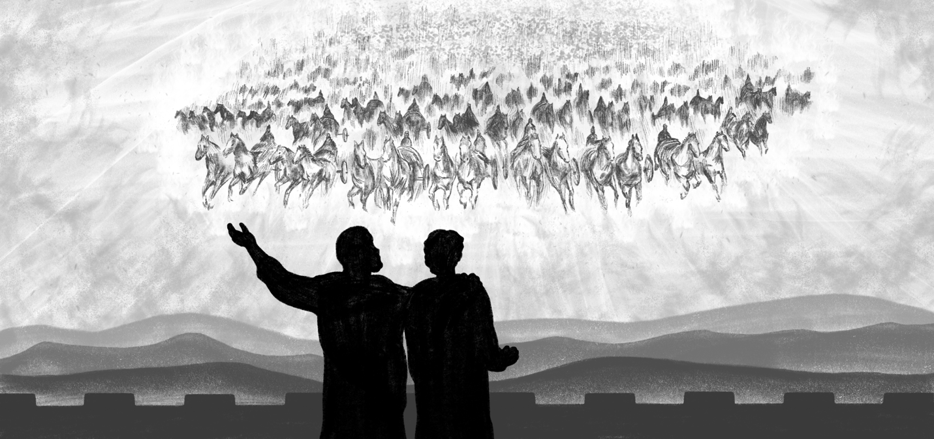
There are several comments earlier in the workbook with relevance to this section:
- Horses & Chariots on pages 21-22
- The King of Syria on page 84
- The contextual similarities between 2 Kings 5 and 6 on page 85
- The Syrians on pages 86-87

The Military Tactics of the Syrian King
- Warfare against Israel appears to be conducted using marauding bands, rather
than full scale war (2 Kings 6:23). This was followed in 6:24 by full-scale war.
- What was the purpose of the Syrian campaign in 6:8? Verse 19 suggests that
they were seeking a specific man… Jehoram the King of Israel. Likely to capture
or kill him.

Elisha’s Omniscient Power
- Elisha was given the ability by God to know the private discussions of
foreign kings miles away. (2 Kings 6:12)
- A rare quality in scripture. It is a divine quality of God’s Himself, given to His son,
and furthered by the work of the angels. (God: Prov. 15:3; Jesus: John 1:48)
- Bible Echo: Ezek. 38:10… Gog’s evil thought devised in the secret recesses of
his mind is known to God and revealed to the prophet Ezekiel.
- Practical Lesson: Nothing is done without the knowledge of God and the angels
which encamp around us. This is a cause of comfort to the faithful, and of fear to
the wicked (Psalm 139:1-4; Dan. 2:22-23; Jer. 23:23-24).

How Did the Syrian Servant Know of Elisha’s Ability?
- Likely this servant had accompanied Namaan in the previous chapter and was
aware of Elisha’s power.

Where Was Namaan?
- There is no mention of Namaan in this chapter, suggesting: A) He left his military
career upon his return to Syria; or B) He was excused from this mission based on
his partiality toward Israel.

Events at Dothan:
- The horses and chariots of the Syrian King moving in the darkness of night (v14),
stand in stark contrast to the Horses and Chariots of God’s immortal armies (Psa.
68:17). See Hezekiah’s recognition of this principle in 2 Chron. 32:7-8.
- The Servant (v15): We don’t know who this servant was. Assuming the events
follow on from chapter 5, this is likely a new servant.
- “Alas, my Master!” (v15): The same words from 6:5. This time evidently a much
more distressing situation than a lost axe head. Nevertheless, God hears the
cries of the faithful in matters great and small.
- Elisha’s response (v16) demonstrates He was aware of God’s presence at
all times.

“Elisha was clearly aware of this presence all the time, and prayed that
his servant could also be reassured by the same confidence. That same reassurance is there for us too, as the Psalmist also declared: ‘The angel of the LORD encamps all around those who fear him, and delivers them’ (Psalm 34:7).”
(Bro Stephen Irving, Men of God, p190)


Opening The Eyes:
An essential element of the New Covenant is that our eyes must be opened to see by
faith and not by sight (2 Cor. 4:18). Through the power of God’s word and the work of
His son, our eyes have been enlightened to the things of God’s truth and an awareness of God’s presence and purpose in the earth (Eph. 1:18).

“Fear Not” (v16):
This is phrase directly associated with the New Covenant.
- It was first spoken to Abraham (Gen. 15:1) when Abraham’s belief (faith) was
accounted as righteousness and the Abrahamic covenant was cut.
- It stands in contrast to the fear associated with the Old Covenant (Heb. 12:21).
- “Fear not” was a repeated phrase at the birth of Jesus Christ (Matt. 1:20;
Luke 1:13; 1:30; 2:10)

Blindness:
- The blindness bestowed upon the Syrian host echoes the events in Sodom
(Gen. 19:11). It echoes the blindness of the nations to the work and purpose of
our God.

- The opening of the eyes will happen to the nations when the Lord Jesus
Christ returns.

The Preaching of Elisha in Samaria:
Elisha spares the Syrian Army from certain death, exhorting the King of Israel to “set
bread and water before them, that they may eat and drink, and go to their master” (v22). Elisha’s teaching echoes that of Christ and the Principles of the New Covenant: Luke 6:35. Echo: Prov. 25:21-22; Rom. 12:20-21.



THE SIEGE OF SAMARIA
2 Kings 7
The city of Samaria was under siege. The situation was desperate. Inflation was soaring. Yet Elisha, who was in the city sharing in its plight, makes a remarkable prophecy! Within 24 hours, all the sorrows would come to an end: inflation wiped out, life returned to normal. A remarkable turn of events.
Then, a second prophecy: The King’s lord who mocked Elisha and failed to believe, would see this happen, but suddenly die.
Two prophecies. Within 24 hours, Elisha would be shown to be a true prophet.
Lesson: God can work in wondrous ways to turn a situation completely around. Nothing is impossible with God! Those who fail to believe and mock God’s word, shall be trodden under foot.


Four Leprous Men
4 of the many lepers in Elisha’s day (Luke 4:27)
4 alternative outcomes they determine (v4), but God provides a 5th which they could not have foreseen

The Number 4 → God Manifest Among
the Gentiles
- Feeding of the 4,000 – Gentiles (Matt. 15:38)
- The sheet in Peter’s vision knit at 4 corners full
of unclean animals – rep. Gentiles (Acts 10-11)
- Four living creatures, representing the multitude
of redeemed from every nation (Rev 4&5)

How did these 4 represent the Gentiles?
- Unclean in the sight of the Jews within the city
- Recognize their helpless situation, and that they were dead men (2 Kings 7:3-4)
- They discover God’s gracious provision in defeating the enemy (2 Kings 7:5)
- They are the first to partake of the spoils, as the Jews within the city are blind to the victory (2 Kings 7:8)
- They put away selfishness and bear the good news of God’s fulfilled word to the King (2 Kings 7:9)

Those Within the City – The Jews After the Flesh
- Ready to put Elisha to death (2 Kings 6:31)
- Kept under the law and shut up to the faith afterward to be revealed (Gal. 3:23)
- Blinded to the work God had accomplished in defeating King sin (Rom. 11:25)
- The good news afterward preached to them, and they partake in the spoils (Rom. 11:26-27)


The Victory Over the Enemy
- This was God’s victory over sin, achieved not by human strength or ingenuity
(Isa. 59:1)
- Accomplished by the noise of the
horses and chariots… God’s divine presence (2 Kings 7:6)
- This victory first represents God’s victory accomplished in Christ in overcoming King sin (2 Cor. 5:19)
- The victory extends to foreshadow the victory Christ and the Saints will achieve over the nations (Zech. 6:1-8)

Trodden Under Foot
- This man heard God’s word, but failed to believe (2 Kings 7:2)
- He perished in his sin (2 Kings 7:20)
- Trodden under foot – see Luke 8:5; Matt. 5:13; Hebrews 10:29 … the seed of God’s word took no root within his heart, and he despised God’s grace through unbelief
- Represents natural Israel who fail to recognize Christ (Rom. 9:31) and Gentiles who likewise fail to respond to the Word (Rom. 11:21)

Lessons from 2 Kings 7
- God’s mercy extended to deliver those in bondage. He can make a way
of deliverance.
- The comfort of divine presence and help in time of need
- The joy of salvation found by those in a desperate situation
- The sharing of the good news to others
- The hope of being part of God’s horsemen and chariots in the future age
- The vision of all Israel brought under the bonds of the New Covenant
- The tragedy of the King’s servant who wouldn’t believe
- The blessing of sharing in the grace God has afforded us

ELISHA’S MINISTRY IN DAMASCUS
2 Kings 8:7-15
“…Go return on Thy way to the wilderness of Damascus: and when thou comest, anoint Hazael to be king over Syria: And Jehu the son of Nimshi shalt thou anoint to be King over Israel…” (1 Kings 19:15-16)

This command was given to the Prophet of Israel, whoever that might be at the
appointed time for this to take place. When Elijah was removed, the command passed to his successor, Elisha, to fulfill. Evidently, Elisha was made aware in some way that the time was now right for this anointing. Elisha heads north
to Damascus.

Ben Hadad: King of Damascus
- Ben-Hadad II reigned from 860-841 BC
- He is previously referenced in 1 Kings 20; 2 Kings 5 and 6:24
- He was already well aware of Elisha’s power and graciousness:
  - Elisha had healed his captain Namaan of leprosy (2 Kings 5)
  - Elisha possessed omniscient power (2 Kings 6:12)
  - Elisha blinded his whole army and restored their sight (6:18,20)
  - Elisha was responsible for saving the Syrian army from death (6:21-23)

A Kingly Gift:
Now, at the end of his life, the Syrian King recognizes the superiority of Elisha,
submitting before him with the words, “Thy son Benhadad” (2 Kings 8:9), and presenting him with many gifts.
- Foreshadowing the submission of Kings to Christ in the Kingdom (Psalm 72:10-11)
- The present is greater than that which Namaan brought (8:9 cp 5:5)
- Elisha refused the gift of Namaan… salvation was not something that could be
purchased (5:16). Did he accept or refuse this gift from Ben Hadad? We are not told.
- Did the gift imply a request to be healed by Elisha? Or was it merely the outcome
he wanted foretold?
- This Syrian King had more faith than Ahaziah King of Israel (2 Kings 1:2)

Hazael
- Reigned Syria from 841-801 BC
- A vessel God would use to bring judgment on Israel, and upon Jehu
(2 Kings 10:32; 13:3)
- God kept his judgments mainly contained to the Northern Kingdom
(2 Kings 12:17-18)
- Vicious in his conquests (2 Kings 8:12; 13:7)
- The extent of his victories, and those of his son Ben Hadad III, are recorded in
2 Kings 10:32-33 and 13:3, 7

Holding Kings to Account:
- Although God had raised up these Kings to execute His judgments, they were
still accountable for their actions. Judgments would come upon Syria! (Amos 1:4)

Elisha:
Elisha was emotionally overcome in the presence of Hazael, knowing the evil he would accomplish. Jesus, likewise, would weep over Jerusalem (Luke 19:41) for what was to befall her. Although the judgements were necessary, God takes no pleasure in the death of the wicked (Ezek. 18:32; 33:11)

THE ARROW OF YAHWEH’S DELIVERANCE
2 Kings 13:14-19
“The total destruction of Syria was dependant not just on God’s ability to give Joash complete victory, but also on the degree of zeal with which the king would prosecute the war and drive the offensive home repeatedly. Jehu had displayed that sort of zeal, but his grandson seemed to lack it… Does the lack of bold and adventurous faith limit the achievement of victory over sin in ourselves?... Partial response, only brings partial victory.”
(Bro. David Wood, Elisah: The Neglected Prophet, p112).

“O my father, my father, the chariot of Israel and the
horsemen thereof” (v14)
A repeat of Elisha’s words to Elijah in 2:12. Joash likely recognized Elisha as God’s representative and the symbol of divine presence in Israel. He feared what would happen to Israel after Elisha’s death. Is it possible Elisha himself was the “saviour” referenced in 13:4-5? The mighty chariots & Chariots of God (6:17) stand in contrast
to Israel’s (13:7).
“Put thine hand upon the bow” (v16)
“Put” / “And he put” Rakab – “to ride”. (Margin: “Make thine hand to ride”). Same word associated with the cherubim (2 Sam. 22:11; Psa 18:10; 68:4,33), which were alluded to at the end of verse 14.
The arrow represents Yahweh’s deliverance against the Syrians. God, as the chariot rider, would direct the armies of Israel to victory.

Elisha’s Hands on Joash’s (v16)
Elisha places his hand upon Joash’s (v16), further emphasizing that God’s providential hand would direct the battles of Israel. This was fulfilled in verse 25.

“Blessed be the LORD my strength which teacheth my hands to war, and my fingers to fight.” (Psalm 144:1)

The Lesson from Aphek (v17)
The reference to Aphek was designed to draw Joash’s mind to 1 Kings 20:26, where the Syrian’s engaged in battle with Israel. Ahab was condemned for failing to utterly destroy the Syrians (20:42). Would Joash now make the same mistake?
“Smite upon the ground” (v18)
The arrows were already established as representing God’s deliverance. Joash does not inquire how many times he should smite. He assumes 3 times would be sufficient. Elisha’s condemnation indicates a half-hearted, lukewarm reception to God’s command. Joash needed the zeal of Jehu. Contrast Jer. 50:14.

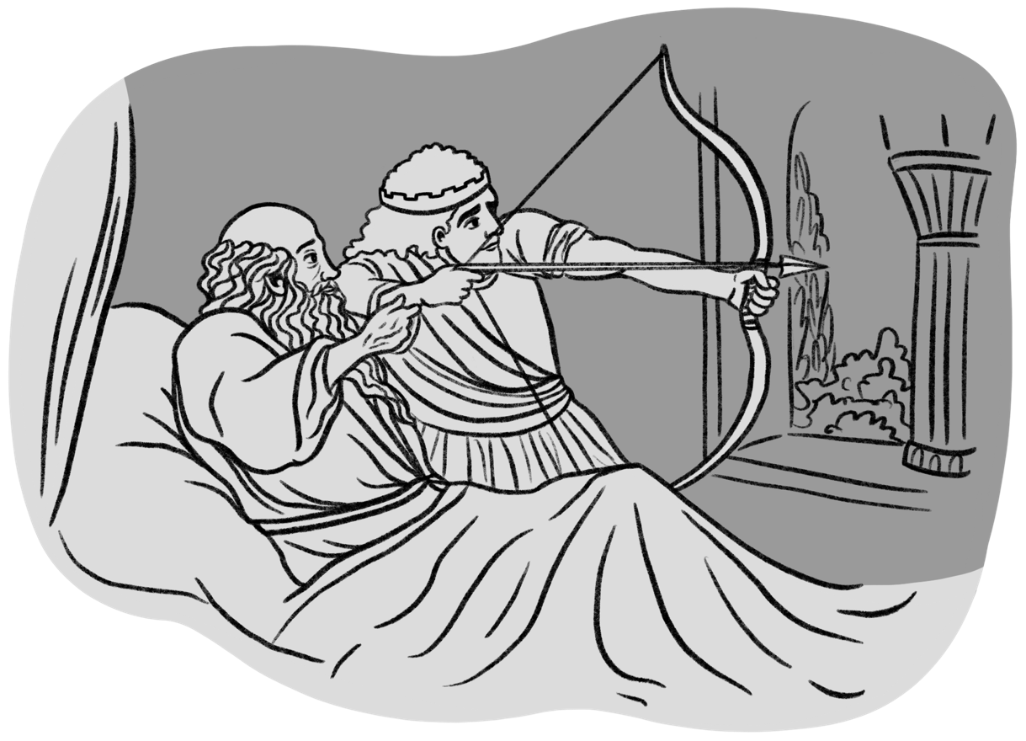

ELISHA’S BONES
2 Kings 13:20-21

How old was Elisha?
As suggested at the outset of the book, Elisha was likely in his 80’s, as the time from his calling to his death was a period of approximately 65 years.

The bands of the Moabites
Similar to the Syrian’s in 2 Kings 5:2, the Moabites launch raiding parties into Israel. It was not a full scale war. The last time we read of the Moabites was in 2 Kings 3:26 when they were defeated by Israel, Judah and Edom.


The Coming in of the Year
Springtime was the time of war – 2 Sam. 11:1; Eccl. 3:8

Raised to Mortality
- The Widow of Zarephath’s Son ~ Elijah
- The Shunamite Woman’s Son ~ Elisha
- A man of 13:21 ~ Elisha
These echo the 3 resurrections to mortality in the ministry of Christ (Jairus’ daughter, the widow’s son at Nain, and Lazarus)

An Echo to Joseph’s Bones
Joseph’s bones were a witness to his belief in the promises of God and the hope of the resurrection. Elisha’s bones similarly speak to the hope of life through association with the man of God. Both men pre-figured the work of the Lord Jesus Christ.

Death and Resurrection
Through association with the death of the Lord Jesus Christ (and his resurrection), there is hope of resurrection to eternal life. (Romans 6:4)

“He revived and stood upon his feet”
The same phrase is used in Ezekiel 37:10 in reference to the spiritual resurrection of the “whole house of Israel” (37:11) at Christ’s return. This is a process that comes about through the recognition of Christ as their saviour at a time when the land is invaded and the entrance of God’s spirit word into their hearts and minds. This was the very essence of Elisha’s ministry. The man in 2 Kings 13 not only represents us but also represents Israel’s redemption through Christ.

